**A Policy Indicator for Road Traffic Noise Emission**

Michael Dittrich, TNO  
Johan Sliggers, Netherlands Ministry of Infrastructure and Environment

**Introduction**

As an environmental factor, noise is second only to air pollution for impact on public health, with road traffic having a major contribution. In the Netherlands around 3 million people are annoyed or sleep disturbed, and 1.5 million are seriously annoyed or seriously sleep disturbed. The most cost-effective means of mitigation are the reduction of noise emissions at source for vehicles, tyres and road surfaces.

Information on numbers and location of annoyed and sleep disturbed people is widely available from surveys and from noise mapping of road networks and agglomerations combined with dose-effect relationships. As required by the Environmental Noise Directive 2002/49/EC, authorities use this information to inform the public and to reduce noise exposure and its impact. This policy is based on the premise that mitigation of noise at source (vehicles and tyres) is well regulated at European level. But an integrated noise policy is lacking, as noise in general and noise source mitigation for vehicles and tyres are under the remit of four different EU Directorates: DG Environment, DG Energy, DG Mobility and Transport and DG Growth.

It is therefore important to make a link between the various noise source mitigation measures and health effects. Insight into the contributions from each noise source to numbers of annoyed and sleep disturbed people will allow efficient selection of mitigation measures for vehicles, tyres and roads. Also the number of people who benefit from of each individual measure can be quantified.

At request of the Ministry of Infrastructure and Environment, TNO has developed a Policy Indicator to link noise source mitigation measures to numbers of affected people. It has been implemented in a spreadsheet which enables the user to quickly determine from a limited number of inputs the effect of noise control at source on average noise levels at the dwelling façade and on estimated numbers of annoyed and sleep disturbed people. Examples of policy measures that can be assessed are quieter tyres based on the noise label, quieter vehicles based on their type approval limit, quiet road surfaces, noise barriers, changes in population densities and traffic flow.

In this paper the structure and implementation of the Policy Indicator is set out, followed by several calculated future scenarios for 2030. Finally, its potential use for national and international policy is discussed.

**The Policy Indicator**

The Policy Indicator is based on a straightforward model, shown schematically in Figure 1 and described in more detail in [1]. The approach is similar to that applied in the Venoliva study for the European Commission in 2011 [2], but improved to better incorporate the effects of noise mitigation measures such as quiet road surfaces in combination with quieter tyres. The noise emission is calculated with the European CNOSSOS model [3], corrected to produce noise levels comparable to the Dutch statutory traffic noise model SRM I and II [4] and emission measurements from Germany [5]. The advantage of the CNOSSOS model is that a split is made between rolling noise and powertrain noise, allowing to separately take into account the effect of noise limits, tyre label and road surface. The sound power emission curves as a function of speed for light vehicles at constant speed are provided in the appendix in Figure A1.

The source sound power levels for each vehicle category (light, medium and heavy vehicle categories used in statutory calculation methods) are separately determined for rolling noise and powertrain noise. The rolling noise is calculated by default for standard dense asphalt concrete (DAC) and for the noise level indicated on the tyre label. The powertrain noise is derived from type approval data and calculated as a function of the vehicle category and the acceleration condition (intermittent or constant traffic flow). For powertrain noise, percentages of the vehicle fleet can be specified that comply with the EU noise limits from particular years of introduction (see Figure 2). A percentage of hybrid or electric vehicles can also be specified.

The noise emissions of the traffic flow are calculated for each road type (residential, main, arterial roads and motorways) with their particular driving conditions, from the noise emission of each vehicle category and the average traffic flows in the Netherlands (see Figure 2).

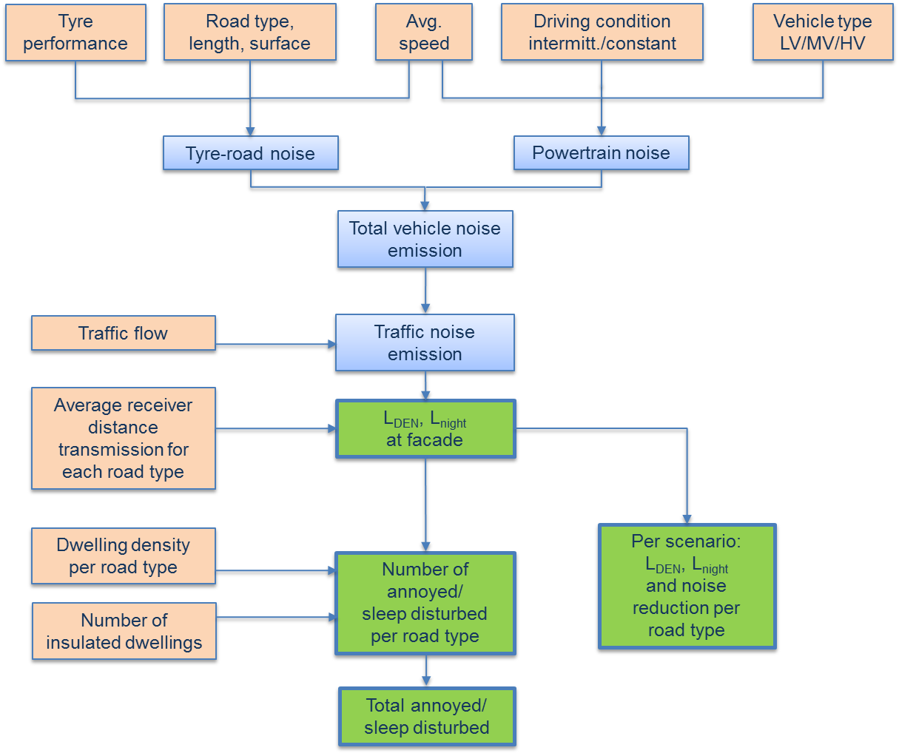

Figure 1: Scheme of the calculation model with input parameters in red and outputs in green.

The input data for infrastructure and traffic for each road type comprise:

* the total lengths of the characteristic road types with dwellings along them;
* the total length and type of quiet road surfaces;
* the total length of noise barriers;
* percentages of sound insulated dwellings;
* the roadside population density;
* driving speeds for each vehicle category;
* average traffic flows for each vehicle type.

These are set out in tables A1 and A2 in the appendix.

Noise mitigation measures are taken into account as follows:

* quiet road surfaces are adjusted for with Dutch rolling noise correction factors for several common surface types;
* the reduction in rolling noise for quieter tyres is derived from the tyre label and the type of road surface;
* the reduction of powertrain noise is determined from the fleet percentages that fulfill current or future limits, or are hybrid or electric vehicles;
* the effect of noise barriers is taken at an average 10 dB reduction in the Lden and Lnight levels at the façade;
* for sound insulated dwellings (only those remediated by authorities), 2.4 inhabitants per dwelling are deducted from the numbers of exposed people.

The average Lden and Lnight noise levels at the façade are calculated at 15 m or 50 m from the road centerline depending on the road type and assuming a situation without obstructions, reflections and with a hard surface between source and receiver. For residential roads and main roads with speeds up to 50 km/h a distinction is made between free flowing and intermittent traffic; one third of the road length is assumed to have intermittent traffic (accelerating or braking) due to junctions, crossings and obstacles. This approach was also taken in the Venoliva study [2].

Using the calculated Lden and Lnight levels for each road type, the roadside population densities, the road lengths with dwellings and the established dose-effect relationships for annoyance and sleep disturbance [6,7], the numbers of (seriously) annoyed and (seriously) sleep disturbed people are calculated for each road type.

The total number of annoyed people has been slightly adjusted to Dutch survey data from 2003 [8] and extrapolated to 2015 according to population growth.

The spreadsheet tool is shown in Figure 2.

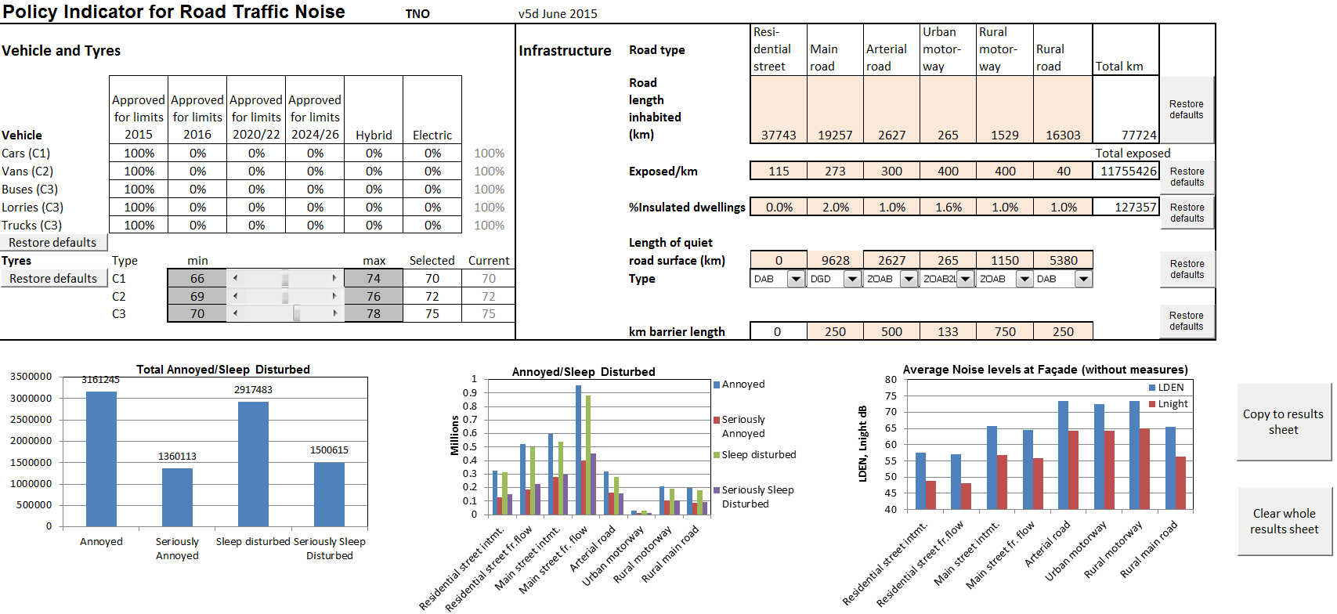

Figure 2: Policy Indicator spreadsheet with vehicle and tyre inputs on top left, infrastructure inputs on top right and calculated average numbers of annoyed, sleep disturbed people and Lden/Lnight façade noise levels below.

**Scenarios for 2030**

The potential applications of the Policy Indicator are illustrated by several scenarios.

The situation in 2015 is taken as the reference scenario (1). Subsequent scenarios for 2030 assume a 1% annual growth in road traffic (2), the best possible separate mitigation measures for vehicles (3), tyres (4) and road surfaces (5) and the combination of all of these (6), as listed in Table 1.

Table 1: Scenarios for the evolution of noise emission levels of road traffic sources.

|  |  |
| --- | --- |
| **Scenario** | **Description** |
| 1. Situation in 2015 | Fleet composition, road infrastructure, mitigation measures and demographics in the Netherlands in 2015. |
| 2. 2030 including 1% growth | 1% growth in traffic, no extra measures and autonomous intake of quieter vehicles and tyres, with a fleet distribution as in Tables 2a/b. |
| 3. 2030 Sc.2 + quiet vehicles | Scenario 2 with 3 dB quieter vehicles compared to the EU-limits for 2024/2026 [9] (Table 2). |
| 4. 2030 Sc.2 + quiet tyres | Scenario 2 only with quieter tyres. Tyres 2 dB quieter than the limits for 2020 proposed by the Netherlands [12] (Table 4). |
| 5. 2030 Sc.2 + quiet road surfaces | Scenario 2 with wider application of quiet road surfaces only (2-layer ZOAB with fine top layer), on all roads with dwellings and speed limit of 50 km/h or more, except calmer streets in residential areas. |
| 6. 2030 Sc.2 + all measures | Combination of scenarios 2,3,4 and 5. |

The currently foreseen European noise limits for vehicles as listed in Regulation 540/2014/EU [9] are set out in Table 2. These are valid for a number of vehicle classes and have been converted to three categories used in the Dutch calculation method [4]: light, medium and heavy vehicles. These limits are most relevant for the powertrain noise. As vehicle lifetime is on average about 13 years, a combination of vehicles with type test approval for different limits will be circulating in 2030, assuming an autonomous influx of new vehicles. This is indicated in Table 3 with percentages of the fleet approved for each limit, used for the calculation scenario 2, the situation in 2030. In scenario 3, full implementation of the 2024/26 vehicle noise limits minus 3 dB is assumed.

The noise emission of tyres is subject to limits according to UNECE Regulation 117, adopted by the EU[10], applicable from 2016. In scenarios 2 en 3 it is assumed that the tyre regulations are unchanged. The Netherlands has proposed tighter limits [11] for 2020 that have not yet been adopted. Scenario 4 assumes full implementation of the Dutch proposal for 2020 minus 2 dB (Table 4). The lifetime of tyres is about 4 years which means that the effect of new tyre limits comes to fruition much sooner than vehicle noise limits.

Table 2: EU vehicle noise limits for 2016-2026 [9], with conversion to equivalent limit values for each vehicle category of the Dutch calculation method. In the last column the noise emission for scenario 3 with quieter vehicles is shown.



Table 3: Percentages of vehicles of the whole fleet in 2030 approved for the various limits, with autonomous introduction of new vehicles (scenario 2).

|  |  |  |  |  |  |  |
| --- | --- | --- | --- | --- | --- | --- |
| **Vehicle/Tyre** | Approved for  2015 limits | Approved for  2016 limits | Approved for 2020/22 limits | Approved for 2024/26 limits | Hybrid | Electric |
| Cars/C1 | 0% | 30% | 45% | 20% | 3% | 2% |
| Vans/C2 | 0% | 30% | 45% | 20% | 3% | 2% |
| Buses/C3 | 0% | 30% | 45% | 20% | 3% | 2% |
| Lorries/C3 | 0% | 30% | 45% | 20% | 3% | 2% |
| Trucks /C3 | 0% | 30% | 45% | 20% | 3% | 2% |

Table 4: Limit values for tyres in dB(A) from 2016, the Dutch GRB proposal for 2020 [11] and the situation for scenario 4 in 2030 with quiet tyres.

|  |  |  |  |
| --- | --- | --- | --- |
| Tyre class | EU/UN Regulation 117 for 2016 | NL proposal for 2020 | Scenario 4  2030+quiet tyres |
| C1 | 70-74 | 67-71 | 65-69 |
| C2  Traction tyres | 72-74  73/73/75 | 70-72  71/73/73 | 68-70  +2 |
| C3  Traction tyres | 73/73/74/75  +2 | 69/71/71  71-73 | 67/69/69  +2 |

Significant noise reductions are achievable with quiet road surfaces. Therefore scenario 5 assumes widespread introduction of quiet road surfaces on all roads with dwellings nearby, with a speed limit of 50 km/h or more, except for calmer streets in residential areas.

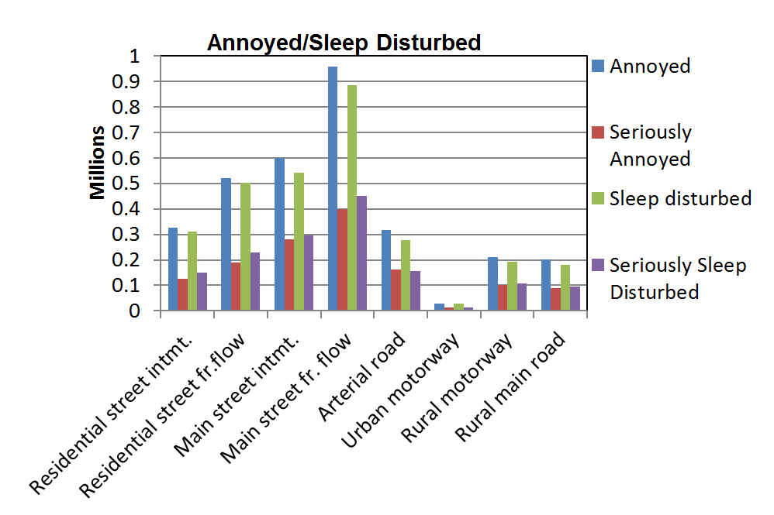

Figure 3: Numbers of annoyed and sleep disturbed for the different road types for the reference situation in the Netherlands in 2015.

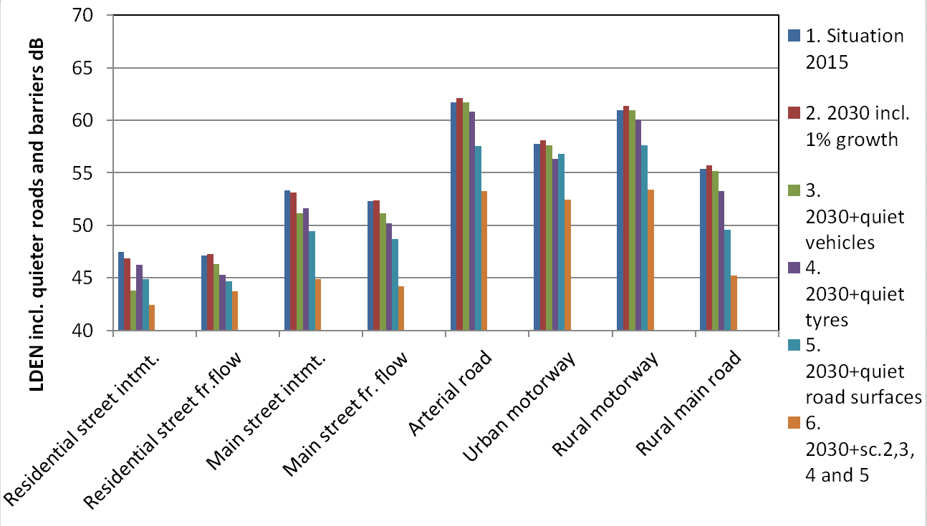

Figure 4: Lden noise levels at the façade for the different road types for the scenarios 1-6 listed   
in Table 1, including effects of quiet road surfaces and noise barriers (where present).

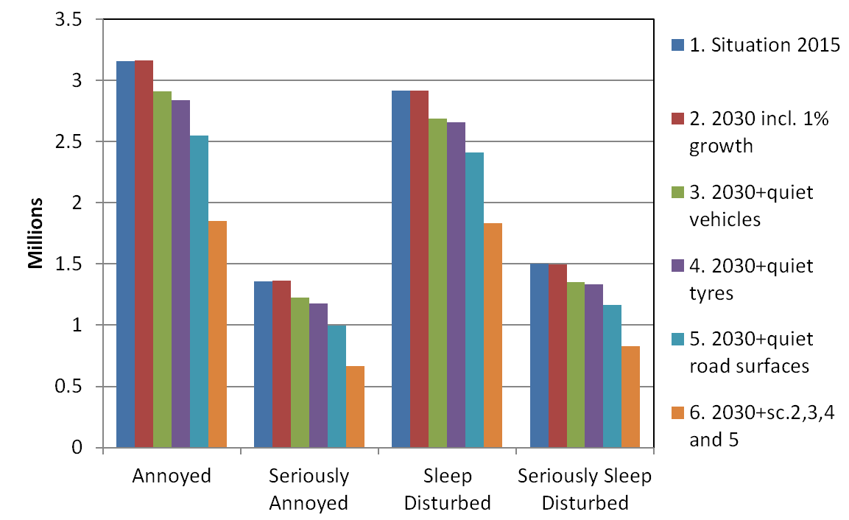

Figure 5: Total numbers of (seriously) annoyed and (seriously) sleep disturbed people for the scenarios 1-6 listed in Table 1.

**Analysis of results**

The numbers of annoyed and sleep disturbed people for the reference situation in 2015 and for the various types of road are set out in Figure 3, and in Figure 5 and Table 5 for the totals for each scenario. The corresponding Lden noise levels at the façade for each scenario and road type are shown in Figure 4.

A moderate annual growth in traffic of 1% is not compensated by the foreseen European noise limits by 2030. A small increase in numbers of annoyed people still occurs. In scenarios 3 and 4, with quieter vehicles and quieter tyres respectively, numbers of (seriously) annoyed and sleep disturbed are reduced by around 10%. In scenario 5, in which the quietest road surfaces are implemented for all roads with dwellings except calmer roads in residential areas, larger reductions of (seriously) annoyed and sleep disturbed of 17-27% are expected. Combination of all mitigation measures as in scenario 6 results in reductions of 37-51%.

Table 5: Numbers and percentages of (seriously) annoyed and sleep disturbed people   
in the Netherlands for each scenario.

|  |  |  |  |  |  |  |  |  |
| --- | --- | --- | --- | --- | --- | --- | --- | --- |
| Scenario | Annoyed | Reduction from  Sc.1 | Seriously Annoyed | Reduction from  Sc.1 | Sleep Disturbed | Reduction from  Sc.1 | Seriously Sleep Disturbed | Reduction from  Sc.1 |
| 1 | 3161245 |  | 1360113 |  | 2917483 |  | 1500615 |  |
| 2 | 3165333 | -0.1% | 1364278 | -0.3% | 2914577 | 0.1% | 1499111 | 0.1% |
| 3 | 2914022 | 8% | 1222993 | 10% | 2687540 | 8% | 1354446 | 10% |
| 4 | 2840506 | 10% | 1176935 | 13% | 2660222 | 9% | 1335718 | 11% |
| 5 | 2550716 | 19% | 995040 | 27% | 2411667 | 17% | 1166955 | 22% |
| 6 | 1854576 | 41% | 664176 | 51% | 1832317 | 37% | 831292 | 45% |

**Discussion and conclusions**

The Policy Indicator can be used for large areas such as countries, regions or major agglomerations. It is not intended or suited for the assessment of small areas or specific locations, and is no replacement for statutory calculation methods and noise mapping, but can be considered as an additional tool for policy support.

The Policy Indicator can be used to underpin focused and integral policies for noise emission derived from health-related targets. The Policy Indicator has been developed for the Netherlands. It would be interesting to have a similar indicator for the EU as a whole. In the EU 55-60 million people are seriously annoyed or sleep disturbed [12] . A combination of all possible source oriented measures as has been done for the Netherlands would reduce these by around 50%. Individual mitigation measures can also be assessed, such as tightening of tyre noise limits [11] or incentives for swifter introduction of quieter vehicles.

The above scenarios clearly illustrate that quiet road surfaces are quite effective.

These are however expensive and not covered by international regulation.

Quieter tyres are also effective in reducing annoyance and sleep disturbance. A key point is that this measure is practically cost neutral if gradually implemented.

The noise limits for tyres are given in ECE regulation R117 and EU Regulation on General Safety [10]. The Netherlands has already proposed tighter limits in the ECE [11]. The proposal will be underpinned with a calculation of reductions of annoyed and sleep disturbed people, using the Policy Indicator. The European Commission has the obligation to evaluate and revise the Regulation on General Safety, which specifies the tyre noise limits. The Commission commenced this process in 2012, starting with safety, but has not yet reviewed the tyre noise limits. Here lies a task for the member states with the results of the Policy Indicator at hand.

Besides noise limits, the public can also be encouraged to buy better tyres. Calculations with the Policy Indicator show that starting the Dutch awareness campaign 'Choose the best tyre' [13] makes sense.

Quieter vehicles also contribute to the reduction of annoyance. Not much can be done currently in relation to the noise limits as the Regulation on Vehicle Noise [9] was revised in 2014.

Voluntary change to quieter vehicles can be incentivised. A means to do this could be the development and introduction of a vehicle noise label [14]. The Commission is also obliged by the same regulation to perform an assessment of such a label and to make a proposal to the Council and the European Parliament. The calculation with the policy indicator also demonstrates that incentivising quieter vehicles can be effective. This type of measure is also highly cost-effective, in the same way as for tyres.

**References**

[1] Dittrich M., de Roo F., Beleidsindicator geluid wegverkeer (Policy Indicator for Road Traffic Noise), TNO report TNO 2015 R10673, The Hague,June 2015.

[2] De Roo, F., Dittrich, M, e.a.: VENOLIVA - Vehicle Noise Limit Values - Comparison of two noise emission test methods, Final report, TNO report MON-RPT-2010-02103, 30 March 2011.

[3] S. Kephalopoulos, e.a.: Common Noise Assessment Methods in Europe (CNOSSOS-EU), Publications Office of the European Union, 2012.

[4] Regeling van de Staatssecretaris van Infrastructuur en Milieu, van 12 juni 2012, nr. IENM/BSK-2012/37333, houdende vaststelling van regels voor het berekenen en meten van de geluidsbelasting en de geluidproductie ingevolge de Wet geluidhinder en de Wet milieubeheer (Reken- en meetvoorschrift geluid 2012) – Bijlage III behorende bij Hoofdstuk 3 van het Reken- en meetvoorschrift. (Dutch calculation method for road traffic noise).

[5] Steven, H., Investigations on Noise Emission of Motor Vehicles in Road Traffic, Final Report of Research Project 200 54 135, RWTÜV Fahrzeug GmbH, Würselen, Germany, February 2005.

[6] Position paper on dose response relationships between transportation noise and annoyance, European Commission, Brussels, February 2002.

[7] Night Noise Guidelines for Europe, WHO, Copenhagen 2009.

[8] E.A.M. Franssen, J.E.F. van Dongen, J.M.H. Ruysbroek, H. Vos, RK Stellato, Hinder door milieufactoren en de beoordeling van de leefomgeving in Nederland - Inventarisatie verstoringen 2003, RIVM rapport 815120001 / 2004, TNO rapport 2004-34.

[9] Regulation (EU) No 540/2014 of the European Parliament and of the the Council of 16 April 2014 on the sound level of motor vehicles and of replacement silencing systems, and amending Directive 2007/46/EC and repealing Directive 70/157/EEC.

[10] Regulation (EC) No 661/2009 of the European Parliament and of the Council of 13 July 2009 concerning type-approval requirements for the general safety of motor vehicles, their trailers and systems, components and separate technical units intended therefor.

[11] J. Sliggers, Possible Future Tyre Noise limits, Informal document GRB-61-03, 61st GRB, 27-29 January 2015.

[12] Zyl Stephan van e.a., Potential benefits of triple A tyres in the EU, Informal document GRB-60-13, 60st GRB, September 2014.

[13] Website campaign ‘Kies de Beste Band’ (Choose the best tyre): [www.kiesdebesteband.nl](http://www.kiesdebesteband.nl)

[14] Sliggers Johan, A noise label for motor vehicles: towards quieter traffic, UNECE GRB 61st meeting, Informal document GRB-61-03, January 2015.

**Appendix**

Table A1: Road data including lengths, numbers of exposed inhabitants, average façade distance and noise characteristics as applied for the Policy Indicator.



Table A2: Average traffic flow rates for each road type and vehicle category



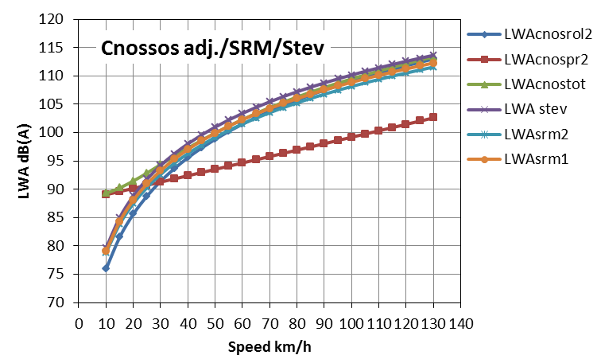

Figure A1: Sound power emission curves for light vehicles at constant speed for the CNOSSOS emission model adjusted to coincide with SRM (including rolling noise, propulsion noise and both combined), the Dutch SRM I and II models and measured emission data from Germany (Stev [4]).