Revised proposal for a Supplement to Regulation No. 48 (Installation of lighting and light-signalling devices)
Note: This informal document is replacing document ECE/TRANS/WP.29/GRE/2015/6. The modifications to the existing text of the Regulation are marked in bold for new or strikethrough for deleted characters.
I. Proposal
Paragraph 2.7.26., renumber as paragraph 2.7.26.1.
Insert a new paragraph 2.7.26.2., to read:
"2.7.26.2. "Side illuminating lamp" means a lamp used to provide supplementary illumination of that part of the road which is located on the left side of vehicle to improve road visibility for oncoming drivers in situation when they are exposed for headlights glare."
Insert new paragraph 6.27. to 6.27.6., to read:
"6.27. Side illuminating lamp (Regulation No. 119)
6.27.1. Presence
Optional on motor vehicles.
6.27.2. Number
One or more.
6.27.3. Arrangement
On the left side for right hand traffic and right side for left hand traffic. One or more lamp is allowed but a horizontal distance between lamps of at least 6 m shall be maintained.
6.27.4. Position
In height: minimum: Not less than 400 mm above the ground;
maximum: Not more than 900 mm above the ground.
6.27.5. Geometric visibility
Defined by angles α and β as specified in paragraph 2.13.:
α = 2° downwards and 30° downwards,
β = from 80° to the front to 80° to the rear.
6.27.6. Electrical connections
The side illuminating lamps shall be so connected that they cannot be activated unless the dipped-beam headlamps are switched ON at the same time. The lamp can be manually or automatically switched OFF when vehicle is present in build-up area and during the day. "
II. Justification
When vehicles pass in the opposing direction, drivers are exposed to headlamp glare. Visibility is impaired. Also, the practical road illumination distance of passing beams adjusted according requirements of Reg. 48 can be limited to 20-50 m. It is illustrated on Fot.1.

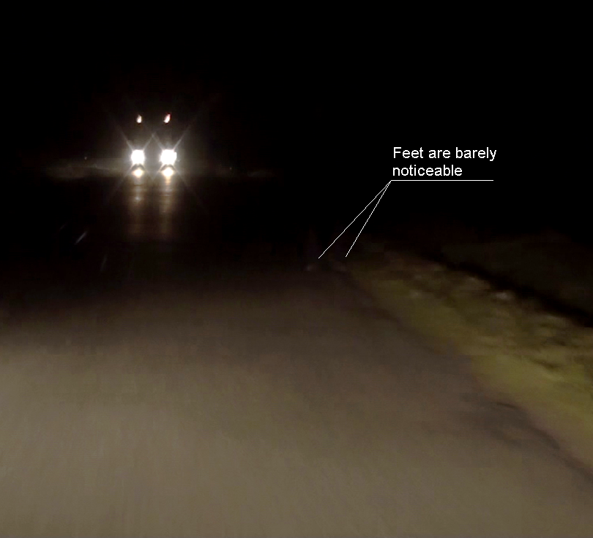
Fot. 1. Real situation. By using typical passing beam pedestrians wearing dark clothes can be seen only at very close distance.
Visibility could be significantly improved by introducing supplementary light emitted by additional “side illuminating lamp” for that part of the road which is located on the left side (for right hand traffic) or right side(for left hand traffic) of approaching vehicles where pedestrians, animals, etc. are “invisible” to the glared driver. It is illustrated on Fot.2.

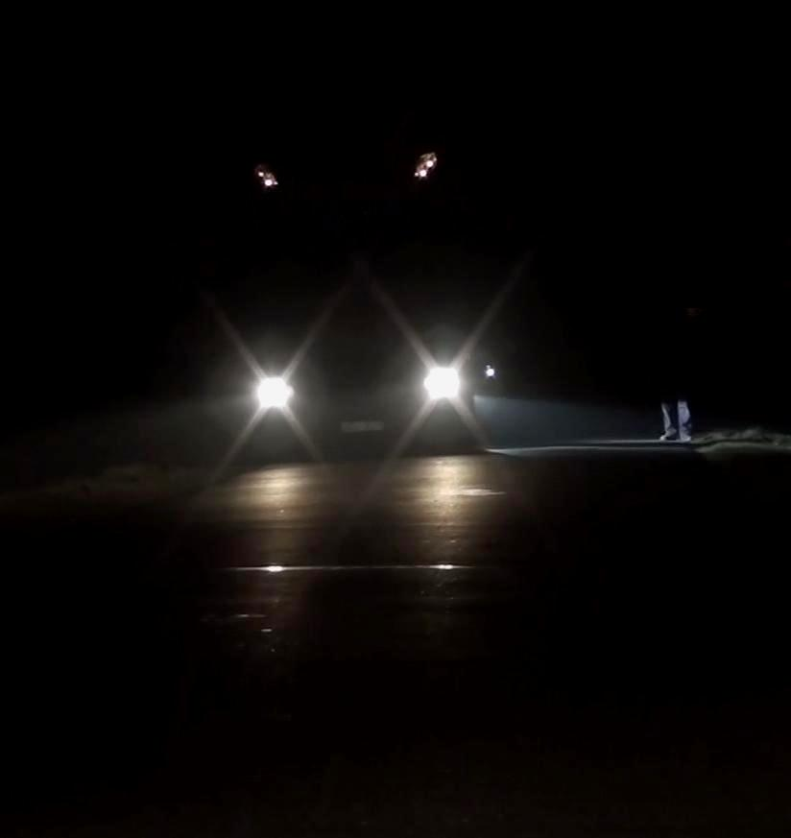
Fot. 2. Side illuminating lamp perfectly illuminates pedestrian’s leg even in black trousers.
Many following vehicles in typical situation of dense traffic equipped with such lights can provide additional illumination at a much greater distance to oncoming drivers. Because these lights are directed down and to the side they not hamper other road users. These are similar to cornering lights but are much less visible to other road users.
Test made with few such lamps in traffic showed that they are very helpful.
These lamps are to be introduced as optional.

__________________

