|  |  |  |  |
| --- | --- | --- | --- |
|  | United Nations | ECE/TRANS/WP.29/GRSG/2015/21 | |
| _unlogo | **Economic and Social Council** | | Distr.: General  10 July 2015  Original: English |

**Economic Commission for Europe**

Inland Transport Committee

**World Forum for Harmonization of Vehicle Regulations**

**Working Party on General Safety Provisions**

**109th session**

Geneva, 29 September – 2 October 2015

Item 2(a) of the provisional agenda

**Regulation No. 107 (M2 and M3 vehicles) –   
Proposals for further amendments**

Proposal for amendments to the 05 and 06 series of amendments to Regulation No. 107 (M2 and M3 vehicles)

Submitted by the expert from Romania[[1]](#footnote-2)\*

The text reproduced below was prepared by the expert from Romania to clarify the requirements regarding the seat spacing. It is based on informal document GRSG-108-35, distributed during the 108th session of the Working Party on General Safety Provisions (GRSG) (see report ECE/TRANS/WP.29/GRSG/87, para. 10). The modifications to the current text of Regulation No. 107 are marked in bold for new characters and strikethrough for deleted characters.

**I. Proposal**

*Annex 3, paragraphs 7.7.8.4.1. and 7.7.8.4.2.,* amend to read:

"7.7.8.4.1. In the case of seats facing in the same direction, the distance between the front of a seat squab and the back of the squab of the seat preceding it (dimension H), shall, when measured horizontally**, parallel to the longitudinal plane of the vehicle** and at all heights above the floor between the level of the top surface of the seat cushion and a point 620 mm above the floor, not be less than:

| *H* | |
| --- | --- |
| Classes I, A and B | 650 mm |
| Classes II and III | 680 mm |

**The distance (dimension H) shall be fulfilled over the zone defined by longitudinal vertical planes 200 mm either side of the median vertical plane of the seating position.**

7.7.8.4.2. All measurements shall be taken, with the seat cushion and squab uncompressed~~, in a vertical plane passing through the centreline of the individual seating place~~."

II. Justification

1. The current text of paragraph 7.7.8.4.2. specifies that the measurements shall be taken in a vertical plane passing through the centreline of the individual seating place.

2. Technical service practice has shown that there are dedicated seats for vehicles M2 or M3 for which the backrest configuration lead to fulfilment of the minimum H dimension only in middle seat line or near them, but the real passenger comfort is not assured (see the photos below).

 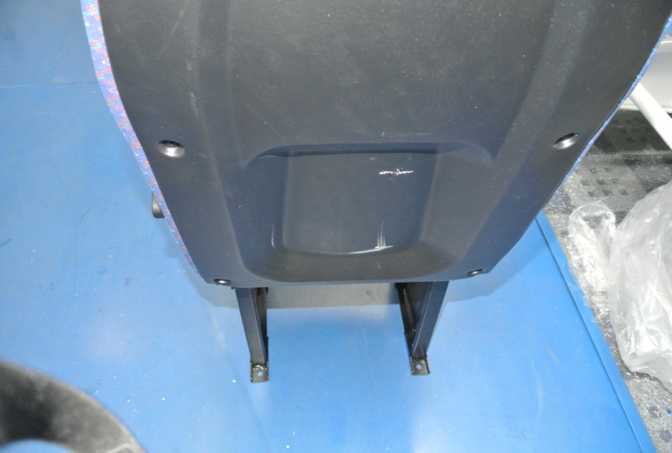

3. The type approval authorities of the member states of the European Union (TAAM) discussed during meetings in 2014 the proper interpretation of the text of the Regulation in case of seats produced with a central recess (sunken area), to comply with dimension H measurement requirement.

4. Type approval authorities decided that the text of the Regulation shall be modified in order to provide an adequate method to measure the H dimension.

5. The text proposed is correlated with the free space over seating positions defined in paragraph 7.7.8.6.2.

1. \* In accordance with the programme of work of the Inland Transport Committee for 2012–2016 (ECE/TRANS/224, para. 94 and ECE/TRANS/2012/12, programme activity 02.4), the World Forum will develop, harmonize and update Regulations in order to enhance the performance of vehicles. The present document is submitted in conformity with that mandate. [↑](#footnote-ref-2)