INF.6
Economic Commission for Europe
Inland Transport Committee
Working Party on the Transport of Dangerous Goods
Joint Meeting of the RID Committee of Experts and the
Working Party on the Transport of Dangerous Goods 26 July 2017
Geneva, 19-29 September 2017
Item 8 of the provisional agenda
Accidents and risk management
Second phase of the TDG Roadmap
Transmitted by the European Union Agency for Railways (ERA)
Introduction
The 11th Workshop of the roadmap on Risk Management of Inland Transport of Dangerous Goods which will be held on 10-12 October 2017 at the headquarters of the European Union Agency for Railways will be the last one of the series of workshops originally planned in document ECE-TRANS-WP15-AC1-2014-GE-INF16.
Considering the progress made during this first phase and the coming publication of the Framework guides on risk management in the context of road, rail and inland waterways transport of dangerous goods, the participants to the first phase and the Agency considered useful to continue with a second phase, focussed on the facilitation of the framework implementation.
The present document aims at presenting the foreseen activities of the second phase of the TDG roadmap and aims at collecting the views of the Joint Meeting delegates.
Second phase TDG Roadmap (2018-2020 activities)
At the 10th workshop, the participants were asked to reflect on the activities that would be useful to undertake to facilitate the future implementation of the guides.
The participants agreed a list of priority actions and suggested the Agency to immediately organise a second phase of the TDG roadmap.
The agreed priorities can be summarized as following:
- The Agency should continue coordinating and facilitating the 2018-2020 TDG Roadmap phase within the limit of the allocated resources for developing the activities presented hereinafter,
- The Agency should establish an ‘Inland TDG risk management’ website (ITDG RM) allowing the dissemination and the promotion of the guides with the primary objective of assisting the future users,
- The developments of the use-case examples by volunteer users should continue, as initiated in 2017. When finalized the use-case examples, in their initial form or in a simplified/anonymous one, should contribute to the assistance material which may be published on the ITDG RM website, as practical examples for the public users,
- The Agency should establish a standing Expert users group, developed from the initial test-user group and extended with the contribution of additional experts. A detailed description of the organization and expected tasks should constitute the mandate of this group. It is anticipated that this mandate should contain objectives relating to the maintenance, continuous improvement and the preparatory tasks for the future versions of the guides. These tasks may include, in parallel a) collecting and assessing the feedback of the public users of the guides in order to progressively achieve better user satisfaction and to address specific needs b) setting the missing – by default – calibration of the framework and c) contributing to the design of the future ‘risk estimation engine’ IT platform and test this future platform before its launching on the ITDG RM website.
- The Agency should convene regular Expert user group meetings and TDG Roadmap supervision meetings allowing to provide necessary institutional support for the implementation and the continuous improvements of the harmonized ITDG risk management framework.
- The Agency should provide relevant inputs to the Joint Meeting for supporting a good coordination of legal developments in the field of data reporting regimes and in particular taking into account the results obtained by the TDG roadmap workgroups A and B during the first phase.
- The Agency should initiate the development of a ‘risk estimation engine’ allowing strong reduction of costs for the implementation of risk-based approach and significantly increasing the number of users of the harmonized framework, including in countries where these methods are not currently used. Eventually the risk estimation engine should be made available on the ITDG RM website and might be subject to access rights to be further defined in order to prevent inappropriate use.
Foreseeable planning (conditioned by allocation of resources)
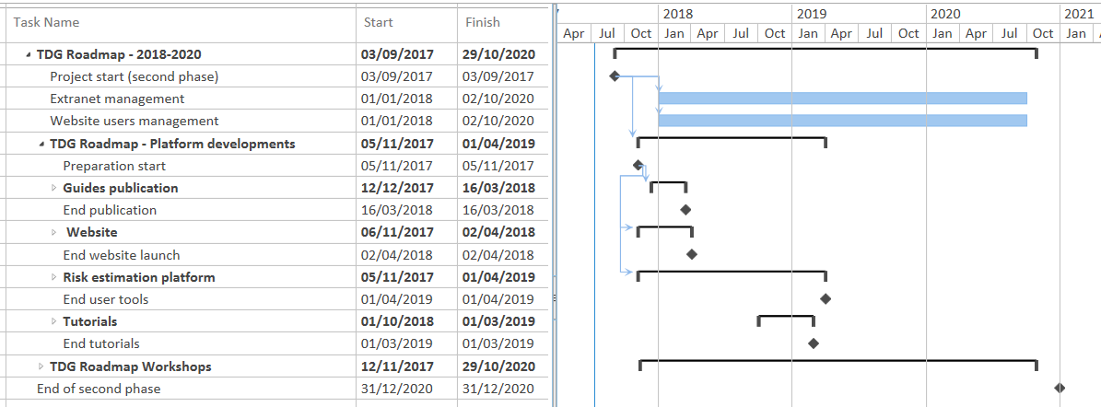
Conclusion
When the ITDG RM website will be completed, including a stable version of the risk estimation engine, the Agency believes that the harmonised platform should be transferred to sectoral transport associations, taking care of its resourcing, management and continuous improvement for the benefits of their members and of the competent authorities. At this time (to be defined), the Agency should only keep a steering and institutional coordination role.
The European Union Agency for Railways would be interested to collect the views of the Joint Meeting delegates on the proposed activities for the period 2018-2020 of the TDG roadmap, and on the proposed orientation for the future management of the framework.

