Transmitted by the experts from The International Automotive Lighting and Light Signalling Expert Group (GTB) | Informal document GRE-77-13  (77th GRE, 4-7 April 2017  agenda item 5 )

Revision of GRE/2017/06
Proposal for amendments to the original version of the Consolidated Resolution on the common specification of light source categories
The changes to GRE/2017/06 are indicated as “track changes”

Please note that the remainder of this page is blank to avoid disturbing the format of the data sheets on the following pages.
I. Proposal
The Status table, amend to read:
“Status table
This consolidated version of this Resolution contains all provisions and amendments adopted so far by the World Forum for Harmonization of Vehicle Regulations (WP.29) and is valid from the date as indicated in the following table until the date on which the next revision of this Resolution becomes valid:
Version of the Resolution | Date * as from which the version is valid | Adopted by WP.29 |  | Clarification
 |  | Session No. | Amendment document No.
1 (Original) | [2017-xx-xx] | 170 | ECE/TRANS/WP.29/2016/111 | Based upon Annexes 1 of Regulations:  - No. 37, up to and including Supplement 44  - No. 99, up to and including Supplement 11  - No. 128, up to and including Supplement 5
[2] | [2018-xx-xx] | [173] | [ECE/TRANS/WP.29/2017/xx] | Introduction of new light emitting diode (LED) forward lighting light source categories L1A/6 and L1B/6 as a package with Supplement [7] to Regulation No.128
* This date is the date of adoption of the amendment to the Resolution by WP.29 or the date of entering into force of an amendment to Regulation No. 37, 99 or 128 adopted by AC.1 as a package with the amendment to the Resolution in the same session of WP.29.
”
Insert a new paragraph 2.5., to read:
“2.5. Thermal characteristics
2.5.1. Thermal point T_{b} means an optional point on the base of an LED light source of which the temperature is stabilised during photometric measurements.
”
Paragraph 3.3., group 1, amend to read:
“
“RESERVED”
Group 1
LED light source categories without general restrictions:
 | Category |  | Sheet number(s)
 | L1A/6 |  | L1/1 to 5
 | L1B/6 |  | L1/1 to 5
”
Paragraph 3.3., group 2, amend to read:
“
Group 2
LED light source categories only for use in signalling lamps, cornering lamps, reversing lamps and rear registration plate lamps:
 | Category |  | Sheet number(s)
 | LR1 |  | LR1/1 to 5
 | LW2 |  | LW2/1 to 5
 | LR3A |  | Lx3/1 to 6
 | LR3B |  | Lx3/1 to 6
 | LW3A |  | Lx3/1 to 6
 | LW3B |  | Lx3/1 to 6
 | LY3A |  | Lx3/1 to 6
 | LY3B |  | Lx3/1 to 6
 | LR4A |  | LR4/1 to 5
 | LR4B |  | LR4/1 to 5
 | LR5A |  | Lx5/1 to 6
 | LR5B |  | Lx5/1 to 6
 | LW5A |  | Lx5/1 to 6
 | LW5B |  | Lx5/1 to 6
 | LY5A |  | Lx5/1 to 6
 | LY5B |  | Lx5/1 to 6
”
Annex 3, List of sheets for LED light sources and their sequence, amend to read:
“
Sheet number(s)
L1/1 to 5
LR1/1 to 5
LW2/1 to 5
Lx3/1 to 6
LR4/1 to 5
Lx5/1 to 6
”
Annex 3,
Sheets L3/1 to 6, renumber as sheets Lx3/1 to 6.
Sheet L3/1, bottom left, amend to read:
“For the notes see sheet Lx3/2.”
Sheets L5/1 to 6, renumber as sheets Lx5/1 to 6.
Before sheet LR1/1, insert new sheets L1/1 to 5, to read (see the following pages; one page per sheet):

Category L1A/6, L1B/6 Sheet L1/1
The drawings are intended only to illustrate the essential dimensions (in mm) of the LED light source
Projection method: 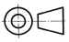

Figure 1***
Main Drawing, L1A/6

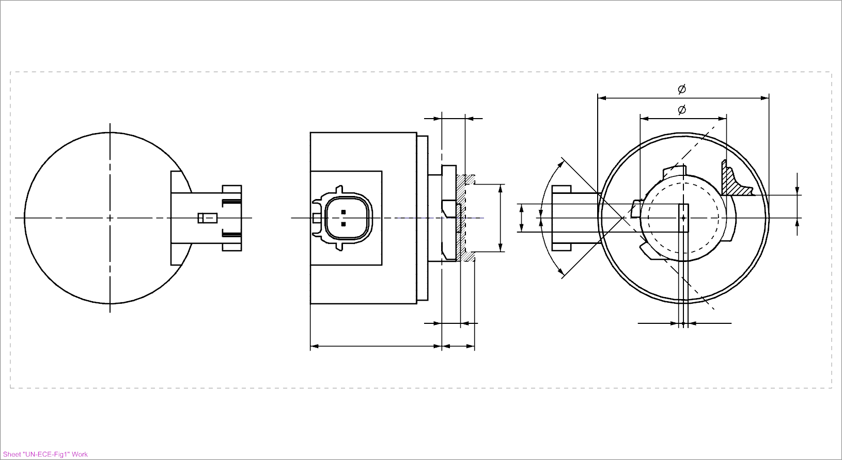 Nominal emitter box ³
Reference plane ¹
Reference axis ² b
Ground m c**
⁴
45°**

h
k
f*

45°**

e g/2* g/2*
V+ d a
Reference lug contact plane ⁸

Figure 2***
Main Drawing, L1B/6

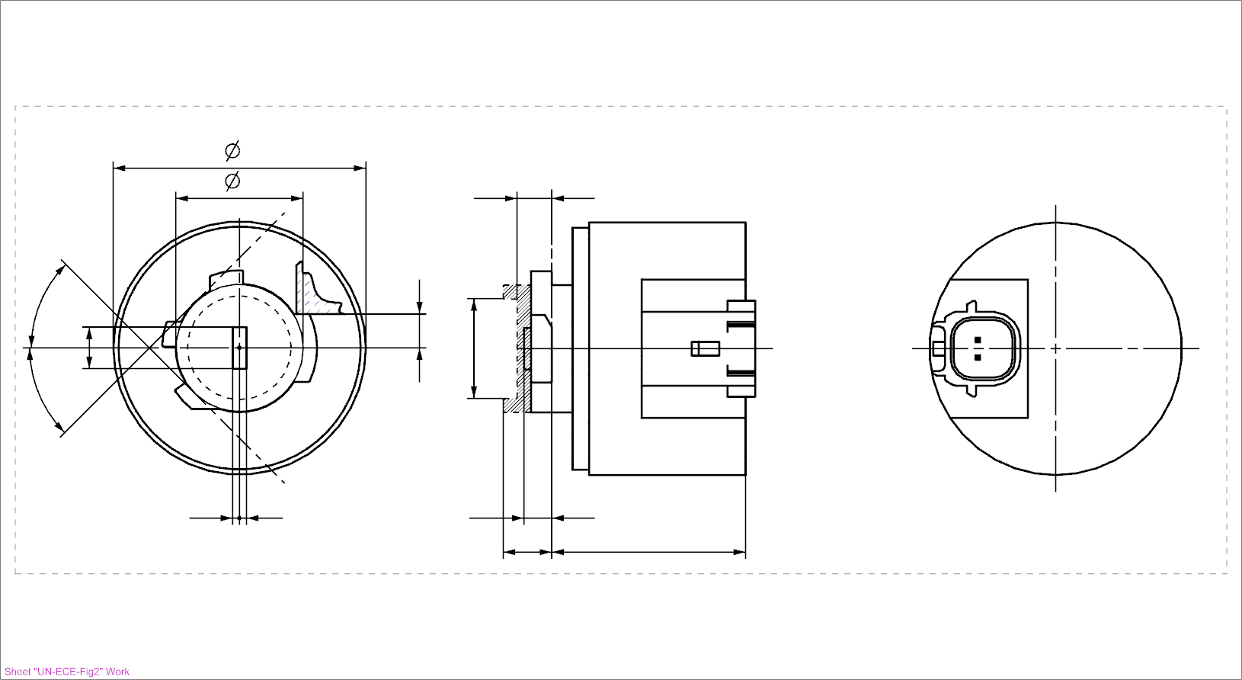 Nominal emitter box ³
45°**
f*
k

45°**
h
Reference plane ¹
b Reference axis ²
c** m Ground
⁴

g/2* g/2* e V+
a d

Reference lug contact plane ⁸

* Dimensions f and g see table 2
** Reference system for the emitter box: for detailed dimensions see relevant cap data sheet.
*** For the notes see sheet L1/2.
Category L1A/6, L1B/6 Sheet L1/2
Table 1
Essential electrical and photometric characteristics of the LED light source
Dimensions |  |  | Production  LED light sources | Standard  LED light sources
a |  | mm | 6.0 max.
b |  | mm | c + 10.0 min.  38.0 max.
c |  | mm | 18.60
d |  | mm | 28.0 max.
e |  | mm | 3.00 ± 0.30 | 3.00 ± 0.10
h⁸ |  | mm | 4.88
k⁹ |  | mm | 7 min.
m⁹ |  | mm | 4.5 max.
Cap [PGJ18.5d-29a] in accordance with IEC Publication 60061 (sheet 7004-185-[2]) ¹⁰

Electrical and photometric characteristics⁵
Rated Values | Voltage (in Volts) |  | 12
 | Power (in Watts) |  | 4.0
Objective values ⁶ | Power (in Watts) at 13.2V DC  at 13.5V DC |  | 6.0 max  6.0 max
 | Luminous Flux (in lumen) at 13.2V DC  at 13.5V DC |  | 350 ± 20%  355 ± 20% | 350 ± 10%⁷  355 ± 10%
 | Luminous Flux (in lumen) at 9V DC |  | 70 min.
Characteristics of the light-emitting area
Contrast |  |  | 150 min. | 150 min.  250 max.
Size of light emitting area in relation to size of nominal emitter box ³ |  |  | 75% min. | 75% min.
Uniformity R_{0.1} – surface ratio with luminance exceeding 10% of average luminance |  |  | 75% min. | 85% min.
Uniformity R_{0.7} – surface ratio with luminance exceeding 70% of average luminance |  |  | 55% min. | 65% min.
Specific thermal test conditions
Maximum test temperature |  |  | 65°C | 65°C
Notes:
¹ The reference plane is defined on the cap and holder fit system according the IEC Publication 60061.
² The reference axis is perpendicular to the reference plane and concentric with the reference diameter c of the cap, intended passing through the centre of the nominal emitter box in figure 3.
³ To be checked by means of the box system in Figure 3.
⁴ A minimum free air space of 5 mm around the light source shall be respected for convection; the connector interface can be neglected.
⁵ The emitted light shall be white.
⁶ After continuous operation for 30 minutes at 23 ± 2.5° C.
⁷ The measured value shall be in between 100 per cent and 90 per cent of the value measured after 1 minute.
⁸ The Light source shall be rotated in the (measuring) holder until the reference lug contacts the plane as defined with dimension h from the (measuring) holder.
⁹ The bounded area defined with the dimensions c, k and m defines the maximum outline in relation to the reference system.
^{10/} LED light source L1A/6 shall be equipped with the right-angle cap and LED light source L1B/6 with the straight cap.

Electrical characteristics, failure condition behaviour:

In case of LED light source failure (no light emitted) the maximum electrical current draw, when operated between 12 V and 14 V, shall be less than 20 mA (open circuit condition).

Category L1A/6, L1B/6 Sheet L1/3

Screen projection requirements:

The following test is intended to define the requirements for the light emitting area of the LED light source and to determine whether the light emitting area is correctly positioned relative to the reference axis and reference plane in order to check compliance with the requirements.

The position, the contrast and the uniformity of the light emitting area are checked by the nominal emitter box system defined in figure 3, which shows the projection when viewing along direction of the reference axis (Gamma = 0°) as defined in Figure 4.

Figure 3
Definition of the nominal emitter box with dimensions as specified in table 2
Reference lug contact plane ⁹ (dimension h see table 1)
h
Nominal emitter box
Reference axis “Cut-off” generating side

“Low scatter zone“** “Low scatter zone“**

g/2

g/2

f/2 f/2

45° 45°

c

Table 2
Dimensions of the nominal emitter box in Figure 3
Dimensions |  |  | f | g
 |  | mm | 4.0 | 1.4
Number of equidistant subdivision to control deviation of luminance |  |  | 3 | 2
** The value of the maximum luminance in the “low scatter zone” expressed as a percentage of the average luminance of the light emitting area shall be not higher than 10 per cent.
Category L1A/6, L1B/6 Sheet L1/4

Normalized luminous intensity distribution:

The following test is intended to determine the normalized luminous intensity distribution of the light source in an arbitrary plane containing the reference axis. The intersection of the reference axis and the upper edge of the box is used as the coordinate system origin.

The light source is mounted on a flat plate with the corresponding mounting lug features. The plate is mounted to the goniometer table by a bracket, so that the reference axis of the light set- up is described in Figure 4.

Luminous intensity data is recorded for the major function with a standard photo-goniometer. The measurement distance should be chosen appropriately, to make sure that the detector is located in the far field of the light distribution.

The measurements shall be performed in C-planes C₀, C₉₀, C₁₈₀ and C₂₇₀, which contain the reference axis of the light source. The test points for each plane for multiple polar angles γ are specified in Table 3.

After measurement the data shall be normalized to 1000 lm according to Paragraph 3.1.11 using the luminous flux of the individual light source under test. The data shall comply with the tolerance band as defined in Table 3.

The drawings are intended only to illustrate the essential set-up for measurement of the LED light source

Figure 4
Set-up to measure the luminous intensity distribution for L1A/6

Reference lug contact plane ⁹ Photo-Detector of Goniometer
h
Reference plane
e

C
γ

C₀

Reference axis
C-plane definition
Viewing direction along reference axis

Category L1A/6, L1B/6 Sheet L1/5

Figure 5
Set-up to measure the luminous intensity distribution for L1B/6

Reference lug contact plane ⁹ Photo-Detector of Goniometer
h
Reference plane
e

C γ

C₀

Reference axis
C-plane definition
Viewing direction along reference axis

The light pattern as described in Table 4 shall be substantially uniform, i.e. in between two adjacent grid points the relative luminous intensity requirement is calculated by linear interpolation using the two adjacent grid points. In case of doubt this may be checked in addition to verification of the grid points given in table 4.

Table 3
Test point values of normalized intensities of normal production and standard lamps, respectively

LED Light sources of
normal production and
Standard LED light sources
Angle γ | Minimum Intensity  in cd/1000 lm | Maximum intensity  in cd/1000 lm
 | C0° / C90° / C180° / C270° | C0° / C90° / C180° / C270°
0° | 266 | 389
15° | 257 | 376
30° | 228 | 339
45° | 183 | 281
60° | 123 | 205
70° | 70 | 149
75° | 40 | 116
80° | 0 | 84
90° | 0 | 21

II. Justification
Part A – Justification for the changes to GRE/2017/06
- Having taken account of the concerns expressed at GRE-76 (ECE/TRANS/WP.29/GRE/76, para. 16), GTB has abandoned the concept of “thermal grade” and proposes the introduction of a maximum test temperature into the light source category datasheets. In this new approach a separate (unique) light source category is specified for every “maximum test temperature”. The definition of the maximum test temperature is necessary to ensure interchangeability between approved light sources from different manufacturers. The choice of installation of a light source with a given maximum test temperature is based on the application in the vehicle and determined by due diligence of the car maker and set maker, in the same way as is now the case with LED modules.
- GTB proposes only category L1/6 with “maximum test temperature” 65 °C. In the future GTB may propose a different category with a higher “maximum test temperature” and based on the above mentioned principle this will then be a separate light source category. By taking this approach there will be type approval traceability from the light source, through the device approval and to the installation on the vehicle; thereby incorrect replacement of the light sources will be avoided due to the different “keying” in the cap and holder design.
- In accordance with this new approach GTB has prepared this document as an update to the current documents on the GRE web site (GRE/2017/06).

Part B – Justification for the proposal
4. This proposal is part of a package with a related proposal for amendment to Regulation No. 128 to introduce LED forward lighting light sources.
5. The L1/6 category was developed taking into account the reference document GRE-77-04 “Introduction and Evaluation of LED Light Source Categories Intended for Forward Lighting Applications”.

