|  |  |  |  |
| --- | --- | --- | --- |
|  | United Nations | ECE/TRANS/WP.29/GRSG/2017/11 | |
| Description: _unlogo | **Economic and Social Council** | | Distr.: General  7 February 2017  Original: English |

**Economic Commission for Europe**

Inland Transport Committee

**World Forum for Harmonization of Vehicle Regulations**

**Working Party on General Safety Provisions**

**112th session**

Geneva, 24-28 April 2017

Item 16 of the provisional agenda

**New regulation on Advanced Driver Assistance Systems (ADAS)**

Proposal for a new Regulation on uniform provisions concerning the approval of motor vehicles with regard to the Blind Spot Information System

**Submitted by the expert from Germany**[[1]](#footnote-2)\*

The text reproduced below was prepared by the expert from Germany to introduce requirements for Blind Spot Information Systems (BSIS) intend to be fitted to heavy goods vehicles to protect vulnerable road users.

I. Proposal

Regulation No. XXX

**Uniform provisions concerning the approval of motor vehicles with regard to the Blind Spot Information System**

1. Scope

1.1. This Regulation applies to the blind spot information system of vehicles of categories N2 (> 8 t gross vehicle weight) and N3; other vehicles may be approved at the request of the manufacturer.

1.2. The requirements of this Regulation are so worded as to apply vehicles in which the driver is on the left. In vehicles in which the driver is on the right these requirements shall be applied by inverting the criteria, when appropriate.

2. Definitions

For the purposes of this Regulation:

2.1. *"Approval of a vehicle type"* means the full procedure whereby a Contracting Party to the Agreement certifies that a vehicle type meets the technical requirements of this Regulation;

2.2. *"Vehicle type with regard to its Blind Spot Information System"* means a category of vehicles which do not differ in such essential respects as:

(a) The manufacturer's trade name or mark;

(b) Vehicle features which significantly influence the performances of the Blind Spot Information System;

(c) The type and design of the Blind Spot Information System.

2.3. *"Blind Spot Information System (BSIS)"* means a system to inform the driver of a possible collision with a bicycle, travelling next to the vehicle, if the driver would initiate a turn manoeuvre.

2.4. *"Reaction time"* means the time between the information signal is given and a driver reaction has occurred. This is assumed to be 1.4 seconds.

2.5. *"Driver Brake deceleration"* means the deceleration that typical drivers apply after receiving the information signal. This is assumed to be 5 m/s² (or the value defined in Regulation No. 13 for the specific vehicle).

2.6. *"Stopping distance"* means the distance required by the vehicle to come to a full stop after the Blind Spot Information Signal has been given, taking into account reaction time and brake deceleration.

2.7. *"Collision point"* means the position where the trajectories of all vehicle points (e.g. between front near-side vehicle corner and rear near-side corner of longest possible trailer) and all bicycle points (e.g. front end of bicycle, rear end of bicycle) would intersect if a turn by the vehicle would be initiated.

2.8. *"Last Point of Information (LPI)"* means the point at which the information signal shall have been given. It is the collision point minus the stopping distance on the vehicle trajectory.

2.9. *"Near side"* means the side of the vehicle near the bicycle. The near side of the vehicle is the right side for right-hand traffic and the left side for left-hand traffic.

2.10. *"Information signal"* means an optical or acoustical signal used to inform the vehicle driver about a nearby cyclist.

2.11. *"Vehicle Trajectory"* means the connection all positions where a specific location of the vehicle (e.g. centre of gravity, front right corner) has been or will be during the course of a test run, projected towards the ground plane.

3. Application for approval

3.1. The application for approval of a vehicle type with regard to the BSIS shall be submitted by the vehicle manufacturer or by their authorized representative.

3.2. It shall be accompanied by the documents mentioned below in triplicate and include the following particular:

3.2.1. A description of the vehicle type with regard to the items mentioned in paragraph 5. below, together with dimensional drawings and the documentation as referred to in paragraph 6.1. below. The numbers and/or symbols identifying the vehicle type shall be specified.

3.3. A vehicle representative of the vehicle type to be approved shall be submitted to the Technical Service conducting the approval tests.

4. Approval

4.1. If the vehicle type submitted for approval pursuant to this Regulation meets the requirements of paragraph 5. below, approval of that vehicle type shall be granted.

4.2. The conformity of the requirements in paragraph 5. below shall be verified with the test procedure as defined in paragraph 6. below, however its operation shall not be limited to these test conditions.

4.3. An approval number shall be assigned to each vehicle type approved; its first two digits (00 for the Regulation in its initial form) shall indicate the series of amendments incorporating the most recent major technical amendments made to the Regulation at the time of issue of the approval. The same Contracting Party shall not assign the same number to the same vehicle type equipped with another type of Blind Spot Information System, or to another vehicle type.

4.4. Notice of approval or of refusal or withdrawal of approval pursuant to this Regulation shall be communicated to the Parties to the Agreement applying this Regulation by means of a form conforming to the model in Annex 1 and photographs and/or plans supplied by the applicant being in a format not exceeding A4 (210 x 297 mm), or folded to that format, and on an appropriate scale.

4.5. There shall be affixed, conspicuously and in a readily accessible place specified on the approval form, to every vehicle conforming to a vehicle type approved under this Regulation, an international approval mark conforming to the model described in Annex 2, consisting of:

4.5.1. A circle surrounding the letter "E" followed by the distinguishing number of the country which has granted approval;[[2]](#footnote-3)

4.5.2. The number of this Regulation, followed by the letter "R", a dash and the approval number to the right of the circle prescribed in paragraph 4.5.1. above.

4.6. If the vehicle conforms to a vehicle type approved under one or more other Regulations annexed to the Agreement, in the country which has granted approval under this Regulation, the symbol prescribed in paragraph 4.5.1. above need not be repeated; in such a case, the Regulation and approval numbers and the additional symbols shall be placed in vertical columns to the right of the symbol prescribed in paragraph 4.5.1. above.

4.7. The approval mark shall be clearly legible and be indelible.

4.8. The approval mark shall be placed close to or on the vehicle data plate.

5. Specifications

5.1. Any vehicle fitted with a BSIS complying with the definition of paragraph 2.3. above shall meet the requirements contained in paragraphs 5.2. to 5.5. of this Regulation.

5.2. General requirements

The effectiveness of the BSIS shall not be adversely affected by magnetic or electrical fields. This shall be demonstrated by compliance with Regulation No. 10, 03 series of amendments to the Regulation.

5.3. Performance requirements

5.3.1. Whenever the system is active, as specified in paragraph 5.3.1.4. below, the BSIS shall inform the driver about bicycles, travelling initially in parallel to the vehicle on the near side of the vehicle, that would be in conflict if the vehicle would start a turn towards the bicycle line of movement.

5.3.1.1. The information signal shall be given at a time when the vehicle driver would still be able to avoid a collision, taking into account an appropriate reaction time and an achievable brake deceleration.

5.3.1.2. The information signal shall meet the requirements as defined in paragraph 5.4. below.

5.3.1.3. The information signal shall be given independently from the activation of turn signals.

5.3.1.4. The BSIS shall be operative for all forward vehicle speeds between 1 km/h and 30 km/h.

5.3.1.5. The BSIS shall be able to give an information signal for all bicycles moving with a speed between 5 km/h and 20 km/h.

5.3.1.6. The BSIS shall not give an information signal for stationary objects that are not pedestrians or cyclists.

5.3.1.7. The information signal shall be provided in such a timely manner that the accident is avoided, i.e. the vehicle is stopped before crossing the bicycle trajectory, if there was a driver brake application, resulting in 5 m/s² brake deceleration, and initiated with a reaction time of 1.4 seconds after the information signal. This shall be tested as specified in paragraph 6.5.

5.3.2. The system shall also provide the driver with the failure warning specified in paragraph 5.4.3. below when tested in accordance with the provisions of paragraph 6.6. below (failure detection test). The warning shall be constant.

5.4. Information signal

5.4.1. The blind spot information referred to in paragraph 5.3.1. above shall be noticeable by the driver and be provided by one warning means out of haptic, optic and acoustic, with spatial indication about the direction of the bicycle.

5.4.2. If the vehicle is equipped with a Camera-Monitor-System of Class II or Class IV according to Regulation No. 46, the information signal may be displayed in the corresponding monitor.

5.4.3. The failure warning referred to in paragraph 5.3.2. above shall be a yellow optical warning signal.

5.4.3.1. The BSIS optical failure warning signal shall be activated either when the ignition (start) switch is turned to the "on" (run) position or when the ignition (start) switch is in a position between the "on" (run) and "start" that is designated by the manufacturer as a check position (initial system (power-on)). This requirement does not apply to warning signalsshown in a common space.

5.4.4. The optical warning signal and optical information signal shall be visible even by daylight; the satisfactory condition of the signals shall be easily verifiable by the driver from the driver's seat.

5.4.5. When the driver is provided with an optical warning signal to indicate that the BSIS is temporarily not available, for example due to inclement weather conditions, the signal shall be constant. The failure warning signal specified in paragraph 5.3.2. above may be used for this purpose.

5.5. Provisions for the periodic technical inspection

5.5.1. At a periodic technical inspection it shall be possible to confirm the correct operational status of the BSIS by a visible observation of the failure warning signal status, following a "power-ON" (off-system OK, on-system fault present).

In the case of the failure warning signal being in a common space, the common space shall be observed to be functional prior to the failure warning signal status check.

5.5.2. At the time of type-approval, the means to protect against simple unauthorized modification of the operation of the failure warning signal chosen by the manufacturer shall be confidentially outlined.

Alternatively, this protection requirement is fulfilled when a secondary means of checking the correct operational status of the BSIS is available.

6. Test procedure

6.1. The manufacturer shall provide a documentation package which gives access to the basic design of the system and, if applicable, the means by which it is linked to other vehicle systems. The function of the system shall be explained and the documentation shall describe how the operational status of the system is checked, whether there is an influence on other vehicle systems, and the method(s) used in establishing the situations which will result in a failure warning signal being displayed.

6.2. Test conditions

6.2.1. The test shall be performed on a flat**,** dryasphalt or concrete surface.

6.2.2. The ambient temperature shall be between 0° C and 45° C.

6.2.3. The test shall be performed under visibility conditions that allow safe driving at the required test speed.

6.3. Vehicle conditions

6.3.1. Test weight

The vehicle may be tested at any condition of load, the distribution of the mass among the axles being that stated by the vehicle manufacturer without exceeding any of the maximum permissible mass for each axle. No alteration shall be made once the test procedure has begun. The vehicle manufacturer shall demonstrate through the use of documentation that the system works at all conditions of load.

6.3.2. The vehicle shall be tested at the tyre pressures for normal running conditions.

6.3.3. In the case where the BSIS is equipped with a user-adjustable information timing, the test as specified in paragraph 6.5.below shall be performed with the information threshold set at its latestsetting. No alteration shall be made once the test procedure has begun.

6.4. Optical failure warning signal verification test

With the vehicle stationary check that the optical warning signal(s) comply with the requirements of paragraph 5.4.3. above.

6.5. Blind Spot Information test

6.5.1. Using cones and the bicycle dummy, form a corridor according to Figure 1, Appendix 1 of this document and the additional dimensions as specified in Table 1, Appendix 1 of this Regulation.

6.5.2. Position the bicycle target (as detailed in Annex 3 of this Regulation) at the appropriate starting position as shown in Figure 1, Appendix 1 of this Regulation.

6.5.3. Position a local traffic sign corresponding to sign C14 as defined in the Vienna convention on road signs and signals (speed limit 50 km/h) or the local sign closest to this sign in meaning on a pole at the entry of the corridor as shown in Figure 1, Appendix 1 of this Regulation.

6.5.4. Drive the vehicle at a speed as shown in Table 1, Appendix 1 of this document with a tolerance of +/- 2 km/h through the corridor.

6.5.5. Do not operate the turn lights when initiating the turn towards the bicycle trajectory.

6.5.6. Move the bicycle dummy on a straight line as shown in Figure 1, Appendix 1 of this document in way that the dummy position crosses line A (Figure 1, Appendix 1) with a tolerance of +/- 0.5 m at the same time when the vehicle crosses line B (Figure 1, Appendix 1) with a tolerance of +/- 0.5 m (verify e.g. with video or picture).

Move the dummy in a way that the dummy moves in a steady state for at least 8 seconds, with the speed as shown in Table 1, Appendix 1 of this document with a tolerance of +/- 0.5 km/h, before reaching the collision point.

6.5.7. Verify that the Blind Spot Information signal has been activated before the vehicle crosses line C, Figure 1, Appendix 1 of this document.

6.5.8. Verify that the Blind Spot Information signal has not been activated when passing the traffic sign and any cones as long as the bicycle dummy is still stationary.

6.5.9. Repeat paragraphs 6.5.1. to 6.5.8. for all test cases shown in Table 1, Appendix 1 of this Regulation.

6.5.10. The test is passed when the Blind Spot Information signal has been activated in all test cases as shown in Table 1, Appendix 1 of this Regulation before the vehicle has crossed line C (see paragraph 6.5.7. above) and the Blind Spot Information signal has not been activated in any test run when the vehicle passes the randomly positioned traffic sign (see paragraph 6.5.8. above).

6.6. Failuredetection test

6.6.1. Simulate a BSIS failure, for example by disconnecting the power source to any BSIS component or disconnecting any electrical connection between BSIS components. The electrical connections for the failure warning signal of paragraph 5.4.3. above shall not be disconnected when simulating a BSIS failure.

6.6.2. The failure warning signal mentioned in paragraph 5.4.3.above shall be activated and remain activated while the vehicle is being driven and be reactivated after a subsequent ignition "off" ignition "on" cycle as long as the simulated failure exists.

7. Modification of vehicle type and extension of approval

7.1. Every modification of the vehicle type as defined in paragraph 2.2. of this Regulation shall be notified to the Type Approval Authority which approved the vehicle type. The Type Approval Authority may then either:

7.1.1. Consider that the modifications made do not have an adverse effect on the conditions of the granting of the approval and grant an extension of approval;

7.1.2. Consider that the modifications made affect the conditions of the granting of the approval and require further tests or additional checks before granting an extension of approval.

7.2. Confirmation or refusal of approval, specifying the alterations, shall be communicated by the procedure specified in paragraph 4.4. above to the Contracting Parties to the Agreement applying this Regulation.

7.3. The Type Approval Authority shall inform the other Contracting Parties of the extension by means of the communication form which appears in Annex 1 to this Regulation. It shall assign a serial number to each extension, to be known as the extension number.

8. Conformity of production

8.1. Procedures concerning conformity of production shall conform to the general provisions defined in Article 2 and Appendix 2 to the Agreement (E/ECE/324‑E/ECE/TRANS/505/Rev.2) and meet the following requirements:

8.2. A vehicle approved pursuant to this Regulation shall be so manufactured as to conform to the type approved by meeting the requirements of paragraph 5. above;

8.3. The Type Approval Authority which has granted the approval may at any time verify the conformity of control methods applicable to each production unit. The normal frequency of such inspections shall be once every two years.

9. Penalties for non‑conformity of production

9.1. The approval granted in respect of a vehicle type pursuant to this Regulation may be withdrawn if the requirements laid down in paragraph 8. above are not complied with.

9.2. If a Contracting Party withdraws an approval it had previously granted, it shall forthwith so notify the other Contracting Parties applying this Regulation by sending them a communication form conforming to the model in Annex 1 to this Regulation.

10. Production definitively discontinued

If the holder of the approval completely ceases to manufacture a type of vehicle approved in accordance with this Regulation, they shall so inform the Type Approval Authority which granted the approval, which in turn shall forthwith inform the other Contracting Parties to the Agreement applying this Regulation by means of a communication form conforming to the model in Annex 1 to this Regulation.

11. Names and addresses of the Technical Services responsible for conducting approval tests and of Type Approval Authorities

The Contracting Parties to the Agreement applying this Regulation shall communicate to the United Nations Secretariat the names and addresses of the Technical Services responsible for conducting approval tests and of the Type Approval Authorities which grant approval and to which forms certifying approval or extension or refusal or withdrawal of approval are to be sent.

**Appendix 1**

**Figure 1**

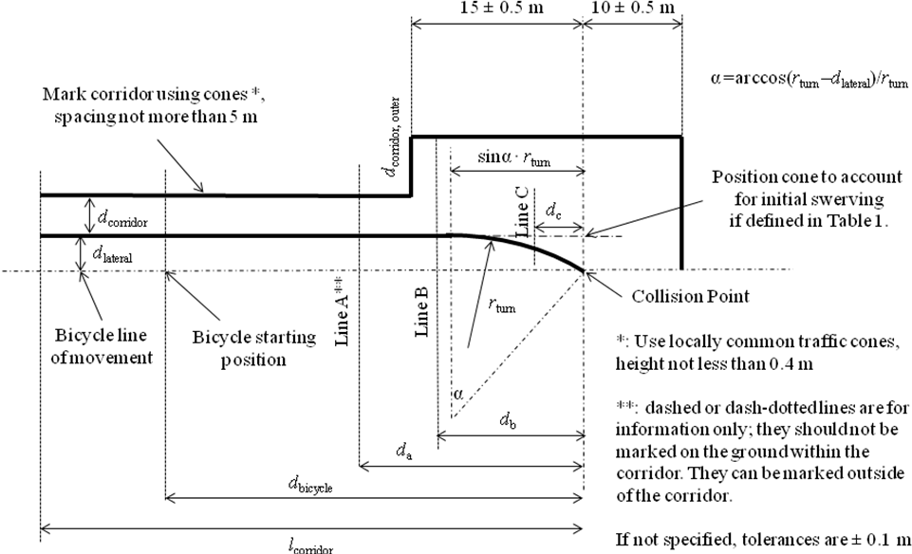

Mark corridor using cones \*, spacing not more than 5 m

Bicycle line of movement

Bicycle starting position

Position cone to account for initial swerving, if defined in Table 1

Collision Point

Line A \*\*

Line B

Line C

\*: Use locally common traffic cones, height not less than 0.4 m

\*\*: dashed or dash-dotted lines are for information only; they should not be marked on the ground within the corridor. They can be marked outside of the corridor.

If not specified, tolerances are ± 0.1 m

Mark corridor using cones \*, spacing not more than 5 m

**Table 1**

|  |  |  |  |  |  |  |  |  |  |  |  |  |  |
| --- | --- | --- | --- | --- | --- | --- | --- | --- | --- | --- | --- | --- | --- |
| *New Test Case* | *Orig. Test Case* | *rturn* | *vvehicle [km/h]* | *vBicycle [km/h]* | *dlateral [m]* | *da [m]* | *db [m]* | *dc [m]* | *dbicycle  [m]* | *lcorridor  [m]* | *dcorridor [m]* | *dcorridor,outer [m]* | *Include cone to account for  initial swerving?* |
| 1 | 1 | 5 | 10 | 20 | 1.5 | 44.4 | 15.8 | 4.3 | < 55 | > 70 | vehicle width  + 1m | 5 | Yes |
| 2 | 4 | 10 | 10 | 20 | 22 | 4.4 | 2 | Yes |
| 3 | 7 | 25 | 20 | 20 | 38.3 | 10.7 | 1 | No |
| 4 | 6 | 25 | 20 | 10 | 4.5 | 22.2 | 43.5 | 10 | 1 | No |
| 5 | 5 | 5 | 10 | 10 | 19.8 | 2.4 | 6 | Yes |
| 6 | 2 | 10 | 10 | 20 | 44.4 | 14.7 | 3.4 | 3 | Yes |
| 7 | 3 | 17.7 | 2 | Yes |
| 8 | 1\* | 5 | 10 | 20 | 1.5 | 44.4 | 15.8 | 4.3 | 1 | No |
| 9 | 4\* | 10 | 10 | 20 | 22 | 4.4 | No |
| 10 | 5\* | 5 | 10 | 10 | 4.5 | 22.2 | 19.8 | 2.4 | No |
| 11 | 2\* | 10 | 10 | 20 | 44.4 | 14.7 | 3.4 | No |
| 12 | 3\* | 10 | 10 | 20 | 17.7 | No |

**Annex 1**

**Communication**

(Maximum format: A4 (210 x 297 mm)

|  |  |
| --- | --- |
|  | issued by : (Name of administration)  ......................................  ......................................  ...................................... |

[[3]](#footnote-4)Concerning: [[4]](#footnote-5) Approval granted

Approval extended

Approval refused

Approval withdrawn

Production definitively discontinued

of a type of vehicle with regard to the Blind Spot Information System (BSIS) pursuant to Regulation No. XXX

Approval No.: Extension No.:

1. Trademark:

2. Type and trade name(s):

3. Name and address of manufacturer:

4. If applicable, name and address of manufacturer’s representative:

5. Brief description of vehicle:

6. Date of submission of vehicle for approval:

7. Technical Service performing the approval tests:

8. Date of report issued by that Service:

9. Number of report issued by that Service:

10. Approval with regard to the BSIS is granted/refused:2

11. Place:

12. Date:

13. Signature:

14. Annexed to this communication are the following documents, bearing the approval number indicated above:

15. Any remarks:



**Annex 2**

**Arrangements of approval marks**

(see paragraphs 4.4. to 4.4.2. of this Regulation)



XXXR - 00185

a = 8 mm min

The above approval mark affixed to a vehicle shows that the vehicle type concerned has been approved in Germany (E1) with regard to the BSIS pursuant to Regulation No. XXX. The first two digits of the approval number indicate that the approval was granted in accordance with the requirements of Regulation No. XXX in its original form.

**[Annex 3**

* **Draft Bicyclist and Bike Target[[5]](#footnote-6)**

1. The Bicyclist and Bike Target (BT) described in this paper represent an average human adult bicyclist on an average standard adult utility bike (Figure 1) in relation to the vulnerable road users detection sensors used in vehicles. The requirements relate, unless not specified otherwise, to the BT including a platform. The BT is designed to work with the following types of automotive sensors technologies: RADAR, Video, Laser and Near-IR-based system similar to the definition of the Articulated Pedestrian Target Specifications.[[6]](#footnote-7) The BT shall be a full 3D-dimensional representation of a real bicyclist and bike, shall have rotating wheels (synchronized to speed), pedalling legs are not mandatory.

Figure 1  
**Bicyclist and Bike Target**

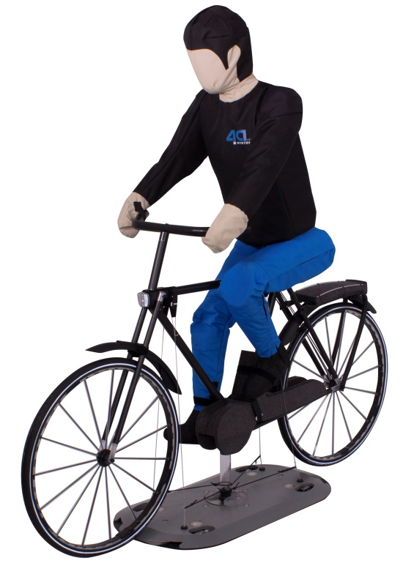

2. The bike target is based on a standard utility bike, male size 28 inch. Other typical dimensions are shown below in Figure 2 and Table 1.

Figure 2  
**Bike target dimensions and dummy posture**

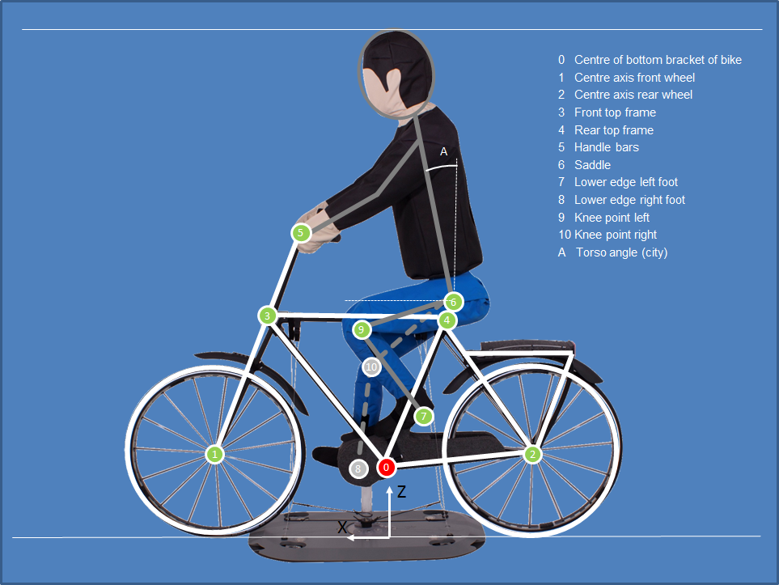

0 Centre of bottom bracket of bike

1 Centre axis front wheel

2 Centre axis rear wheel

3 Front top frame

4 Rear top frame

5 Handle bars

6 Saddle

7 Lower edge left foot

8 Lower edge right foot

9 Knee point left

10 Knee point right

A Torso angle (city)

Table 1

**Bike target dimensions**

|  |  |  |  |
| --- | --- | --- | --- |
| *Segment* | *X*  *[mm]* | *Z*  *[mm]* | *Tolerance*  *[mm]* |
| 0 Centre of bottom bracket of bike | 0 | 280 | ± 10 |
| 1 Centre axis front wheel | 670 | 340 | ± 10 |
| 2 Centre axis rear wheel | -540 | 340 | ± 10 |
| 3 Front top frame | 430 | 855 | ± 10 |
| 4 Rear top frame | -215 | 860 | ± 10 |
| 5 Handle bars | 310 | 1180 | ± 10 |
| 6 Saddle | -235 | 935 | ± 10 |
| 7 Lower edge left foot[[7]](#footnote-8) | 105 | 495 | ± 20 |
| 8 Lower edge right foot | 80 | 200 | ± 20 |
| 9 Knee point, left[[8]](#footnote-9) | 150 | 860 | ± 20 |
| 10 Knee point, right | 85 | 700 | ± 20 |
| Total height | 1865 | | ± 20 |
| Total length | 1890 | | ± 20 |
| A Torso angle *[°]* | 10° (optional 30°) | | ± 2° |

3. In order to ensure a realistic scenario, special requirements concerning radar reflection shall be fulfilled. Thus, the diameter of the frame, seat stay and chain stay shall be as followed:

Frame: 25 mm – 35 mm

Seat stay: 15 mm – 25 mm

Chain stay: 15 mm – 25 mm

4. The material of the frame, stays, spokes, steering and rim consists of a black coloured metallic outer surface to ensure that their reflection represent the one of a real bicycle.

5. Dimensions of the bicyclist target are based on an adult pedestrian target, described by Articulated Pedestrian Target Specifications [[9]](#footnote-10), representing average (50th percentile) male. The shape of the bicyclist target has to comply in its contours with the 50 percent RAMSIS Bodybuilder based on the RAMSIS version 3.8.30 to a permitted tolerance of ± 20 mm. The stature body height of the adult BT is, according to EN ISO 7250-1: 2016-05 is 1800 mm.

Figure 3

**Bicyclist target dimensions in standing posture**

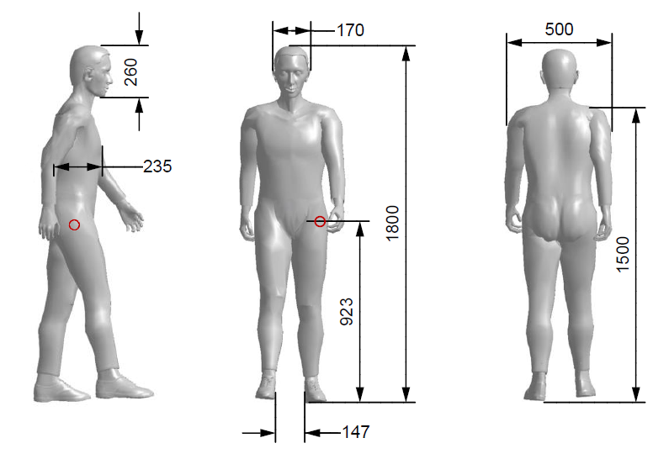

Table 2

**Bicyclist target dimensions in standing posture**

|  |  |  |
| --- | --- | --- |
| *Segment* | *Dimension*  *[mm]* | *Tolerance*  *[mm]* |
| Body height (incl. shoes) | 1800 | ± 20 |
| H-Point height | 920 | ± 20 |
| Shoulder width | 500 | ± 20 |
| Shoulder height | 1500 | ± 20 |
| Head width | 170 | ± 10 |
| Head height | 260 | ± 10 |
| Torso depth | 240 | ± 10 |

6. The posture of the bicyclist target represents a natural driving position, facing forward, both hands on the steering wheel, with right foot down and left foot up (see Figure Figure 4). The same dummy posture is used for all driving directions. The posture definition includes: lower edge of left and right foot, knee point left and right (see Figure and Table 2).

Figure 4

**Posture of bicyclist target**

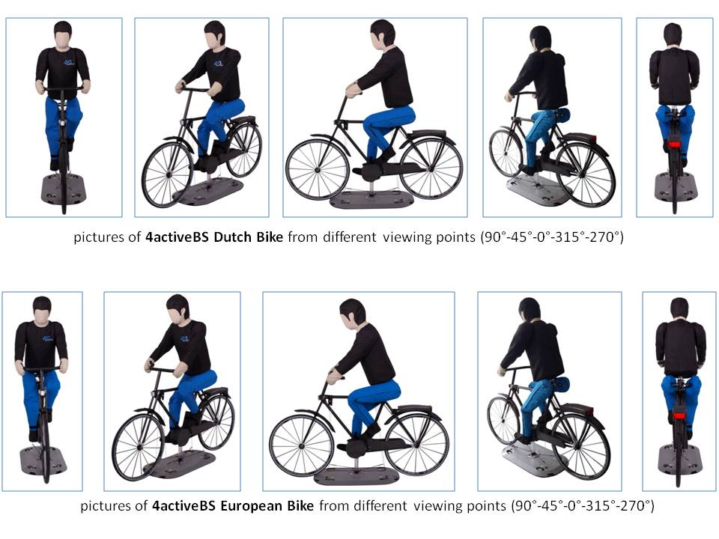

7. There shall be a possibility to check and correct the body posture and angle of legs and arms in an easy and practical way corresponding to the defined tolerances, e.g. with the help of a tool with a reference shape.]

**Annex 4**

**Function of test parameters**

1. The appropriate Table 1 in Appendix 1 as a function of test parameters can be generated by the following MATLAB (usable with any other compatible software like e.g. open source packages SCILAB or Octave).

% Input variables for test cases, ID refers to original test ID

r\_turn = [5 10 10 10 5 25 25]; % [m]

d\_lat = [1.5 4.5 4.5 1.5 4.5 4.5 1.5]; % [m]

speed\_dummy = [20 20 20 20 10 10 20]; % [km/h]

speed\_vehicle = [10 10 10 10 10 20 20]; % [km/h]

impact\_pos = [6 6 3 0 0 0 6];

decel = 5; % [m/s²]

t\_react = 1.4; %[s]

% Do not plot the available vehicle data

plot\_vehicle\_data = 0;

% This sorts the test cases for better testing (e.g. not much changes

% in-between).

sort\_indices = [1 4 7 6 5 2 3];

r\_turn=r\_turn(sort\_indices);

d\_lat=d\_lat(sort\_indices);

speed\_dummy=speed\_dummy(sort\_indices);

speed\_vehicle=speed\_vehicle(sort\_indices);

impact\_pos=impact\_pos(sort\_indices);

% Add the second set of test cases with tighter corridor

r\_turn = [r\_turn 5 10 5 10 10];

d\_lat = [d\_lat 1.5 1.5 4.5 4.5 4.5];

speed\_dummy = [speed\_dummy 20 20 10 20 20];

speed\_vehicle = [speed\_vehicle 10 10 10 10 10];

impact\_pos = [impact\_pos 6 0 0 6 3];

% Position a cone to prevent following exact curvature?

cone = [1 1 0 0 1 1 1 0 0 0 0 0];

% Require speeds stationary at this ttc

ttc\_start = 8;

% Calculate angle of bend until arriving at bicycle trajectory

alpha = acos((r\_turn-d\_lat)./r\_turn)\*180/pi;

% Calculate distance travelled in turn

d\_turn = alpha\*pi/180.\*r\_turn;

% Calculate distance projected to bicycle trajectory

d\_turn\_projected = sin(alpha\*pi/180).\*r\_turn;

% Calculate stopping distance including reaction time

d\_stop = ones(1,length(speed\_vehicle)).\*t\_react.\*speed\_vehicle/3.6 + (speed\_vehicle/3.6).^2/2/decel;

% Calculalte position for bicycle steady-state

d\_a = ttc\_start.\*speed\_dummy/3.6;

% Calculate position for vehicle steady\_statea

d\_b = ttc\_start.\*speed\_vehicle/3.6 - d\_turn + d\_turn\_projected - impact\_pos;

% Make sure this is larger than 15 m in all cases. 15 m is the position

% where the corridor opens up, and we want to have everything steady state

% by then.

% Calculate LPI (d\_c). This calculation requires a distinguishment between

% the cases where the last point of information is in the turn and

%cases where it is before the turn.

% Initialise d\_c

d\_c = zeros(1,length(d\_stop));

% Perform a loop for all test cases

for i = 1:length(d\_stop)

if d\_stop(i)>d\_turn(i) % this is the case where the LPI is outside of the bent

d\_c(i)=d\_stop(i) - d\_turn(i)+d\_turn\_projected(i);

else

beta = alpha(i)\*((d\_turn(i)-d\_stop(i))/d\_turn(i));

d\_c(i) = d\_turn\_projected(i)-r\_turn(i)\*sin(beta\*pi/180);

beta = [];

end

end

% Output table

table = [r\_turn' speed\_vehicle' speed\_dummy' d\_lat' d\_a' d\_b' d\_c'];

disp(table)

% Generate diagrams

% This is relevant for plotting

X = [5 3 2 2 6 1 1]; % m

X=X(sort\_indices);

X = [X 1 1 1 1 1];

w\_vehicle = 2.5; % m

d\_bicycle = 55; % m

l\_corridor = 70; % m

if plot\_vehicle\_data

load data;

end

close all

for i = 1:length(speed\_vehicle)

figure(i);

if plot\_vehicle\_data

rel = find(strcmp({meta.Type},['Case' int2str(sort\_indices(i))]));

for j = rel

hold on;

plot(bla(j).x\_vut(bla(j).rel),bla(j).y\_vut(bla(j).rel),'-r');

end

end

ha(1) = line([-r\_turn(i)\*sin(alpha(i)\*pi/180) -l\_corridor],[d\_lat(i) d\_lat(i)]);

ha(2) = line([-15 -l\_corridor],[d\_lat(i)+w\_vehicle+1 d\_lat(i)+w\_vehicle+1]);

ha(3) = line([-15 -15],[d\_lat(i)+w\_vehicle+1 d\_lat(i)+w\_vehicle+1+X(i)]);

ha(4) = line([-15 10],[d\_lat(i)+w\_vehicle+1+X(i) d\_lat(i)+w\_vehicle+1+X(i)]);

ha(5) = line([10 10],[d\_lat(i)+w\_vehicle+1+X(i) 0]);

ha(6) = line([r\_turn(i).\*sin(0:0.01:alpha(i)\*pi/180)]-d\_turn\_projected(i),[r\_turn(i).\*cos(0:0.01:alpha(i)\*pi/180)]-r\_turn(i)+d\_lat(i));

set(ha,'LineWidth',2,'Color','k');

hb = line([-d\_bicycle 0],[0 0]);

set(hb,'LineWidth',2,'LineStyle',':','Color','k');

hc(1) = line(-[d\_c(i) d\_c(i)],[-10 X(i)+10]);

hd(1) = text(0.5-d\_c(i),-10,'Line C');

hc(2) = line(-[d\_b(i) d\_b(i)],[-10 X(i)+10]);

hd(2) = text(0.5-d\_b(i),-10,'Line B');

hc(3) = line(-[d\_a(i) d\_a(i)],[-10 X(i)+10]);

hd(3) = text(0.5-d\_a(i),-10,'Line A');

hc(4) = line(-[d\_bicycle d\_bicycle],[-10 X(i)+10]);

hd(4) = text(0.5-d\_bicycle,-10,'Bicycle Start');

set(hc,'LineWidth',1,'Color','k','LineStyle','-');

set(hd,'Rotation',90)

if cone(i)

hold on

plot(0,d\_lat(i),'kx');

end

grid on

axis equal

pos = axis;

axis([pos(1) pos(2) -12 18]);

xlabel('x [m]');

ylabel('y [m]');

annot(['Test Case ' int2str(i) ' as defined in Table 1, Appendix 1'],1);

end

2. The following Figures 1 to 12 show the test cases as scaled diagrams.

Figure 1

**Test Case 1, as defined in Table 1, Appendix 1**



Figure 2

**Test Case 2, as defined in Table 1, Appendix 1**



Figure 3

**Test Case 3, as defined in Table 1, Appendix 1**



Figure 4

**Test Case 4, as defined in Table 1, Appendix 1**



Figure 5

**Test Case 5, as defined in Table 1, Appendix 1**



Figure 6

**Test Case 6, as defined in Table 1, Appendix 1**



Figure 7

**Test Case 7, as defined in Table 1, Appendix 1**



Figure 8

**Test Case 8, as defined in Table 1, Appendix 1**



Figure 9

**Test Case 9, as defined in Table 1, Appendix 1**



Figure 10

**Test Case 10, as defined in Table 1, Appendix 1**



Figure 11

**Test Case 11, as defined in Table 1, Appendix 1**



Figure 12

**Test Case 12, as defined in Table 1, Appendix 1**



II. Justification

The justification and information about the test procedure was provided in informal document GRSG-109-19 and in presentations GRSG-110-18-Rev.1 and GRSG-111-24. The draft Regulation will be further explained during the 112th session of the Working Party on General Saftey Provisions (GRSG) on the basis of another informal document.

1. \* In accordance with the programme of work of the Inland Transport Committee for 2016–2017 (ECE/TRANS/254, para. 159 and ECE/TRANS/2016/28/Add.1, cluster 3.1), the World Forum will develop, harmonize and update Regulations in order to enhance the performance of vehicles. The present document is submitted in conformity with that mandate. [↑](#footnote-ref-2)
2. The distinguishing numbers of the Contracting Parties to the 1958 Agreement are reproduced in Annex 3 to the Consolidated Resolution on the Construction of Vehicles (R.E.3), document ECE/TRANS/WP.29/78/Rev.4 - www.unece.org/trans/main/wp29/wp29wgs/wp29gen/wp29resolutions.html [↑](#footnote-ref-3)
3. Distinguishing number of the country which has granted/extended/refused/withdrawn an approval (see approval provisions in the Regulation). [↑](#footnote-ref-4)
4. Strike out what does not apply. [↑](#footnote-ref-5)
5. [This section contains the draft specification for the ACEA and Euro NCAP Bicycle Target to be used from 2018 on. A final specification is expected in February 2017, and it is foreseen that there are not much changes.] [↑](#footnote-ref-6)
6. ACEA: Articulated Pedestrian Target Specifications Version 1.0. [↑](#footnote-ref-7)
7. Lowest point of shoe – centre line tibia. [↑](#footnote-ref-8)
8. Knee point: rotation point of knee. [↑](#footnote-ref-9)
9. ACEA: Articulated Pedestrian Target Specifications Version 1.0. [↑](#footnote-ref-10)