Submitted by the IWG on WLTP  WLTP-25-04e | Informal document GRPE-78-21-Rev.1  78th GRPE, 8-11 January 2019,  agenda item 3(b)

Proposal for amendments to ECE-TRANS-WP29-GRPE-2019-02e
The text reproduced below was prepared by the IWG on Worldwide harmonized Light vehicles Test Procedure (WLTP). The modifications to the current text of Amendment 5 of GTR 15 are marked in bold for new or struck through for deletion.
Proposal
II.Text of the global technical regulation, 3. Definitions, amend to read:
"3.5.9. "Predominant mode" for the purpose of this UN GTR means a single driver-selectable mode that is always selected when the vehicle is switched on, regardless of the driver-selectable operating mode in operation selected when the vehicle was previously shut down, and which cannot be redefined or switched to another mode. After the vehicle is switched on, the predominant mode can only be switched to another driver-selectable mode by without an intentional action of the driver.
Correction/justification: Clarifies when a predominant mode can be switched to another driver-selectable mode.
Proposal
II.Text of the global technical regulation, 5. General requirements, amend to read:

"5.4. Petrol Fuel tank inlet orifices"
Correction/justification: The title has been amended to include not just petrol but also ethanol.
Proposal
II.Text of the global technical regulation, 5. General requirements, amend to read:

"5.5.1. The manufacturer shall authorise modifications if these those modifications are necessary for the diagnosis, servicing, inspection, retrofitting or repair of the vehicle."
Correction/justification: Minor language improvement.
Proposal
II.Text of the global technical regulation, 5.8. General requirements, amend to read:

"5.8. Road load matrix family
The road load matrix family may be applied for vehicles designed for with a technically permissible maximum laden mass ≥ 3,000 kg.
Vehicles with a technically permissible maximum laden mass ≥ 2500 kg may be part of the road load matrix family provided the driver seat R-point height is above 850 mm from the ground.
“R-point” means “R” point or “seating reference point” as defined in paragraph 2.4. of Annex 1 to the Consolidated Resolution on the Construction of Vehicles (R.E.3.)."
Correction/justification: The road load matrix method was intended to cover vehicles that have a maximum permissible laden mass just below 3 tons, e.g. for administrative reasons. The wording "designed for" was open to interpretation by some authorities. A solution was reached by deleting "designed for" and including vehicles with a maximum permissible laden mass of ≥ 2500 kg but satisfying the requirement that the R point of such vehicles must be at least 850 mm above ground in the road load matrix method.
Proposal
Annex 2, paragraph 2.(j)., amend to read:

"MC is the technically permissible maximum laden mass of the combination (see paragraph 3.2.27. of this GTR)gross train mass (gross vehicle mass + max. trailer mass), kg."
Correction/justification: MC may not necessarily be the sum of gross vehicle mass and maximum trailer mass. For example, a vehicle may have a technical permissible maximum laden mass of 3500 kg and may be able to tow a 3500 kg trailer but the clutch can only take a combination of 6000 kg (on e.g. a 12% gradient).
Proposal
Annex 2, paragraph 4.(a)., amend to read:

"Gears used during accelerations or constant speed sections at vehicle speeds ≥ 1 km/h shall be used for a period of at least 2 seconds."
Correction/justification: From the WLTC and gear shift task force. Eliminates the use of a gear for only one second.
Proposal
Annex 4, paragraph 4.3.1.4.2., amend to read:
"$p_{j}=\frac{h×σ_{j}}{\sqrt{n×∆t_{pj}}\sqrt{n} ×∆t_{pj}} ≤0.030"$
Correction/justification: The original equation led to an incorrect dimensional analysis.
Proposal
Annex 4, paragraph 4.3.1.3.5., new paragraph:
"4.3.1.3.5. It is recommended that coastdown runs shoul be conducted successively without undue delay between runs. If there is a delay between runs (e.g. for a driver break, checking vehicle integrity, etc.), the vehicle shall be warmed up again as described in paragraph 4.2.4. and the coastdown runs shall be re-commenced from this point."
Correction/justification: Allowing for interruptions during coastdown runs using stationary anemometry.
Proposal
Annex 4, paragraph 4.3.2.4.4., new paragraph:
"4.3.2.4.4. It is recommended that coastdown runs should be conducted successively without undue delay between runs. If there is a delay between runs (e.g. for a driver break, checking vehicle integrity, etc.), the vehicle shall be warmed up again as described in paragraph 4.2.4. and the coastdown runs shall be re-commenced from this point."
Correction/justification: Allowing for interruptions during coastdown runs using on-board anemometry.
Proposal
Annex 4, paragraph 4.3.2.6.3., amend to read:
"Using a linear least squares regression technique, all data points shall be analysed at once to determine $A_{m}$, ${ B}_{m}$, ${ C}_{m}$, ${ a}_{0}$, ${ a}_{1}$, ${ a}_{2}$, $a_{3}$and $a_{4}$ given ${Mm}_{e},\left(\frac{dh}{ds}\right), \left(\frac{dv}{dt}\right), v, v_{r},$and $ρ$."
Correction/justification: In the name of consistency, the variable for the effective mass of the vehicle shall be written m_{e} and not M_{e}.
Proposal
Annex 4, paragraph 4.3.2.6.7., amend to read:
"Given ${Mm}_{e},\left(\frac{dh}{ds}\right), \left(\frac{dv}{dt}\right), v, v_{r},$and $ρ$, A_{m}, B_{m}, C_{m}, a₀, a₁, a₂, a₃ and a₄ shall be determined."
Correction/justification: See above for paragraph 4.3.2.6.3.
Proposal
Annex 4, paragraph 4.5.5.2.1., amend to read:
"$c_{1}$ is the coefficient of the first order term as determined in paragraph 4.4.4. of this annex, Nm/(km/h) Nm·(h/km);
$c_{2}$ is the coefficient of the second order term as determined in paragraph 4.4.4. of this annex, Nm/(km/h)² Nm·(h/km)²"
Correction/justification: Consistency and clarity of units.
Proposal
Annex 4, paragraph 5.1.2.1., amend to read:
"$c_{1}$ is the first order running resistance coefficient, Nm/(km/h) Nm·(h/km), and shall be set to zero;
$c_{2}$ is the second order running resistance coefficient, Nm/(km/h)² Nm·(h/km)² as defined by the equation:"
Furtheremore in the same paragraph:
"c_{2r} is the second order running resistance coefficient of the representative vehicle of the road load matrix family, N/(km/h)² N·(h/km)²;"
Correction/justification: Consistency and clarity of units.
Proposal
Annex 4, paragraph 5.2.2, amend to read:
"f₁ is the first order road load coefficient, N/(km/h), and shall be set to zero;
$f_{2}$ is the second order road load coefficient, N/(km/h)² N·(h/km)², defined by the following equation:"
Correction/justification: Consistency and clarity of units.
Proposal
Annex 4, paragraph 6.5.2.3.2., amend to read:
"If Ccoasting down in opposite directions is not possible, and the equation used to calculate ∆t_{ji} in paragraph 4.3.1.4.2. of this annex shall not apply."
Correction/justification: Minor language improvement.
Proposal
Annex 4, paragraph 7.3.2., amend to read:
"The vehicle coastdown mode shall be approved and recorded by the responsible authority and its use shall be recorded."
Correction/justification: Minor language improvement.
Proposal
Annex 6, paragraph 2.6.4.3., amend to read:
"The extent of such additional preconditioning shall be recorded by the responsible authority."
Correction/justification: The responsible authority will record numerous procedural items and as such they must not be listed individually.
Proposal
Annex 6, Figure A6/6, amend to read:
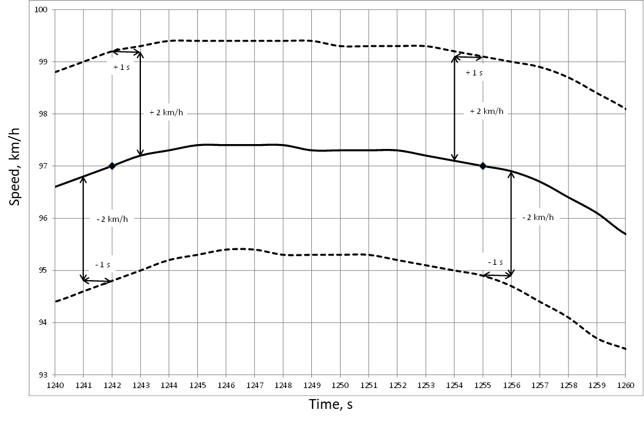
Correction/justification: The original diagram did not have x and y axes labeled.
Proposal
Annex 6, Appendix 1, paragraph 3.2., amend to read:
"Calculation of exhaust and CO₂ emissions, and fuel consumption of multiple periodically regenerating systems"
Correction/justification: Language improvement (correctness, consistency).
Proposal
Annex 6, Appendix 1, paragraph 3.2., amend to read:
"The calculation of $K_{i}$ for multiple periodically regenerating systems is only possible after a certain number of regeneration events for each system."
Correction/justification: Language improvement (correctness, consistency).
Proposal
Annex 7, paragraph 3.2.3.2.2.3.1., amend to read:
"For the purpose of the interpolation method, the aerodynamic drag of optional equipment within one road load family shall be measured at the same wind speed, either v_{low}v_{low} or v_{high}v_{high}, preferably v_{high}v_{high}, as defined in paragraph 6.4.3. of Annex 4. In the case that v_{low}v_{low} or v_{high}v_{high} does not exist, (e.g. the road load of V_{L} and/or V_{H} are measured using the coastdown method), the aerodynamic force shall be measured at the same one wind speed within the range ≥ 80 km/h ≤ and ≤ 150 km/h. For Class 1 vehicles, it shall be measured at the same wind speed lower than or equal to ≤150 km/h."
Correction/justification: For consistency with the rest of GTR 15, the terms v_{low} and v_{high} are not italicised. Furthermore, the second and third sentences have been rewritten in the sake of clarity.
Proposal
Annex 8, paragraph 3.4.4.2.1.2.(b), amend to read:
$"d_{DS1}$ is the length of dynamic speed segment 1, km;
$d_{DS2}$ is the length of dynamic speed segment 2, km;"
Correction/justification: Consistency in the use of dynamic speed segment.
Proposal
Annex 8, paragraph 4.5.1.5., amend to read:
"The linearity of charge-sustaining CO₂ mass emission for vehicle M shall be verified against the linearly interpolated charge-sustaining CO₂ mass emission between vehicle L and H over the applicable cycle by using the corrected measured values referring to the step 6 used M_{CO2,CS,c,6} of Table A8/5 of this annex.
Correction/justification: Error in transferring text from the author.

