**Proposal for the 06 series of amendments of UN Regulation No. 22 (Protective helmets)**

**Submitted by the experts from the Informal Working Group on UN Regulation No. 22**

The text reproduced below was prepared Submitted by the experts from the Informal Working Group on UN Regulation No. 22 aiming to introduce some corrigendum to the approved proposal. Modifications to document ECE/TRANS/WP.29/2019/25 are marked in bold for new or strikethrough for deleted characters.

**I. Proposal**

*Paragraph 2.7.,* amend to read:

"2.7. "lower face cover **(chin guard)**" means a detachable, movable or integral (permanently fixed) part of the helmet covering the lower part of the face;"

*Paragraph 2.23.,* amend to read:

"2.23. "trade mark" means the trade name which is used by the manufacturer **or by the holder of the manufacturer's name or by his duly accredited representative** and declared on the approval certificate to mark the helmet or the visor.

*Paragraph 2.24.,* amend to read:

"2.24. "HPI ~~Head~~ **Helmet** Position Index" means…..~~.~~"

*Paragraph 4.4.,* amend to read:

"4.4. The marking shall be ~~indelible~~, clearly legible, **resistant to wear** and in readily accessible place.”

*Paragraph 5.1.4.1.4.,* amend to read:

"*5.1.4.1.4.*  The marking on the helmet and, if appropriate, lower face cover shall be clearly legible, ~~indelible~~ and resistant to wear.”

*Paragraph 5.1.4.1.5.,* amend to read:

" *5.1.4.1.5.*  The ~~label~~ **marking** can also include, not in alternative, a bar or QR code for digital reading.”

*Paragraph 5.1.12.,* amend to read:

" *5.1.12* The ~~label~~ **approval marks** referred to in paragraph 5.1.9. above shall be clearly legible and resistant to wear.

*Paragraph 5.1.4.2.1., amend to read:*

*"* *5.1.4.1.2.1. a slash and symbol:*

*…………*

"NP" if the helmet has a **detachable or movable** non protective lower face cover.

*…………”*

*Paragraph 5.1.14., delete the paragraph:*

*~~"~~**~~5.1.14.~~* ~~Approval of helmets larger than size 62 shall be granted without additional tests if such helmets belong to a type already approved which comprises size 62 in its range of sizes.”~~

*Paragraph 5.2.5., amend to read:*

*"* *5.2.5.* A ~~ultradistructive label~~ **ultra-destructive marking** can also be an acceptable marking on the visors.

*Introduce new paragraph 5.3 and 5.3.1:*

“**5.3. Approval of a Sun Shield**

**5.3.1. Where the sun shield meets the requirements of this UN Regulation, it shall be marked. The marking shall be reported on the Approval Certificate of the helmet where it is installed.**”

*Paragraph 6.16.3.4., amend to read:*

*“* 6.16.3.4. Visors shall have a luminous transmittance τv ≥ 80 per cent , relative to the standard illuminant D65. A luminous transmittance 80 per cent > τv ≥ 35 per cent **– or 20 per cent only in case of photochromic and/or liquid crystal visor-** , measured by the method given in paragraph 7.8.3.2.1.1….When describing the transmittance properties of photochromic, liquid crystal or equivalent visors, two values ~~as~~ **are** to be considered: one corresponds to the faded state, the other to the darkened state….

Figure 2

Symbol “Daytime use only”

Note: this symbol or indication must **be** visible and extend over at least 1 cm2”

*Paragraph 6.2.2., amend to read:*

*“* 6.2.2. Note: this symbol or indication must **be** visible and extend over at least 2 cm2*“*

*Paragraph* 7.3.1.3.1.*., amend to read:*

*"* 7.3.1.3.1. … When testing impact points B, X, P, R **and extra** **points** the helmet is tipped towards the rear so that the …”

*Paragraph 7.3.1.4. – Test, amend to read:*

*"* 7.3.1.3.1. The test shall be completed in not more than five minutes after the helmet is taken from the conditioning chamber.

Tests at point S shall be carried out after tests at points B, X, P and R. **For the extra point the sequence is up to the technical service.**

**…**

**On the helmet on its base configuration:**

8.2 (+ 0.15/- 0.0) m/s for linear high energy, only flat anvil shall be used

6.0 (+ 0.15/ -0.0) m/s for linear low energy, both anvils may be used.**”**

*Paragraph 7.3.1.3.5 –amend to read:*

*7.3.1.3.5* …No helmet shall be modified from its original specification as manufactured. Accessories must be fitted in accordance with the helmet manufacturer’s instructions. **Only** **accessories tested during the type approval procedure of the helmet keep the type approval valid.**

*Paragraph 7.3.3.4. – Table 1., amend to read:*

*"”*

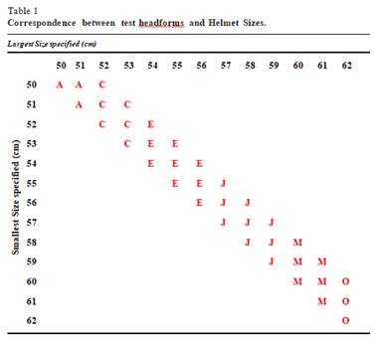

*Paragraph 7.3.4.2.1.–amend to read:*

*7.3.4.2.1.* …**~~Any other point inside the extent of protection [paragraph 6.4.1.] as particular ventilation holes and/or special features on helmet should be considered.~~**

*Paragraph 7.4.3.3. – Figure amend to read:*

*“”*

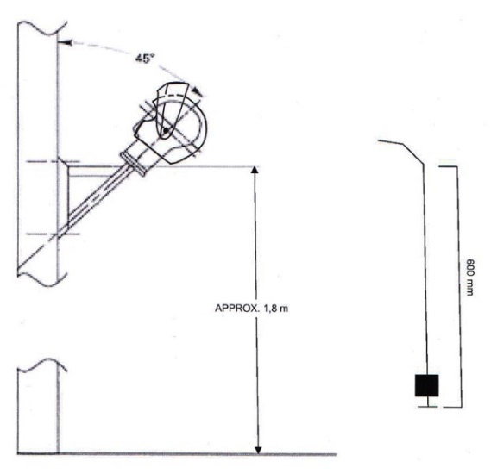

*Paragraph* 7.8.2.2.*, amend to read:*

*"* 7.8.2.2 The test apparatus used shall be as described in paragraph 7.8.2.2.1., the metal punch being placed in contact with the visor in the vertical symmetrical plane of the headform ~~to the right of point K~~. The apparatus ……..”

*Paragraph 7.9.1.1., amend to read:*

*"* 7.9.1.1. Prior to any type of further conditioning for ~~mechanical or~~ optical test, as specified in paragraph 7.9.1., …*”*

*Paragraph 8.2 to be added*

**“8.2. Each technical service shall store the raw data of test § 7.13 to be able to make them available for the approval authority for the purpose of improvement of the regulation at a later stage.”**

*Annex 2, amend to read*

“…The approval number shows that approval was granted in accordance with the requirements of the Regulation incorporating the ~~05~~ **06** series of amendments at the time of approval and that its production serial number is 1952…”

*Annex 4*

*Figure 2A – measure 31 shall be modified as 32 in line with paragraph 6.16.3.8.:*

*“”*

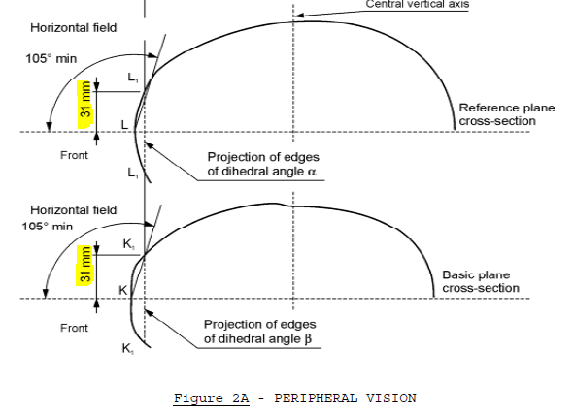

*Annex 7*

*Paragraph 2.3 Table 1 - Contents shall be modified as:*

*“*Correct the value in column Izz/Kg cm2 for headform J with **193.1** and change cm” with **cm2***”*

*Paragraph 2.7., amend to read*

*“*The ~~head~~ **headform** shall be positioned so that the head form bottom plan is horizontal.

*Paragraph 3.1., amend to read:*

" 3.1. Principle

…………in accordance to the HPI (~~head~~ **helmet** positioning index) provided by the manufacturer, …….:”

*Paragraph 3.2.3. last sentence amend to read:*

*“………….*

The guidance system shall be attached to the helmet carrier that ~~keeps~~ **maintains the headform** **and** the helmet in **its initial** position during the raise and drop of the head form/helmet assembly **by limiting the rotation to a maximum of 5 degrees.**

The helmet carrier shall not affect the head form/helmet assembly during the impact **meaning no less than 30 ms from initial contact between helmet and anvil** ~~with the anvil and 30 ms after the first contact with the anvil.”~~

*Annex 17*

*Paragraph 2.2. Amend to read:*

“2.2. Propulsion equipment

The apparatus shall be capable of imparting known speeds of up to ~~195~~ **80** m/s to a 6 mm nominal diameter steel ball of 0,86 g minimum mass. ……”

*ADD a new annex 19 GUIDE LINE*

*A – Sampling (In annex)*

A - Sampling

Helmet configuration 1:

Shell 1: L(59-60), XL(61-62), XXL(63-64)

Shell 2: XS(53-54), S(55-56), M(57-58)

Approval test sampling:

-2 samples XXL(63-64) for Rigidity test of the shell 1

-5 samples XXL(63-64) for Impact Absorption

-2 samples XXL(63-64) for Oblique impact test

-1 sample XL(61-62) for checking coverage area and field of vision requirements

-2 samples of the shell 1 size chosen as worst case for Extra point

-2 samples of the shell 1 size chosen as worst case for Hi/Low energy Impact

-2 samples L(59-60) for Impact Absorption

-1 sample L(59-60) for retention system tests (Detaching + Dynamic test)

-1 sample M(57-58) for Projection and surface friction (This sample is chosen to representative of both shells)

-2 samples M(57-58) for Rigidity test of the shell 2

-5 samples M(57-58) for Impact Absorption

-2 samples M(57-58) for Oblique impact test

-1 sample S(55-56) for checking coverage area and field of vision requirements

-2 samples of the shell 2 size chosen as worst case for Extra point

-2 samples of the shell 2 size chosen as worst case for Hi/Low energy Impact

-2 samples XS(53-54) for Impact Absorption

-1 sample XS(53-54) for retention system tests (Detaching + Dynamic test)

Total samples: 35

Production Qualification test sampling:

-20 samples XXL(63-64) for Impact Absorption Shell 1

-20 samples M(57-58) for Impact Absorption Shell 2

-10 samples L(59-60) for Dynamic retention system test Shell 1

-10 samples XS(53-54) for Dynamic retention system test Shell 2

Total samples: 60

Remarks:

-If there are more than one buckle must be added 10 samples of each shell for each different buckle.

Helmet configuration 2:

Shell 1: XL(61-62), XXL(63-64)

Shell 2: M(57-58), L(59-60)

Shell 3: XS(53-54), S(55-56)

Approval test sampling:

-2 samples XXL(63-64) for Rigidity test of the shell 1

-5 samples XXL(63-64) for Impact Absorption

-2 samples XXL(63-64) for Oblique impact test

-2 samples of the shell 1 size chosen as worst case for Extra point

-2 samples of the shell 1 size chosen as worst case for Hi/Low energy Impact

-1 sample XL(61-62) for retention system tests (Detaching + Dynamic test)

-1 sample M(57-58) for Projection and surface friction (This sample is chosen to representative of all shells) -2 samples L(59-60) for Rigidity test of the shell 2

-5 samples L(59-60) for Impact Absorption

-2 samples L(59-60) for Oblique impact test

-2 samples of the shell 2 size chosen as worst case for Extra point

-2 samples of the shell 2 size chosen as worst case for Hi/Low energy Impact

-2 samples M(57-58) for Impact Absorption

-1 sample M(57-58) for retention system tests (Detaching + Dynamic test)

-2 samples S(55-56) for Rigidity test of the shell 3

-5 samples S(55-56) for Impact Absorption

-2 samples S(55-56) for Oblique impact test

-2 samples of the shell 3 size chosen as worst case for Extra point

-2 samples of the shell 3 size chosen as worst case for Hi/Low energy Impact

-1 sample XS(53-54) for retention system tests (Detaching + Dynamic test)

Total samples: 45

Production Qualification test sampling:

-20 samples XXL(63-64) for Impact Absorption Shell 1

-20 samples M(57-58) for Impact Absorption Shell 2

-20 samples S(55-56) for Impact Absorption Shell 3

-10 samples XL(61-62) for Dynamic retention system test Shell 1

-10 samples M(57-58) for Dynamic retention system test Shell 2

-10 samples XS(53-54) for Dynamic retention system test Shell 3

Total samples: 90

Helmet configuration 3:

Shell 1: XS(53-54), S(55-56), M(57-58), L(59-60), XL(61-62), XXL(63-64)

Approval test sampling:

-2 samples XXL(63-64) for Rigidity test

-5 samples XXL(63-64) for Impact Absorption

-2 samples XXL(63-64) for Oblique impact test

-1 sample XL(61-62) for checking coverage area and field of vision requirements

-2 samples size chosen as worst case for Extra point

-2 samples size chosen as worst case for Hi/Low energy Impact

-2 samples L(59-60) for Impact Absorption

-1 sample M(57-58) for Projection and surface friction

-2 samples M(57-58) for Impact Absorption

-1 sample S(55-56) for checking coverage area and field of vision requirements

-2 samples XS(53-54) for Impact Absorption

-1 sample XS(53-54) for retention system tests (Detaching + Dynamic test)

Total samples: 23

Production Qualification test sampling:

-20 samples XXL(63-64) for Impact Absorption

-10 samples XS(53-54) for Dynamic retention system test

Total samples: 30

**II. Justification**

1. Added definition of “chin guard” in order to bring clarity to its intended meaning
2. Additional text to align with paragraphs 3.1.1 and 3.1.2 of this Regulation
3. editorial modification for typing error: errata=head, corrige=helmet
4. Modification to provide clarification to approval markings, removes confusion on the interpretation of the word “indelible”, and to align and maintain consistency with other sections of the regulation. See paragraph 5.1.6
5. It is also not clear if the word “indelible” translates well in other CP languages
6. Modification to provide clarity to markings, remove confusion on the interpretation of the word “indelible”, and to align and maintain consistency to other sections of the regulation. E.g. paragraphs 5.1.6 and 5.2.5
7. Editorial modification to align with paragraphs 5.1.4.1.4 and 5.1.5 and to ensure consistency of wording
8. Editorial modification to align with other paragraphs in the Regulation
9. for sake of coherence, NP symbol concerning NP helmet type that have has a detachable or movable non protective lower face cover.
10. Editorial modification because the sentence is redundant respect the paragraph 7.3.3.2 Note 5
11. Editorial correction
12. To clearly identify the approved sun shield and too avoid any mistake with sun shield available on the market but not complying with the requirements of this UN Regulation
13. Editorial correction
14. In case of photochromic and/or liquid crystal visor the dark state, transmittance is controlled by the ambient light or user. This allows in the case of dark situation to go back to the fade (clear) state allowing a proper vision of the road. Thus, it is feasible to assimilate the dark level to the one authorized for the sunshield
15. Editorial modification to clarify that the helmet positioning is valid even for the extra points
16. Editorial modification to clarify that the helmet manufacturer can be responsible of only those accessories approved within the homologation process.
17. Editorial modification to clarify which helmets to use for high and low energy test.
18. Typing error in the table
19. Extra points position is already offering a wide choice of positions without the need of further testing points that will not help the reproducibility between labs
20. It has been added the helmet drawing
21. The old limitation for the position of the point of impact is not in line with the actual procedure
22. Editorial modification as no mechanical tests are prescribed in this case
23. Editorial correction
24. Typing error
25. Typing error
26. Editorial correction
27. See point 1 🡺 editorial modification for typing error: errata=head, corrige=helmet
28. Clarification in the text
29. Typing error
30. Informative guide line to support the sampling