Informal document Amending ‘Proposal for Amendments to the 03 series of Amendments to UN Regulation No. 79 (Steering equipment)’
Submitted by the expert from the European Association for Electromobility
The text reproduced below was prepared by the expert from the European Association for Electromobility (AVERE) introducing an amendment to UN Regulation No. 79. It is aimed at clarifying the text of the Regulation. The modifications to the existing text of the Regulation are marked in bold for new and strikethrough for deleted characters.
I. Proposal
Paragraph 5.6.4.6.4, amend to read:
"5.6.4.6.4. | The lateral movement of the vehicle towards the intended lane shall not start earlier than 1 second after the start of the lane change procedure. Additionally, the lateral movement to approach the lane marking and the lateral movement necessary to complete the lane change manoeuvre, shall be completed as one continuous movement.  The lane change manoeuvre shall not be initiated before a period of 3.0 seconds and not later than 15.0 5.0 seconds after the deliberate action of the driver described in paragraph 5.6.4.6.2. above.  [If the ACSF function has not commenced the lane change manoeuvre 10.0 seconds after the deliberate action of the driver, the driver will be notified through an acoustic or visual warning when the manoeuvre is about to commence.]

Annex 8, Paragraph 3.5.1.2., amend to read:
"3.5.1.2. | The requirements of the test are fulfilled if:  (a) The lateral movement towards the marking does not start earlier than 1 second after the lane change procedure was initiated,  (b) The lateral movement to approach the lane marking and the lateral movement necessary to complete the lane change manoeuvre are completed as one continuous movement,  (c) The recorded lateral acceleration does not exceed 1 m/s²,  (d) The moving average over half a second of the lateral jerk does not exceed 5 m/s³,  (e) The measured time between the start of the lane change procedure and the start of the lane change manoeuvre is not less than 3.0 seconds and not more than 15.0 5.0 seconds.  (f) The system provides information to the driver to indicate that the lane change procedure is ongoing,  (g) The lane change manoeuver is completed in less than 15 5 seconds for M₁, N₁ vehicle categories and less than 10 s for M₂, M₃, N₂, N₃ vehicle categories,  (h) ACSF of Category B1 automatically resumes after the lane change manoeuvre is completed, and  (i) The direction indicator is deactivated not before the end of the lane change manoeuvre and no later than 0.5 seconds after ACSF of Category B1 has resumed.
Paragraph 5.6.4.6.8.1, amend to read:
"5.6.4.6.8.1. | The lane change procedure shall be suppressed automatically by the system when at least one of the following situations occurs before the lane change manoeuvre has started:  - The system detects a critical situation (as defined in paragraph 5.6.4.7.);  - The system is overridden or switched off by the driver;  - The system reaches its boundaries (e.g. lane markings are no longer detected);  - The system has detected that the driver is not holding the steering control at the start of the lane change manoeuvre;  - The direction indicator lamps are manually deactivated by the driver;  - The lane change manoeuvre has not commenced within 15.0 5.0 seconds following the deliberate action of the driver described in paragraph 5.6.4.6.2.;  - The lateral movement described in paragraph 5.6.4.6.4. is not continuous.
II. Justification
- Paragraph 5.6.4.6.4.
- We suggest changing the maximum time for starting the lane change maneuver to 15 seconds based on accumulated data from real world driving that shows the following distribution of turn indicator times across 1000 vehicles in a one-month window. The 15 second value, corresponds to the majority of use cases and is in line with natural driving behavior.
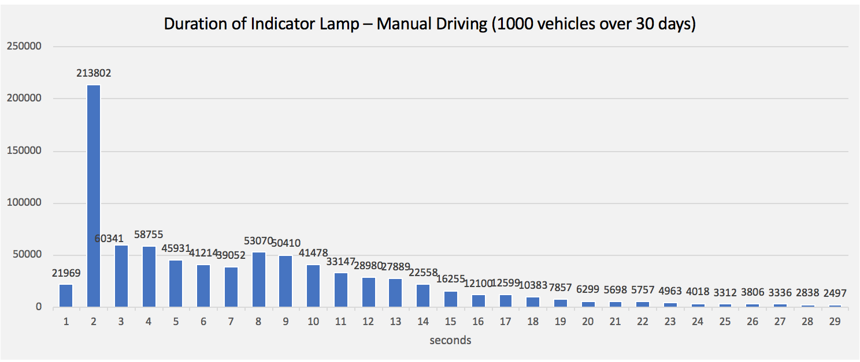

- Annex 8, Paragraph 3.5.1.2.
- Adjustments to reflect changes proposed for the other provisions described in this document.

- Paragraph 5.6.4.6.8.1
- Adjustments to reflect changes proposed for the other provisions described in this document.

