Draft Appendix on Traffic Critical Scenarios
to the Annex on audit/assessment to the new UN Regulation on Automated Lane Keeping systems (ALKS)
I. Justification
This informal document was drafted as an Appendix to the Annex 4 to the new regulation on Automated Lane Keeping systems (ALKS) to address ‘scenarios” pillar especially for the traffic critical scenarios of the new test and assessment methods.
[This document reflects the ongoing investigation of the VMAD group to use scenarios for approval testing and is based on an attentive skilled driver model that reacts on a single most important object based on simulation. VMAD further investigates requirements for validation of more complex vehicle-environment interaction, transition of control and the possibilities of various types of simulation methods to validate specific requirements of the AD-functions.]
This document defines traffic critical scenarios for Annex 4 of the regulation which needs to be divided into preventable and unpreventable, according to the requirement in the regulation which stipulates:
“The activated system shall not cause any collisions that are reasonably foreseeable and preventable.”
Preventable scenarios are those where the validation should prove that ALKS does not result in an accident.
Unpreventable scenarios are those where the validation should prove that collision mitigation strategy of ALKS should be implemented in an accident.
II. Proposal
Appendix
Traffic critical scenarios for ALKS
- Traffic critical scenarios
The following three are traffic critical scenarios:
- Cut-in: the ‘other vehicle’ merges in front of the ‘ego vehicle’
- Cut-out: the ‘other vehicle’ exits the lane of the ‘ego vehicle’
- Deceleration: the ‘other vehicle’ decelerates in front of the ‘ego vehicle’
Each of these traffic critical scenarios can be created using the following parameters/elements:
- Road geometry
- Ego vehicle’s behavior/ manoeuvre
- Other vehicle‘s behavior/ manoeuvre
- Performance model of ALKS
Traffic critical scenarios of ALKS are divided into preventable and unpreventable scenarios. They are determined based on the performance model of the ALKS shown below;
〇 Human driver with ADAS model
In low-speed ALKS scenario, the avoidance capability required for the driver model is braking control only. As a result, this driver model is separated into the following three segments: “Risk perceive situation”; “Delay in time”; and, “Deceleration degree and Max. G-force”. Following is a visual representation of these segments:
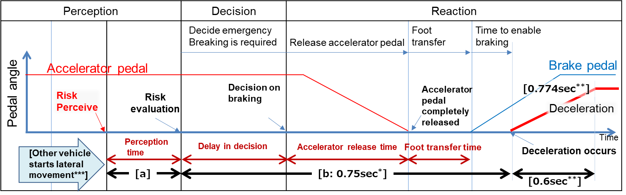
Note: [a] depend on each scenario
_________________________________________________________________
[*/ = 0.75sec is a common data in Japan.
**/ = 0.6sec and 0.774G are a data from experiments of NHTSA and Japan. (Coefficient of road friction is 0.6.)
***/= Timing of other vehicles start moving from lane keep to cut-in (or cut-out). It is indicated by lateral movement distance.

  - Driver model for the three ALKS scenarios:
2.1.1. For Cut in scenario:
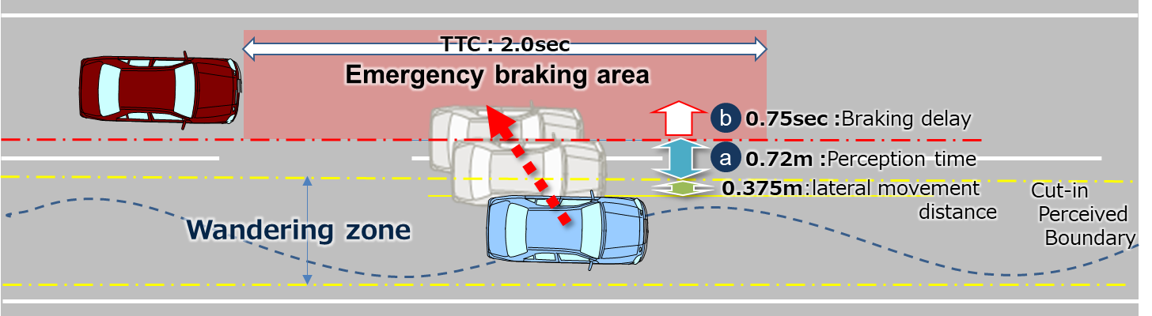
The lateral wandering distance the vehicle will normally wander within the lane is [0.375m] .
The perceived boundary for cut-in occurs when the vehicle exceeds the normal lateral wandering distance (prior to lane change)
[a] is perception distance. It defines the distance required to perceive that a vehicle is executing a cut-in manoeuvre [a] is obtained from the following formula;
[a:0.72m] = (Max lateral movement speed: 1.8m/s) x (Risk perception time: 0.4sec)
Max lateral movement speed is real world data in Japan.
Risk perception time is driving simulator data in Japan.
[2sec*] is specified as the maximum Time To Collision (TTC) for which we conclude that there is a danger in the longitudinal direction.
[*/=TTC 2.0sec is based on the UNR guidelines on warning signals.]

2.1.2. For Cut out scenario:
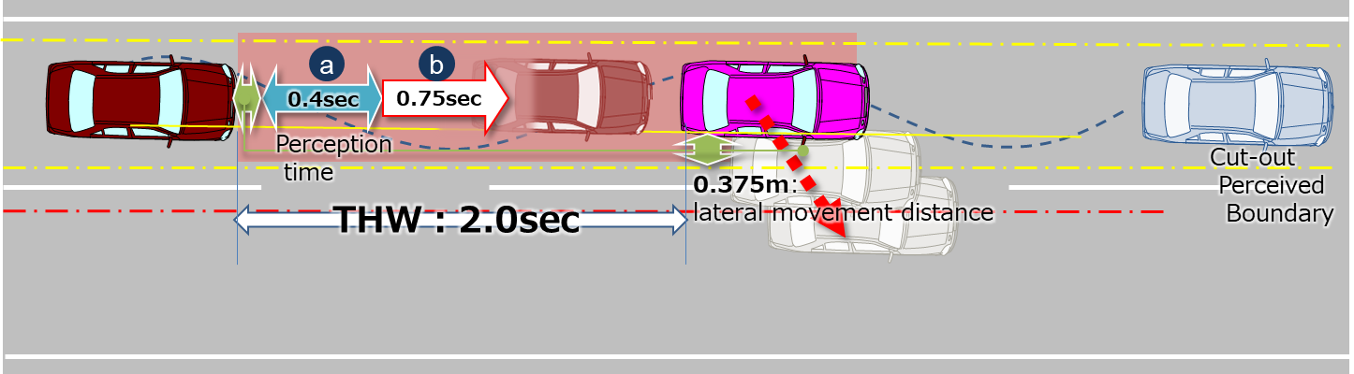
The lateral movement distance of leading vehicle when it starts lateral movement is [0.375m].
This parameter is skilled human driver that assumes a critical situation when leading vehicle moves [0.375m].
[a:0.4sec] is perception time (= delay in risk evaluation). Risk perceived position of side vehicle is determined by lateral movement speed of it.
[2sec**] is specified as the maximum Time Head Way (THW) for which we conclude that there is a danger in longitudinal direction.
[**/=THW 2.0sec is according to other countries’ regulations and guidelines.]

2.1.3. For Deceleration scenario:
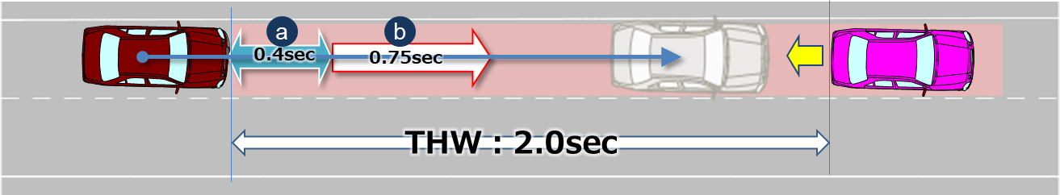
The delay in perception (= Risk evaluation delay time) is [a:0.4sec]. Risk perceived timing of leading vehicle is determined by deceleration rate of it.

2.2. Parameters
Parameters below are essential when describing the pattern of the traffic critical scenarios in section 2.1.
Additional parameters could be added according to the ODD/OD (e.g. friction rate of the road).
Initial condition | Initial velocity | Ve0 = Ego vehicle
 |  | Vo0 = Leading vehicle in lane or in adjacent lane
 |  | Vf0 = Vehicle in front of leading vehicle in lane
 | Initial distance | dx0 = Distance in Longitudinal direction between ego and leading vehicle in lane or in adjacent lane
 |  | dy0 = Inside Lateral distance between outside edge line of ego vehicle in parallel to the vehicle's median longitudinal plane within lanes and outside edge line of another vehicle in parallel to the vehicle's median longitudinal plane in adjacent lines.
 |  | dx0_f = Distance in longitudinal direction between front end of leading vehicle and rear end of vehicle in front of leading vehicle
Vehicle motion | Lateral motion | Vy = Lateral velocity
 | Deceleration | Gx_max = Maximum deceleration G
 |  | dG/dt = Deceleration rate (Jerk)

Following are visual representations of parameters for the three types of scenarios
Cut in | 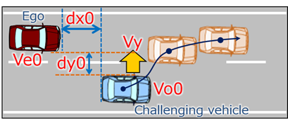
Cut out | 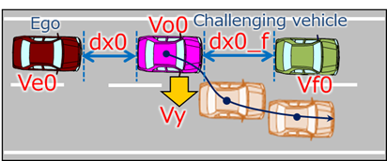
Deceleration | 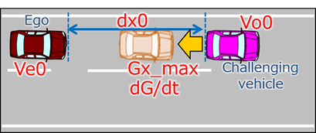

2.3. Data sheet
In addition to the above-mentioned driver models, following data sheets are available for checking within each scenario if the ADS would avoid a collision, taking into account any combination of each parameter within the vehicle speed that ALKS is able to function.
2.3.1. Cut in
(Data sheets image)
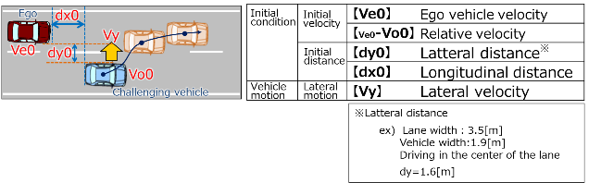
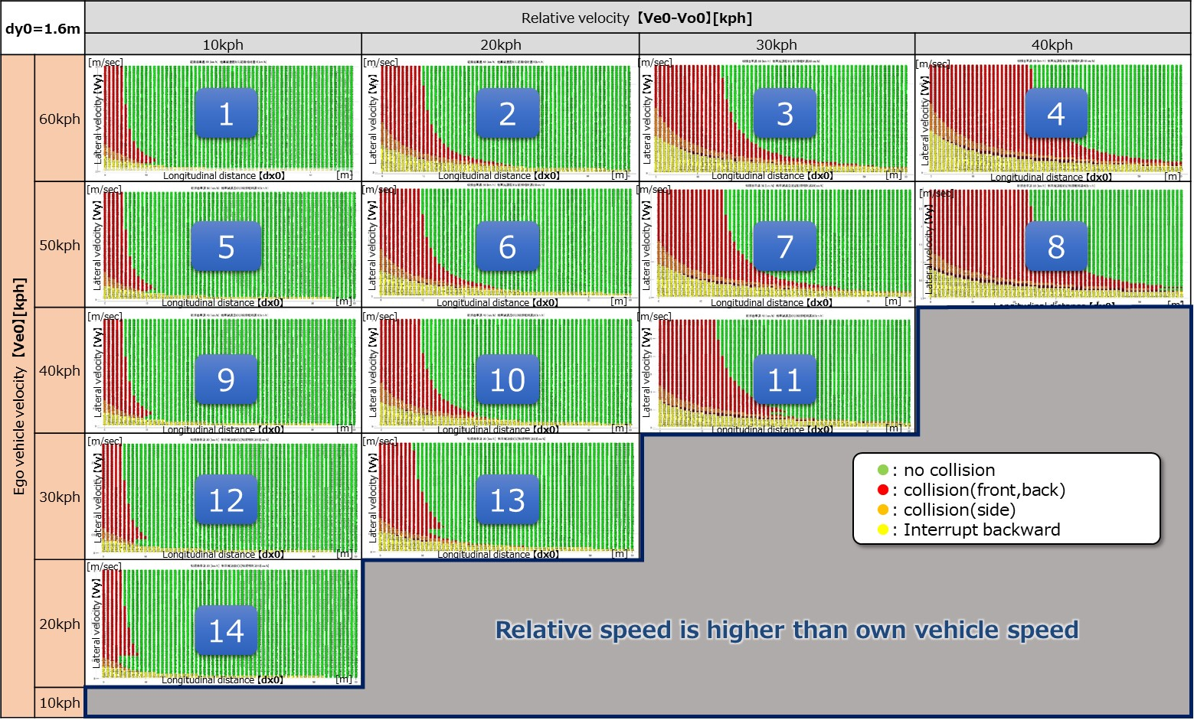
Ve0：60[kph]
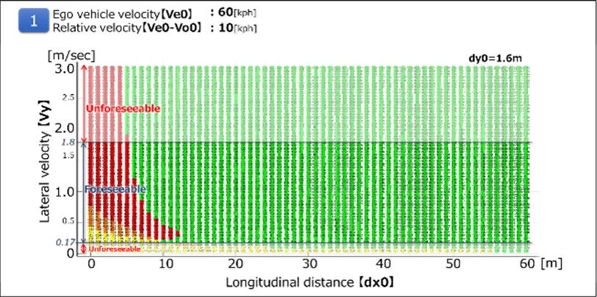

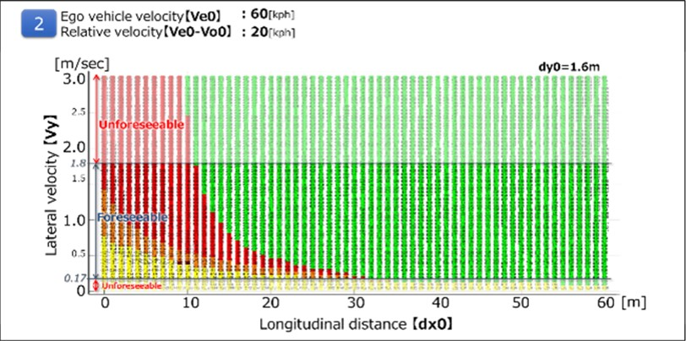
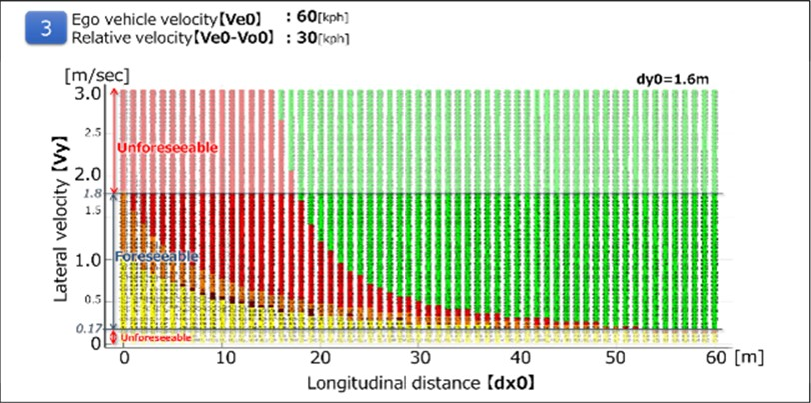

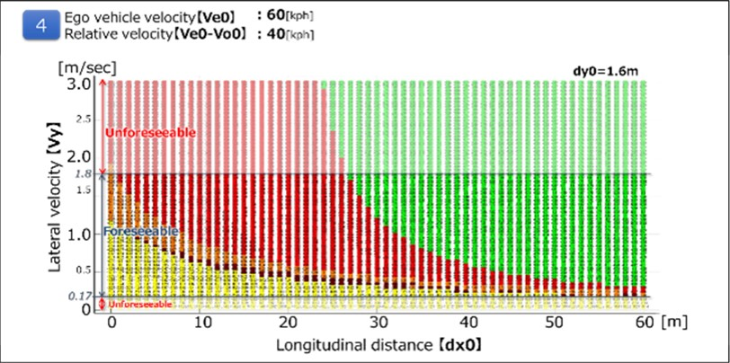

Ve0：50[kph]
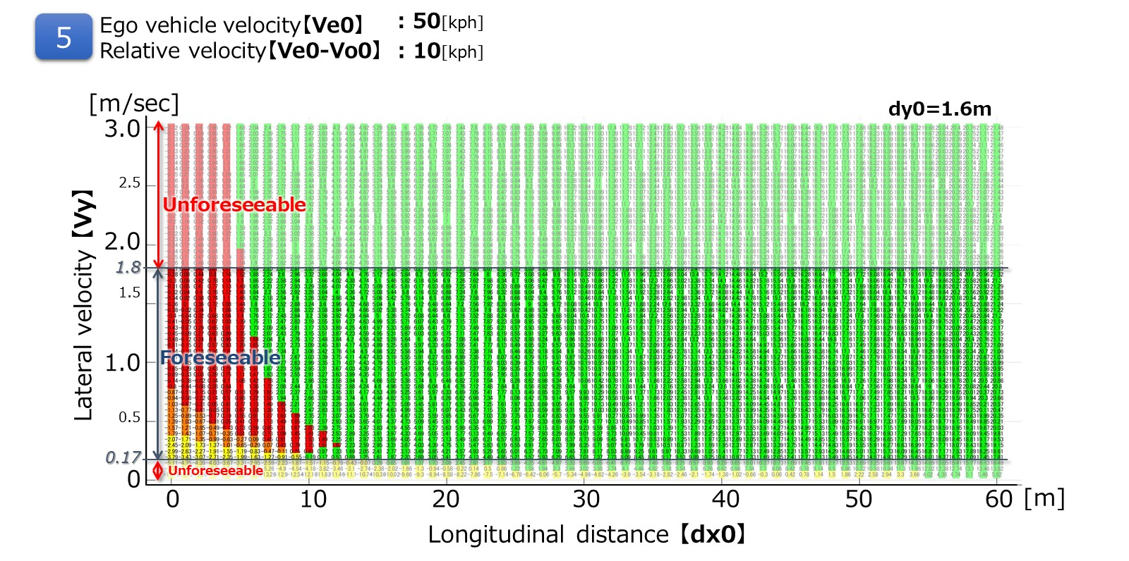

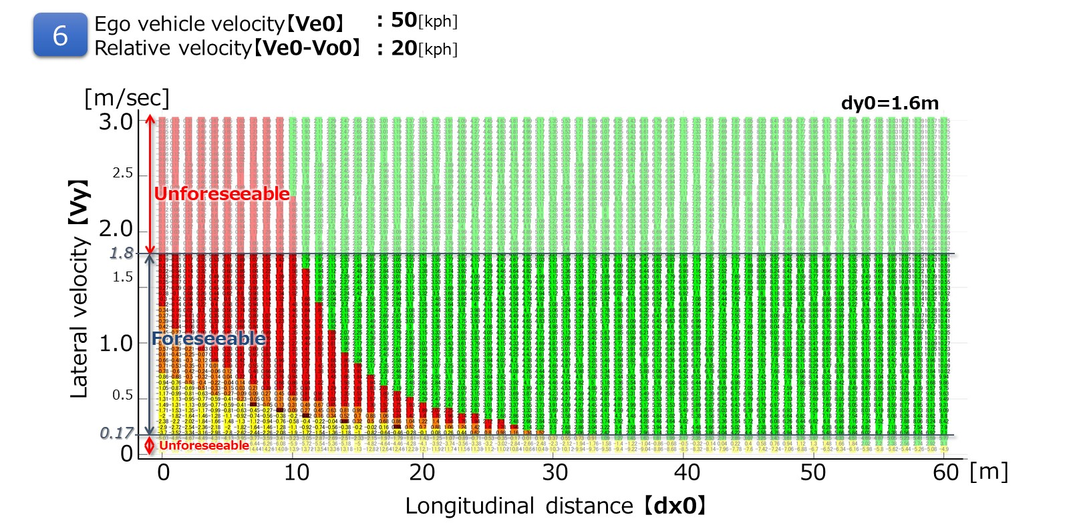

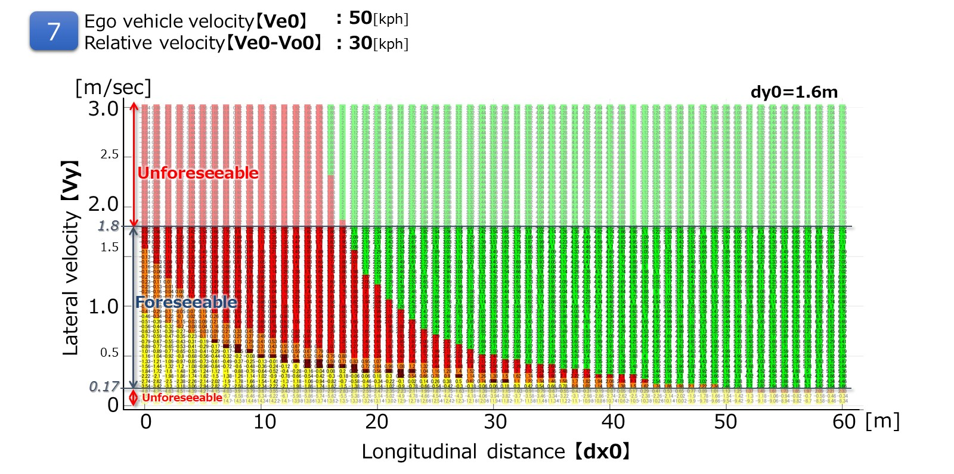

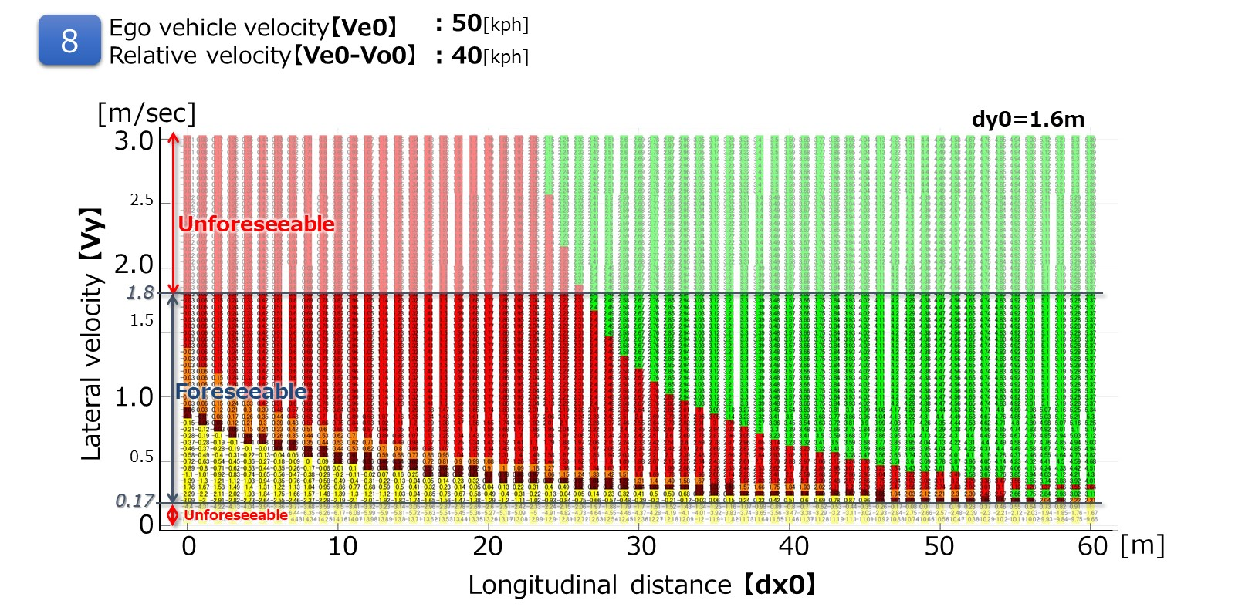

Ve0：40[kph]
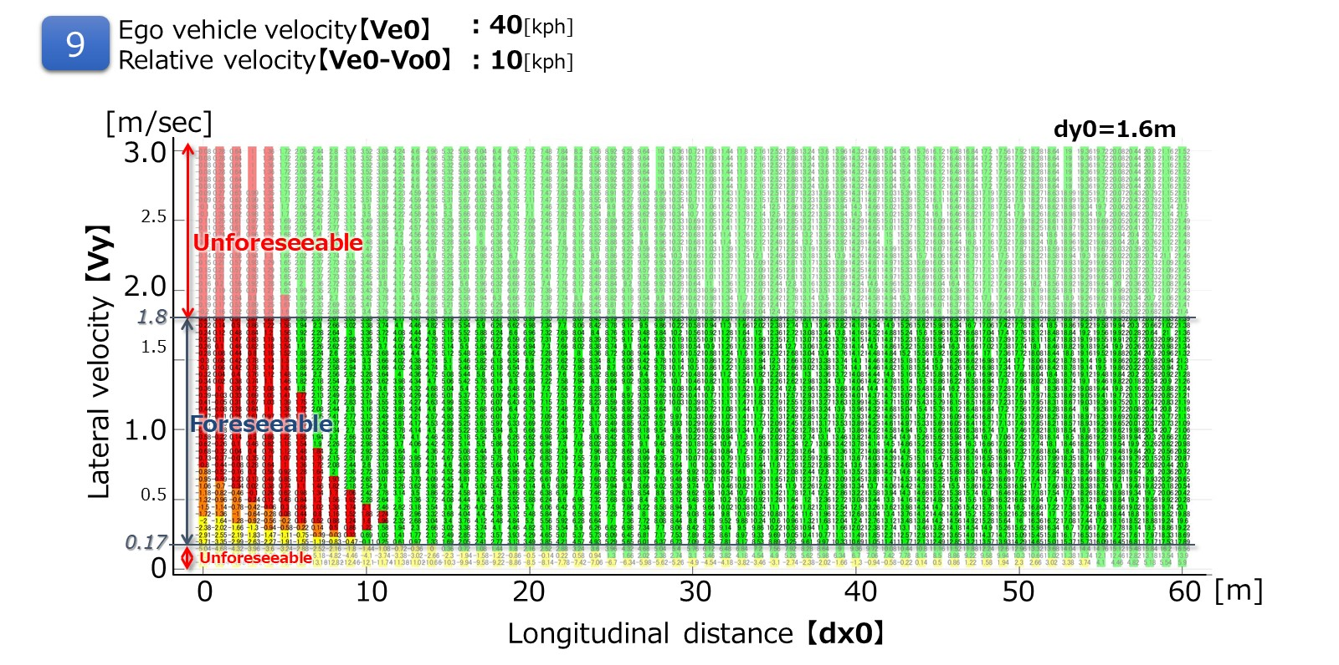

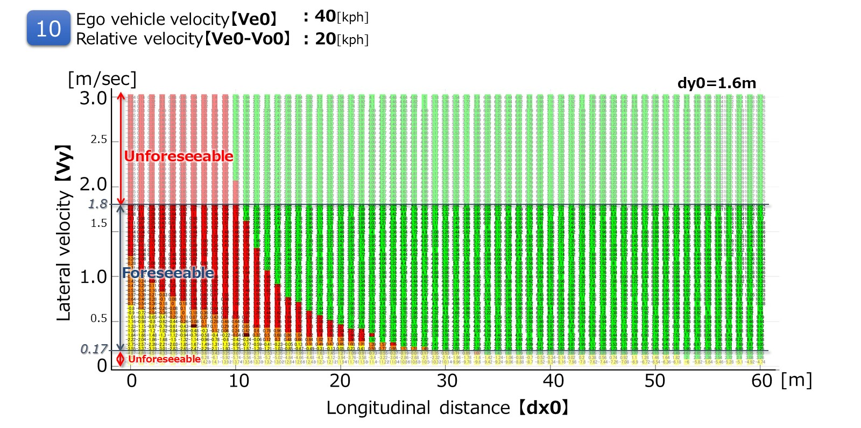

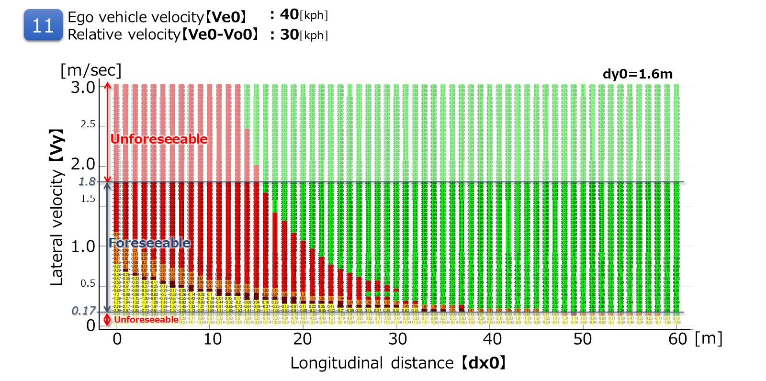

Ve0：30[kph]
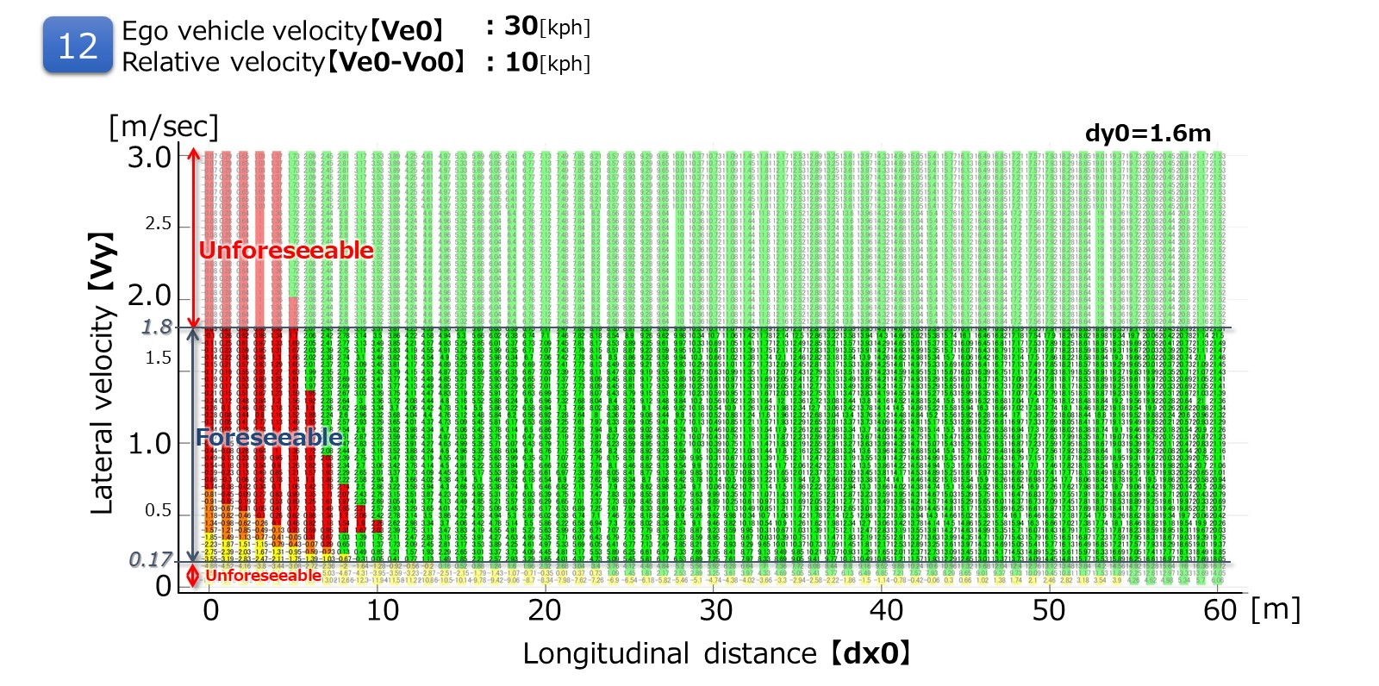

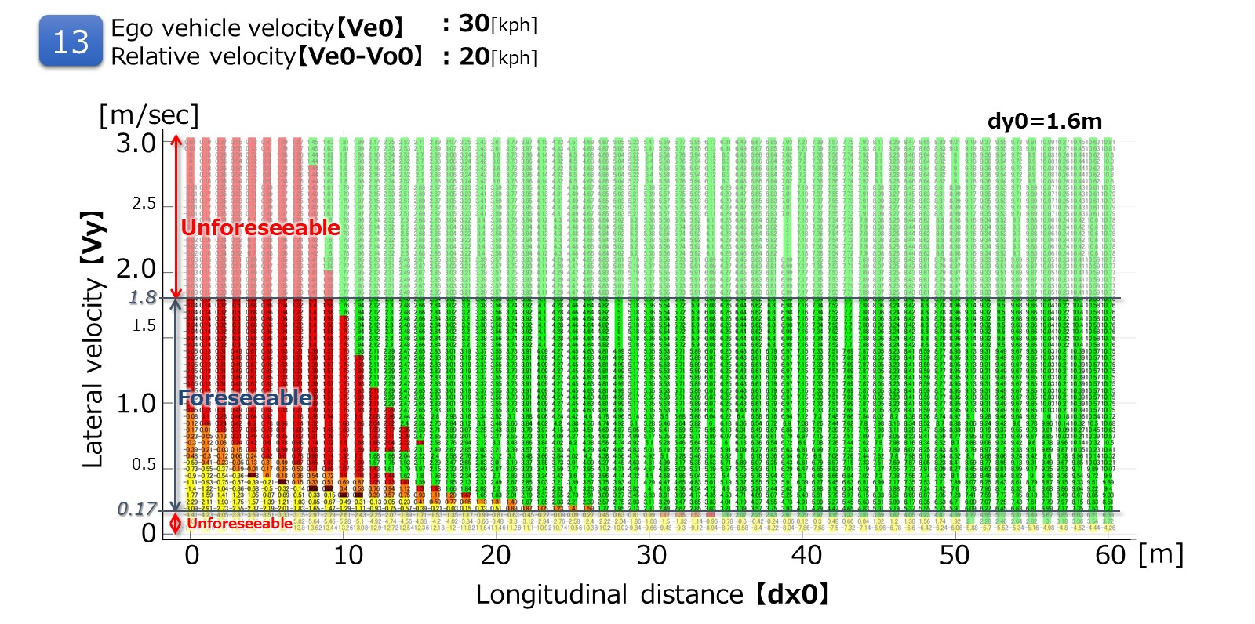

Ve0：20[kph]
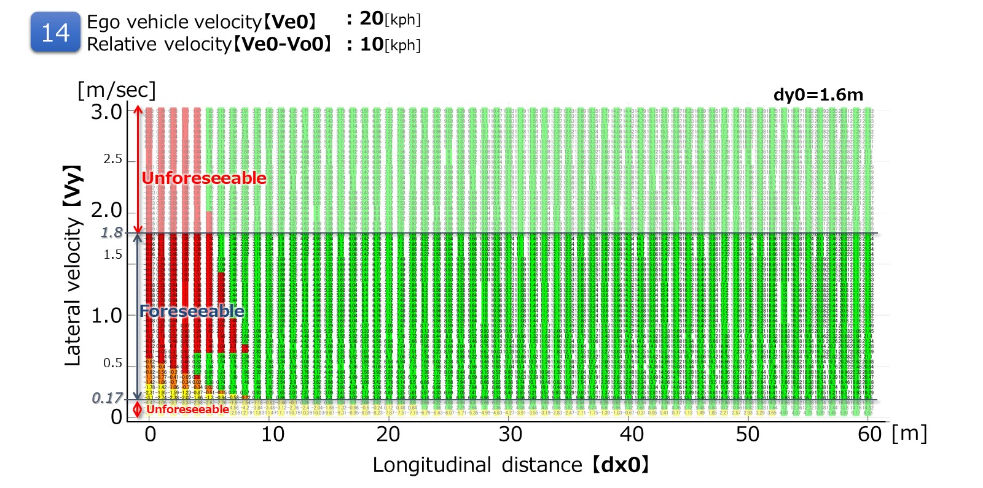

2.3.2 Cut out
It is possible to avoid all the deceleration (stop) vehicles ahead of the preceding vehicle cut-out in the following running condition at THW 2.0 sec.
(Data sheets image)
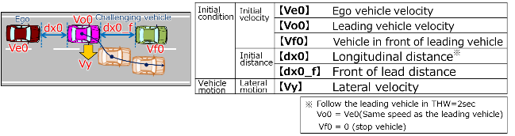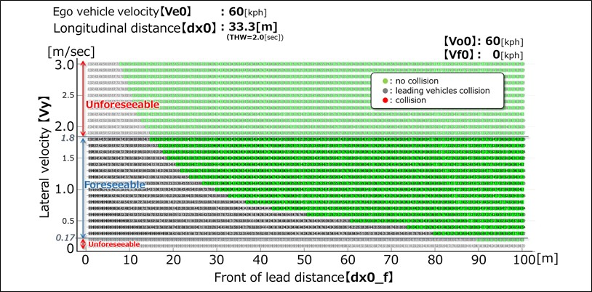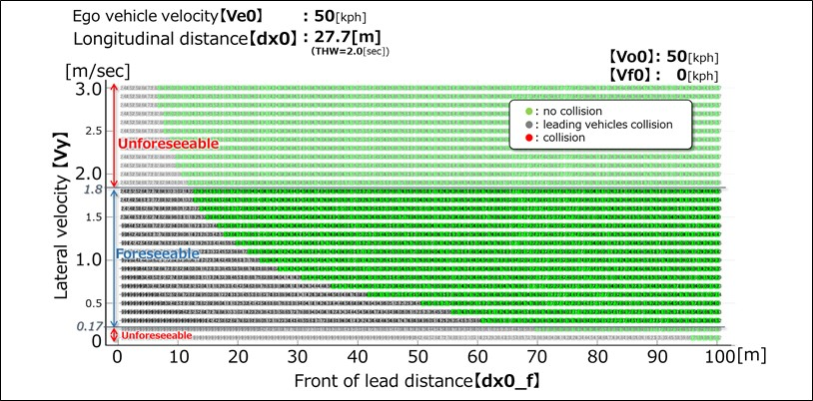
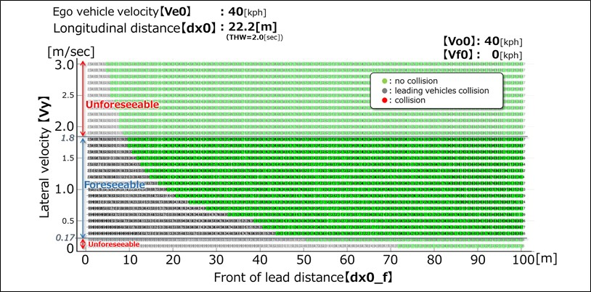
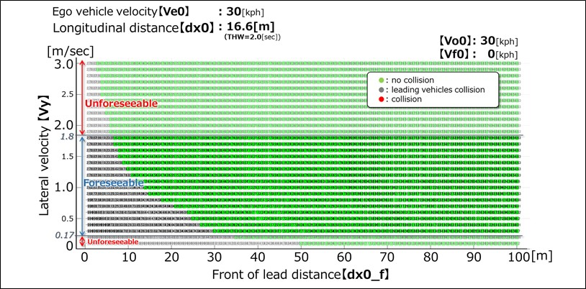

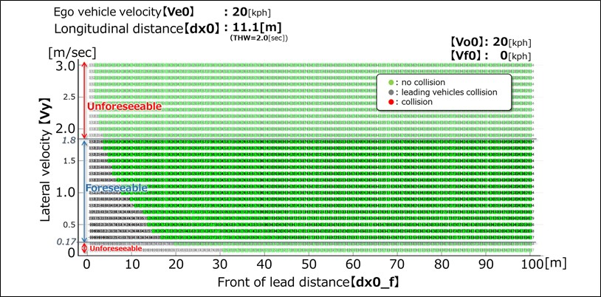
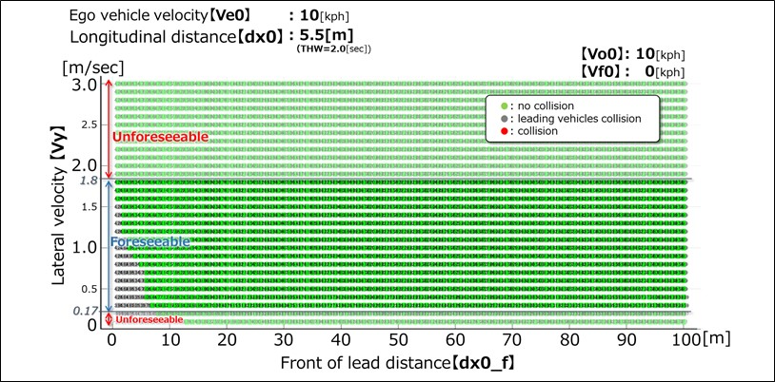

2.3.3. Deceleration
It is possible to avoid sudden deceleration of -1.0G or less in the follow-up driving situation at THW 2.0sec.
(Data sheet image)
