Submitted by the expert from Finland | Informal document GRSG-117-06  (117th GRSG, 8–11 October 2019  agenda item 8)
Draft amendments to UN Regulation No. 55 (Mechanical couplings)
The text reproduced below was prepared by the expert from the Finland to update the provisions on mechanical couplings. The modifications to the current text of the UN Regulation are marked in bold for new or strikethrough for deleted characters.
I. Proposal for Supplement 9 to the 01 series of amendments to UN Regulation No. 55 (Mechanical couplings)
Annex 5, paragraph 3.4., amend to read:
"3.4. Minimum articulation of the coupled drawbar eye
The drawbar eye, when coupled to a drawbar coupling but not fitted to a vehicle, shall have the degrees of articulation given below. If part of the articulation is provided by a special joint (Class C50-X drawbar couplings only), the field of application, given in the communication form shown in Annex 1, shall be restricted to the cases stated in Annex 7, paragraph 1.3.8. Any flexible components providing part of the articulation are not considered to be a special joint."
II. Proposal for the 02 series of amendments to UN Regulation No. 55 (Mechanical couplings)
Paragraph 13, amend to read:
"13.1. Until the United Nations Secretary-General is notified otherwise, Contracting Parties applying this Regulation that are Member States of the European Union (at the time of adoption of the 01 series of amendments, Austria, Belgium, Denmark, Finland, France, Germany, Greece, Ireland, Italy, Luxembourg, Netherlands, Portugal, Spain, Sweden and United Kingdom) declare that, in relation to mechanical coupling devices and components, they will only be bound by the obligations of the Agreement to which this Regulation is annexed with respect to such devices and components intended for vehicles of categories other than M₁.
13.2. As from the official date of entry into force of the 02 series of amendments, no Contracting Party applying this Regulation shall refuse to grant or refuse to accept type approvals under this Regulation as amended by the 02 series of amendments.
13.3. As from 1 September 2021, Contracting Parties applying this Regulation shall not be obliged to accept type approvals to the preceding series of amendments, first issued after 1 September 2021.
13.4. Until 1 September 2023, Contracting Parties applying this Regulation shall accept type approvals to the preceding series of amendments, first issued before 1 September 2021.
13.5. As from 1 September 2023, Contracting Parties applying this Regulation shall not be obliged to accept type approvals issued to the preceding series of amendments to this Regulation.
13.6. Notwithstanding the transitional provisions above, Contracting Parties who start to apply this Regulation after the date of entry into force of the most recent series of amendments are not obliged to accept type approvals which were granted in accordance with any of the preceding series of amendments to this Regulation.
13.7. Notwithstanding paragraph 13.5., Contracting Parties applying this Regulation shall continue to accept type approvals issued according to the preceding series of amendments to this Regulation, for the vehicles, equipment or parts which are not affected by the changes introduced by the 02 series of amendments.
13.8. Contracting Parties applying this Regulation shall not refuse to grant type approvals according to any preceding series of amendments to this Regulation or extensions thereof."

Annex 3, amend to read:
"
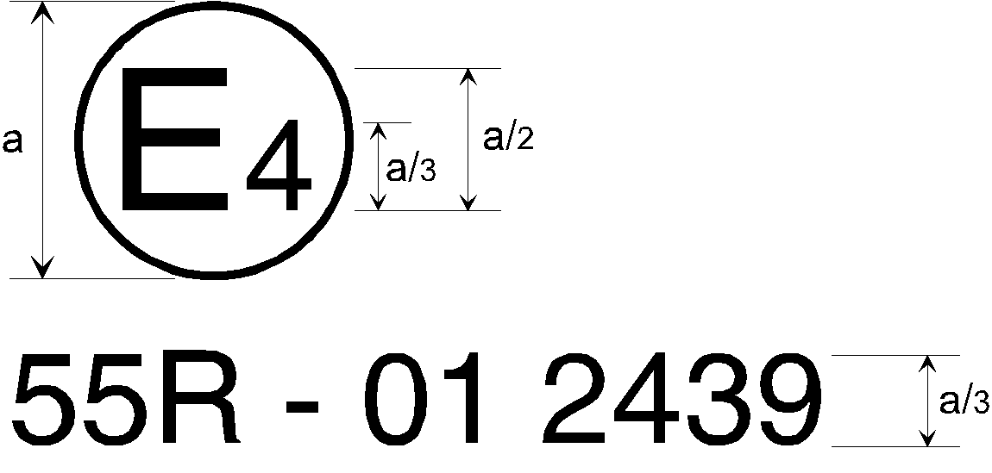
2
a = 8 mm minimum

The mechanical coupling device or component or vehicle bearing the approval mark shown above is a device or component approved in the Netherlands (E 4), under approval number 2439, meeting the requirements of the 01 02 series of amendments to this Regulation.
Note: The approval number and additional symbols shall be placed close to the circle and either above or below the letter "E", or to the right or left of that letter. The digits of the approval number shall be on the same side of the letter "E" and face in the same direction. The use of Roman numerals as approval numbers should be avoided so as to prevent any confusion with other symbols."

Annex 5, paragraph 4.1., amend to read:
"4.1. General requirements for drawbar eyes of Class D50:
All drawbar eyes of Class D50 shall be able to satisfy the test stated in Annex 6, paragraph 3.4.
Class D50 drawbar eyes are intended for use with C50 drawbar couplings. Drawbar eyes shall not be able to rotate axially (because the respective couplings can rotate).
If Class D50 drawbar eyes are fitted with sleeves, they shall comply with the dimensions shown in Figure 9 (not permitted for Class D50-C) or Figure 10. The sleeves shall not be welded into the drawbar eyes. Class D50 drawbar eyes shall have the dimensions given in paragraph 4.2. The form of shank for drawbar eyes of Class D50-X is not specified, but shall be limited by the form drawn in Figure 11 and for a distance of 210 mm from the centre of the eye the height "h" and the width "b" shall be within the limits given in Table 6."
III. Justification
1. In case part of the articulation is provided by flexible components the current wording leaves room for interpretation. Approval documentation of the C50 coupling devices on the market show the use restriction according to Annex 7, paragraph 1.3.8. has not been used in case of flexible components providing part of the articulation. Apparently, at the moment current wording has been widely interpreted according to this clarified proposal.
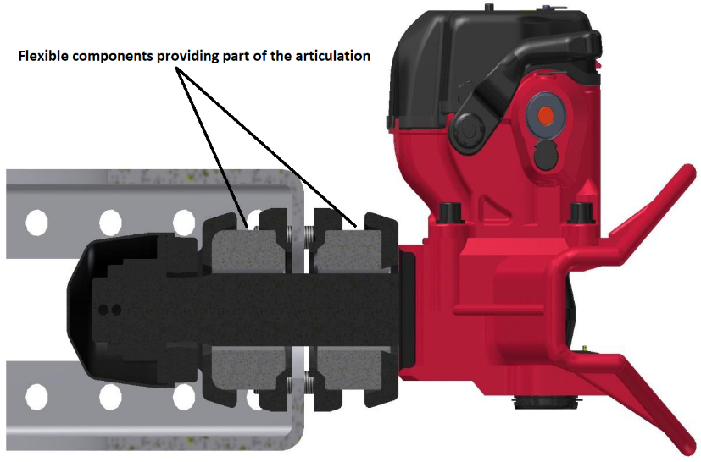

2. High capacity vehicle combinations made possible in Finland require high D-value coupling devices. This means the dimensions of the coupling devices are often very near to the limits of the current regulations. In Finland incompatible type-approved drawbar eyes and drawbar couplings has been found in the market surveillance. The main issue is the vertical thickness of the shank of the drawbar eye. Maximum dimensioned D50-X shank cannot fully articulate inside of C50 drawbar couplings as shown in the photographs below.
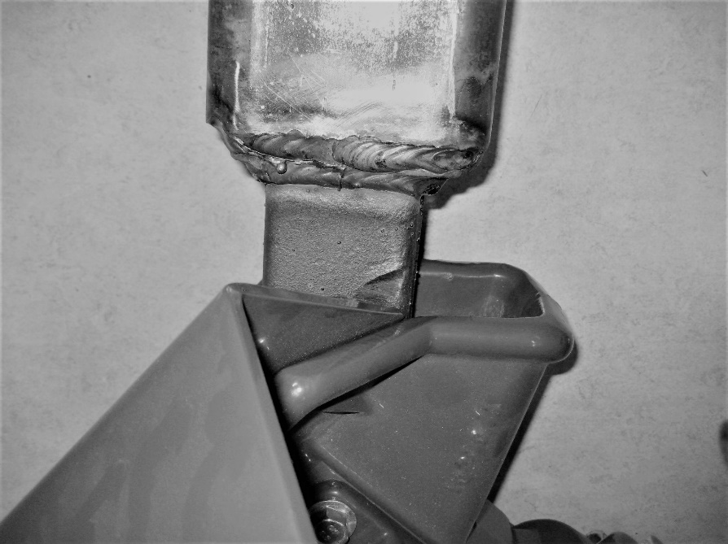
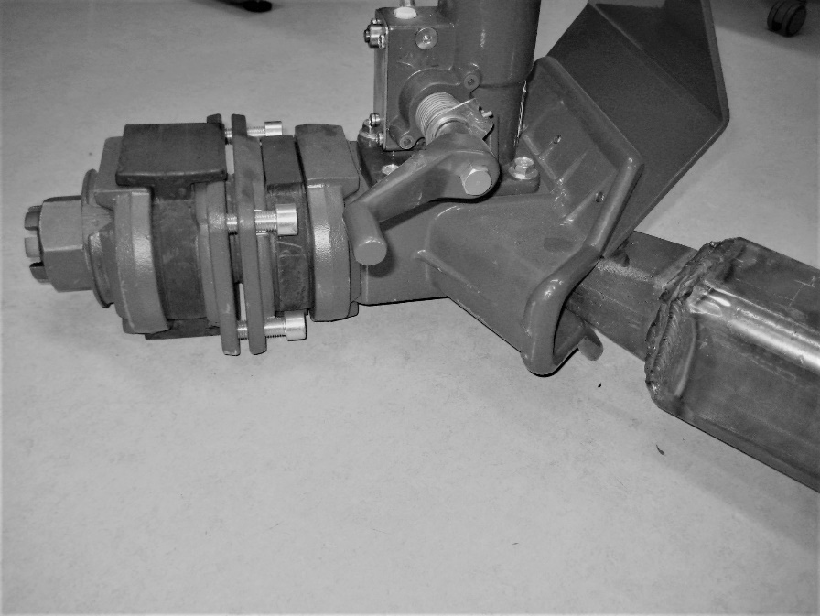
Clarified dimensioning of the D50-X shank would ensure the compatibility with the C50 couplings.
See examples:
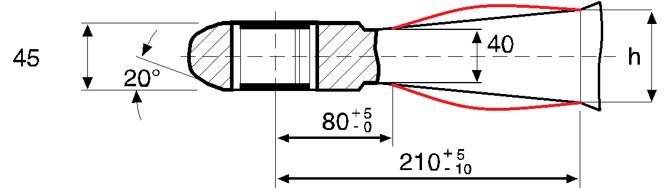 NOT OK

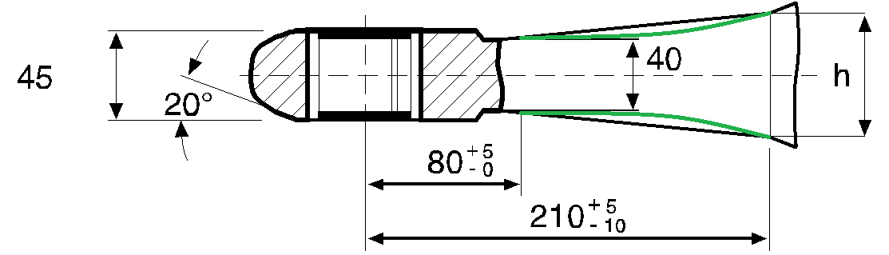 OK

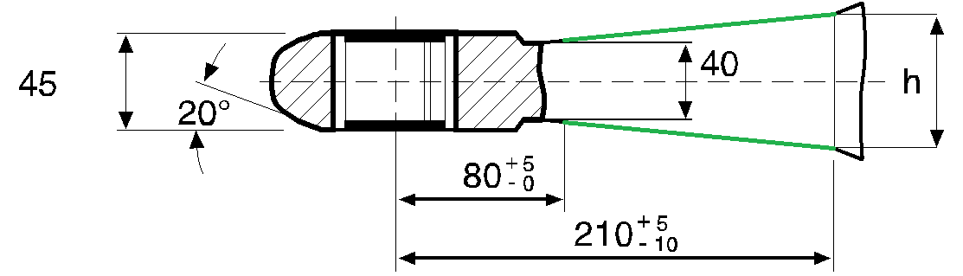 OK

Transitional provisions for the 02 series of amendments are proposed. The new 02 series of amendments would only be mandatory for D50-X drawbar eyes.
Example of an arrangement of the approval mark in the Annex 3 shall also be updated.

