Proposal for a Supplement to UN Regulation No. 151

The text reproduced below was prepared by the expert from VRU-Proxi Informal Working Group to clarify the elements to be considered for the determination of the vehicle front right corner in the UN Regulation No. 151. The modifications to the current text of UN Regulation No. 151 are marked in bold for new or strikethrough for deleted characters.

I. Proposal

Paragraph 2.16., amend to read:

“2.16. "Vehicle front right corner" means the projection of the point that results from the intersection of the vehicle side plane (not including devices for indirect vision) and the vehicle front plane (not including devices for indirect vision and any part of the vehicle which is more than 2.0 m above the ground) on the road surface.”

II. Justification

This proposal for amendment to “vehicle front right corner” aims at ensuring that the BSIS detection zone is not adversely affected by specific elements added at later stages of completion of the vehicle. Taking the example of a crane truck, since the crane boom of the truck protrudes from the front of the cab, the position of the vehicle front plane is changed from the standard vehicle.

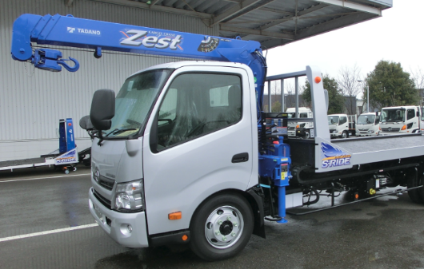
crane boom

