|  |  |  |  |
| --- | --- | --- | --- |
|  | United Nations | ECE/TRANS/WP.11/2021/12/Rev.1 | |
| United Nations logo | **Economic and Social Council** | | Distr.: General  10 February 2022  English  Original: French |

**Economic Commission for Europe**

Inland Transport Committee

**Working Party on the Transport of Perishable Foodstuffs**

**Seventy-eighth session**

**Geneva, 3–6 May 2022**

Item 6 of the provisional agenda

**ATP Handbook**

Amendments to paragraph 6 (c) (iii) of Annex 1, Appendix 1 of the ATP Handbook: Rules to be observed for the installation of mounted units, units with deflectors, under-frame units or units that can be offset

Transmitted by the Government of France

Revision 1

Introduction

1. Some refrigeration units may be installed in spaces reserved for them in the body or integrated into aerodynamic deflectors, or may have condensers mounted in the engine compartment or under the vehicle chassis.

2. Such installations may result in a reduction of expected performance owing to impeded airflow at the condenser inlet.

3. The ATP Handbook allows for the consideration of specific provisions and for clarification of the general cases defined in the annexes to the ATP Agreement.

I. Proposed amendment to the ATP Handbook

4. It is proposed to add to the ATP Handbook, in paragraph 6 (c) (iii) of Annex 1, Appendix 1, the following text:

*“The provisions below are intended to provide clarification for the installation of recessed units, units with deflectors, under-frame units or units that can be offset.”*

***Equipment concerned***

*Case No. 1: Standard production vans with integrated insulation and unit partially recessed in the roof:*

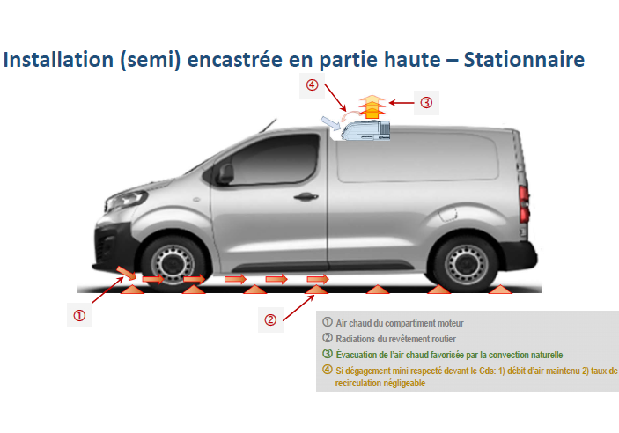

*Case No. 2: Standard production vans with integrated insulation and unit partially recessed in the roof, with a roof air deflector:*

**

*Case No. 3: Chassis cabs with front-mounted units and a deflector over the cab:*

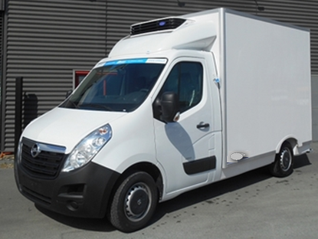

*Case No. 4 : Standard production vans with integrated insulation and the unit installed under the chassis or in the engine compartment:*

**

***Provisions to be applied by manufacturers of thermal appliances***

*The manufacturer shall specify:*

*- All the precautions to be taken during manufacture by the body manufacturer to ensure performance equivalent to that of the type test report.*

*- The minimum distances to be observed for bodywork components to ensure performance equivalent to that of the type test report.*

*The competent authority shall assess the steps taken by the manufacturer to ensure that all the scenarios and their impacts have been taken into account in order to ensure performance equivalent to that of the type test report.*

***Provisions to be applied by manufacturers of thermal appliances***

*The body manufacturer must respect the recommendations made by the manufacturer of the thermal appliance.* *The installation of the unit shall, where appropriate, be subject to formal validation by the thermal appliance manufacturer if at least one of the requirements defined by the thermal appliance manufacturer calls into question the performance of the unit.*

*Mandatory safety features shall not serve as grounds for dispensation from the specifications established by the thermal appliance manufacturer.* *Furthermore, the installation of the unit shall not call into question the vehicle’s conformity with regulatory and normative provisions other than those referred to in this note.*

***Provisions to be applied by fitters of thermal appliances***

*The fitter of the thermal appliance shall comply with the fitting instructions established by the manufacturer of the thermal appliance, which may be amended by the body manufacturer in accordance with the provisions of the preceding paragraph.*

*Any other modifications must be formally validated by the thermal appliance manufacturer.*

***Specific provisions to be applied for fitting recessed thermal appliances (cases Nos. 1 to 3)***

*Case No. 1*

*The installation instructions must specify that:*

*- A minimum distance must be maintained between the walls of the recessed drip basin and the air inlet of the condenser;*

*- A maximum depth of the drip basin must be ensured.* *The drip basin must not be deeper than the maximum height of the unit’s condenser.*

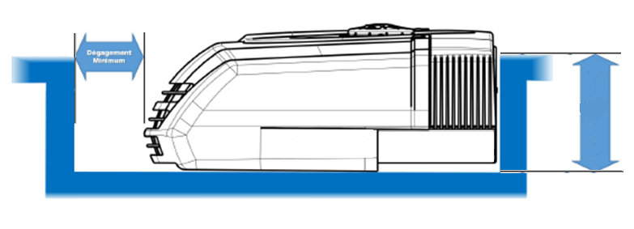

*Case No. 2*

*The installation instructions must specify that:*

*- In addition to the conditions required for case No. 1, and in cases where a deflector has been added, a minimum free area must be ensured for the air flow at the inlet and outlet of the condenser.* *It should be specified that the unit and the cover should be installed so that they are flush.*

*Case No. 3*

*The installation instructions must specify that:*

*- The deflector shall, if necessary, be cut to allow for the circulation of an air flow to and from the condenser.* *The minimum free area must be ensured to allow for the air flow in and out of the condenser.*

**

II. Impact

5. This amendment specifies the good practices to be followed in the design of equipment equipped with such appliances.