INF.3
Economic Commission for Europe  Inland Transport Committee  Working Party on the Transport of Perishable Foodstuffs  Seventy-eighth session  Geneva, 3-6 May 2022  Item 3 (c) of the provisional agenda  Activities of other international organizations dealing  with issues of interest to the Working Party:  standardization organizations | 27 April 2022  English

Liaison with ISO TC 315
Transmitted by Tranfrigoroute International on behalf of the ISO liaison representatives
Summary
Executive summary: Report of liaison with ISO TC315
Action to be taken: Information only.
Related documents: NA.
Introduction
1. Back in 2021, a new ISO Technical Committee (TC) has been established with the intent to deal with Cold chain logistics.
2. It has been discussed that a liaison between WP 11 and this new TC 315 would be beneficial for both.
3. In April 2022, a liaison between UNECE and ISO/TC 315 has been officially approved
4. Accordingly, Yan Zhang (UNECE); Alibech Mireles Diaz (UNECE) and Lionel Pourcheresse (AFNOR expert) have been registered as a liaison representatives from UNECE to TC 315 in the ISO database (ISO Global Directory).
About ISO/TC 315
Title: Cold chain logistics
Scope: Standardization in the field of cold chain logistics. The scope will include, but is not limited to:
- terms and conditions for carriage/storage service of refrigerated goods, physical handling of refrigerated goods (acceptance, loading, trans-shipment, storage, sorting, transportation and delivery),
- maintenance and control methods of temperature-controlled facilities, quality control methods throughout the cold chain (e.g. temperature monitoring and control, prevention of damage, loss and delay),
- hygiene management during carriage/storage service to prevent contamination of goods,
- facilitation of logistical efficiency
- manpower management, staff education and training, safety management for staff and workplaces,
- safety and reliability of carriage/storage services,
- information management and data processing such as customer management and
- cargo/parcel tracking (including labelling), as well as terminology.
Excluded: Standardization covered by ISO/TC 34 (Food products), ISO/TC 34 /SC 17 (Management systems for food safety), ISO/TC 86 (Refrigeration and air conditioning), ISO/TC104 (Freight containers), ISO/TC 122 (Packaging), ISO/TC 234 (Fishery and aquaculture), ISO/TC 276 (Biotechnology), ISO/TC 283 (Occupational health and safety management) and ISO/TC 304 (Healthcare organization management).
Secretariat: JISC (Japan)
Chair: Dr. Toshinori NEMOTO
Committee manager: Ms. Yukiko MIZUNO

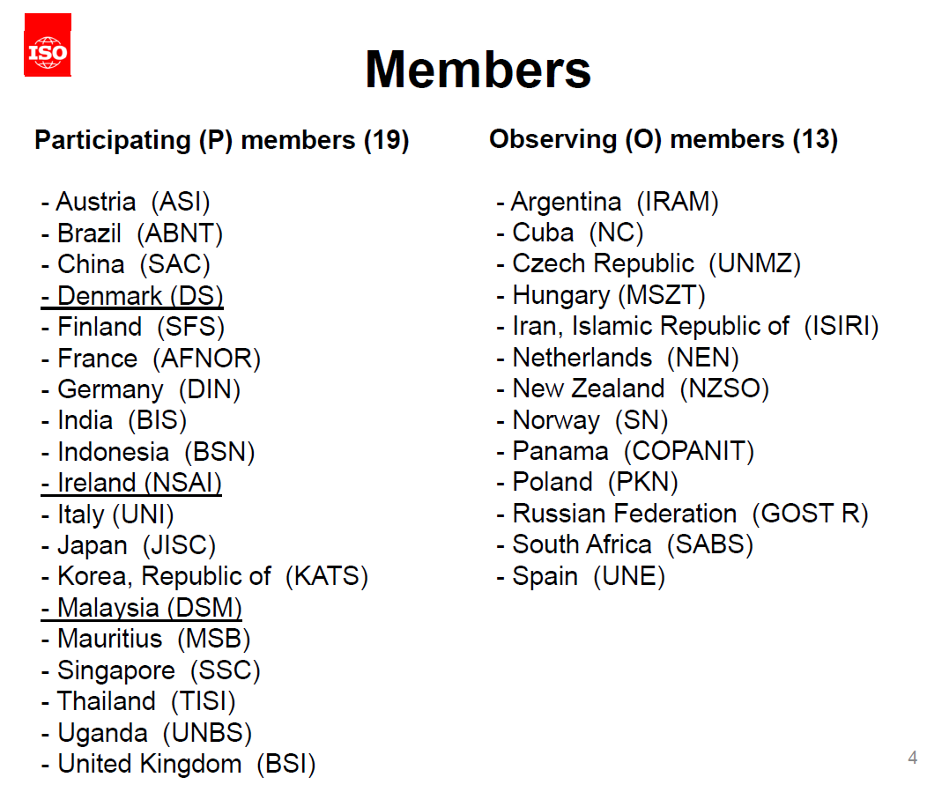
Updates from the last plenary
1. Title and scope (CIB 01/2021)
TC 315 title and scope which were agreed at the first TC plenary was confirmed.
2. Projects (NP ballots)
Two NPs were submitted and approved:
- "Contactless delivery"
- "Services between businesses – Storage and transport"
3. Working groups (CIB 02, 03, 04 and 05)
Two working groups were proposed and approved:
- WG2 “Contactless delivery” (Convenor: Ms. Xianghua Zhu)
- WG3 “Services between businesses – Storage and transport” (Convenor: Mr. Takayuki Mori)

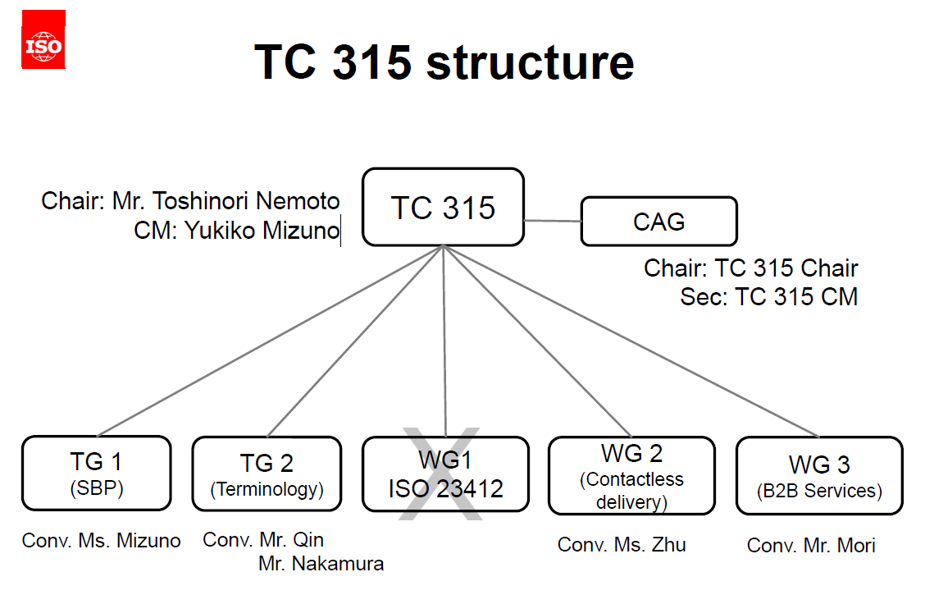

More information: https://www.iso.org/committee/6880159.html

