|  |  |  |  |
| --- | --- | --- | --- |
|  | United Nations | ECE/TRANS/2024/4 | |
| _unlogo | **Economic and Social Council** | | Distr.: General  11 December 2023  Original: English |

**Economic Commission for Europe**

Inland Transport Committee

**Eighty-sixth session**

Geneva, 20-23 February 2024

Item 4 of the provisional agenda

**Meeting on the adoption of the  
Inland Transport Committee Strategy for Reducing  
Greenhouse Gas Emissions from Inland Transport  
for Government Delegates only with the Participation  
of the Chairs of the Committee’s Subsidiary Bodies**

In-depth Report on Inland Transport and Climate Change, Part 1: Getting towards net zero – Status, Projections and Greenhouse Gas Emissions Trends

Note by the secretariat[[1]](#footnote-2)\*

|  |
| --- |
| *Summary* |
| Two in-depth reports have been prepared by the secretariat with the support of an external consultant (Nikola Medimorec) as background material to the draft Inland Transport Committee strategy to reduce Greenhouse gas (GHG) emissions from in land transport.  This first in-depth report looks, in the first part, at the past and present contribution of inland transport to GHG emissions, globally and regionally in overall GHG emission from the transport sector, and the impact that the COVID pandemic has had on the GHG emissions.  In a second part, it analyses some of most prominent forward looking GHG emissions projections for the transport sector, and some possible pathways to achieve the goals of the Paris Agreement.  In its final part, this in-depth report takes stock of high profile activities that have recently emerged at the international level, highlighting the potential role of partnerships, international financial institutions and the private sector could play to help support the decarbonization of the inland transport sector. |
|  |

I. Inland Transport’s Contribution to Climate Change

A. Current Global Situation of Transport-based Greenhouse Gas Emissions

1. The world has exceeded 1.2°C of global warming since the start of the industrial era, with each decade registering higher temperatures than the preceding one.[[2]](#footnote-3) So far, in every year of the 21st century, the global average temperature has been at least 0.5°C above the average of 1951-1980, with 2016 and 2020 surpassing 1.0°C above the average.[[3]](#footnote-4)

2. Global fossil CO2 emissions exceeded 37.4 gigatonnes in 2019, dropped by 2 gigatonnes to reach 35.5 gigatonnes in 2020 and rebounded to 37.6 gigatonnes in 2021 and recorded a new all-time high with 38.1 gigatonnes in 2022.[[4]](#footnote-5) The transport sector was the second largest emitting sector after the power industry (power industry excluding “other sectors”[[5]](#footnote-6)) and accounted for 20.7 per cent of global fossil CO2 emissions in 2022. It decreased slightly from 21.9 per cent in 2019.[[6]](#footnote-7)

3. Between 2010 and 2019, CO2 emissions from the transport sector increased by 18 per cent, with an average annual increase of 2.1 per cent. This was the fastest growth in CO2 emissions among combustion sectors globally. In 2020, transport again experienced the greatest emission decline among combustion sectors, after falling by 14.2 per cent as a result of the impacts of the COVID-19 pandemic. This decline reduced transport emissions to 2011 levels at 7.05 gigatonnes. Transport emissions nearly completely recovered, rising to 7.5 gigatonnes of CO2 in 2021 and 7.9 gigatonnes in 2022, recording for both years the strongest annual CO2 emission growth (see Figure I).[[7]](#footnote-8)

Figure I

**Changes in CO2 emissions by sector, 2010 to 2022**

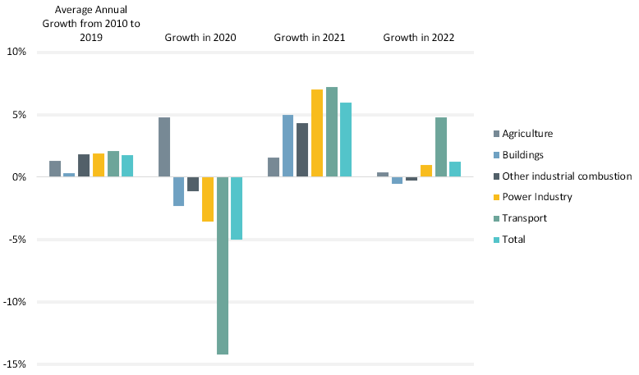

4. The transport sector is not on track to achieve its global climate and sustainability goals. Drastic reductions in transport emissions and improved access to integrated transport systems worldwide are urgently required to achieve decarbonised pathways.[[8]](#footnote-9) Doing this will require not only adequate investments in transport adaptation and resilience, but also the repurposing of funds currently going into fossil fuel subsidies as well as an acceleration of investments aimed at achieving transport system transformation.[[9]](#footnote-10)

5. In 2023 – the halfway point between the 2015 adoption of the United Nations Sustainable Development Goals and their target year of 2030 – it was estimated that none of the 17 Sustainable Development Goals would be met in their entirety, and that only 12 per cent of the Sustainable Development Goal targets would be achieved. This includes several Sustainable Development Goals related to the transport sector, such as Sustainable Development Goal 3 (good health and well-being), Sustainable Development Goal 7 (affordable and clean energy), Sustainable Development Goal 9 (industry, innovation and infrastructure), Sustainable Development Goal 11 (sustainable cities and communities) and Sustainable Development Goal 13 (climate action). Efforts to achieve a just energy transition have also seen little progress, despite being increasingly acknowledged at the global level.[[10]](#footnote-11)

6. In addition to the climate crisis, the world experienced significant challenges and major crises during 2021 and 2022, including the impacts of the COVID-19 pandemic and border conflicts; this was followed by global economic downturn, further disruption of supply chains and the ongoing energy crisis.[[11]](#footnote-12)

7. These events have made transport and mobility systems more vulnerable to systemic shocks. Natural hazards, extreme weather events and rising sea levels pose a substantial threat to both transport systems and people’s livelihoods. However, these effects are expected to increase due to climate change which greatly increases the vulnerability of populations as well as transport systems.Beyond the often-heavy human toll, extreme weather events can also have severe impacts on transport-related infrastructure. More than a quarter of the world’s road and rail assets are exposed to at least one cyclone, earthquake or flooding hazard annually.[[12]](#footnote-13) Natural hazards contribute to huge financial losses, leading to an estimated USD 15 billion annually in direct damage to transport systems worldwide. Of this damage, an estimated USD 8 billion occurs in low- and middle-income countries, which experience the highest costs relative to their GDP.[[13]](#footnote-14)

B. Inland Transport Situation

8. During 2010-2019, the transport sector experienced the fastest growth in CO2 emissions among combustion sectors globally, rising 2.1 per cent annually on average and 18 per cent overall.[[14]](#footnote-15) Inland transport was responsible for a growing share of CO2 emissions from fuel combustion. The share of inland transport in total transport CO2 emissions was between 77 per cent and 78 per cent in 1990, 2000 and from 2010 to 2019, then inland transport recorded an 81 per cent share in 2020 and 80 per cent in 2021.[[15]](#footnote-16)

Figure II

**Development of inland transport’s share in total transport emissions in 2000, 2015 and 2021**

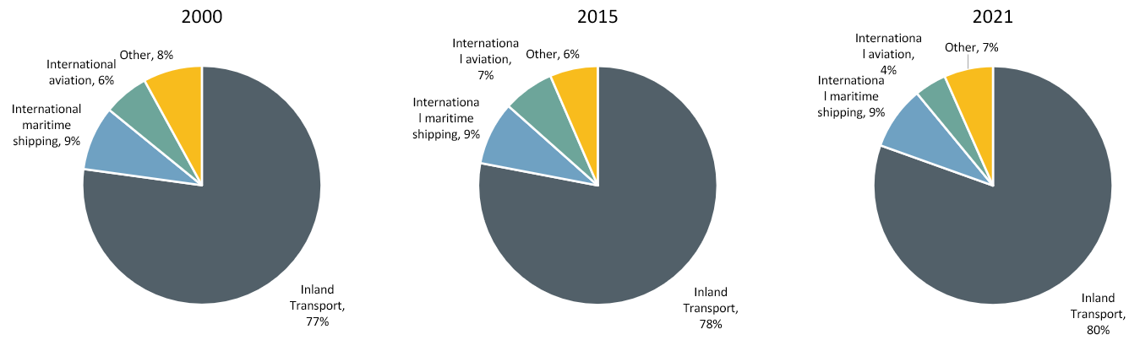

9. Emissions from freight transport (all modes considered) represent a growing share of transport emissions. As of 2019, freight accounted for 42 per cent of global transport CO2 emissions and passenger transport accounted for 58 per cent.[[16]](#footnote-17) Inland transport is estimated to account for 30 per cent of freight activity (41 of 139 trillion tonne-km) but it represented 74 per cent of freight transport emission in 2019. The picture is the opposite for passenger transport: inland transport is estimated to account for 92 per cent of passenger activity (41 out of 44.4 trillion passenger-km) in 2020, and it accounted for 83 per cent of passenger transport CO2 emissions in 2019.[[17]](#footnote-18)

10. With respect to air pollution, inland transport contributes 5 per cent of the mortality from fine particulate matter (PM2.5) globally, while there are important regional differences.[[18]](#footnote-19)

C. Emissions by Income Country Groups

11. Globally, the gap in transport CO2 emissions between the 38 member countries of the Organisation for Economic Co-operation and Development (OECD) and the 160 non-OECD countries has nearly closed, with OECD countries contributing 51.5 per cent of transport emissions in 2022. However, looking at the different income groupings, high-income countries were responsible for 51.3 per cent of transport CO2 emissions, while low-income countries contributed less than 1 per cent in 2022[[19]](#footnote-20). Per capita transport CO2 emissions totalled 2.9 tonnes in high-income countries, 0.50 tonnes in middle-income countries and 0.07 tonnes in low-income countries in the same year (see Figure III). Per capita transport CO2 emissions have doubled in middle-income countries since 1980, while barely changing in low-income countries.[[20]](#footnote-21)

12. Examining income inequalities further on an individual basis, the top 1 per cent of individual emitters globally contribute more than 1,000 times the CO2 emissions of the bottom 1 per cent, with the highest disparities being experienced in transport. In the case of North America, road transport makes up as much as one-quarter of the CO2 emissions from the richest income group.[[21]](#footnote-22)

Figure III

**Per capita transport CO2 emissions versus per capita gross domestic product, by country grouping, 2021**

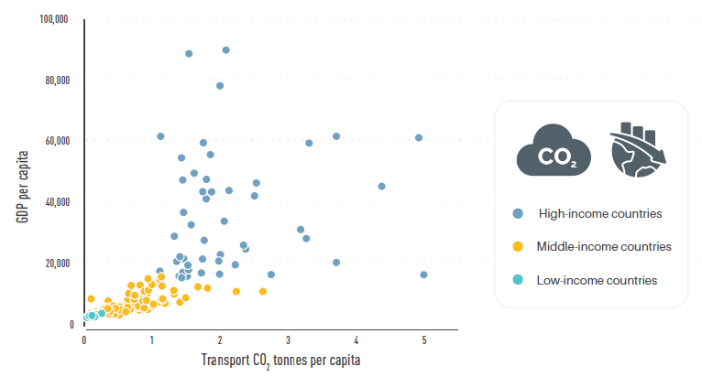

D. Regional Situation

13. Regions contribute differently to transport CO2 emission growth (see Figure IV). During 2010-2022, Africa experienced the highest growth in transport CO2 emissions among regions, at 49.8 per cent, followed by Asia at 38.9 per cent. However, Africa’s absolute transport CO2 emissions of 387 million tonnes were the second lowest regionally, after Oceania’s, in 2022. Latin America and the Caribbean recorded a 17 per cent growth during the same period. Transport CO2 emissions fell 4 per cent in Europe between 2010 and 2022.[[22]](#footnote-23)

14. Among the regions, Latin America and the Caribbean witnessed the strongest drop of transport CO2 emissions with a decrease of 16.4 per cent from 2019 to 2020 due to the COVID-19 pandemic. North America and Europe saw reductions of 14.1 per cent and 13.2 per cent, respectively. All regions, except Asia and Europe, surpassed latest by 2022 the pre-COVID-19 pandemic transport CO2 emission levels of 2019.

Figure IV

**Regional growth in transport CO2 emissions**

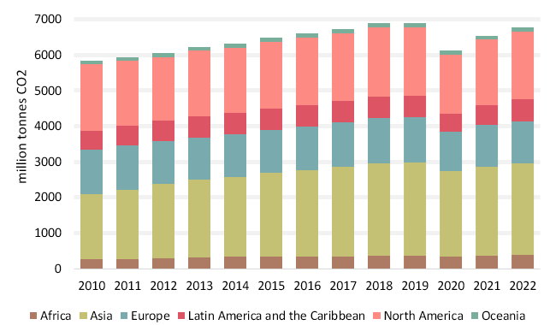

1. Africa Regional Trends

15. Transport contributed over one-quarter (26 per cent) of total CO2 emissions in Africa in 2022. The region’s transport CO2 emissions increased by nearly 50 per cent between 2010 and 2022, the highest growth among all regions. However, the region’s per capita transport CO2 emissions overall are 3.4 times below the global average of 0.86 tonnes per capita. Africa’s transport CO2 emissions reduced by 8.2 per cent in 2020 but rebounded by 9.1 per cent in 2021.[[23]](#footnote-24)

* Total transport CO2 emissions (2022): 387 million tonnes
* Share of global transport CO2 emissions (2022): 5.7 per cent
* Per capita transport CO2 emissions (2022): 0.27 tonnes
* Transport CO2 emissions per USD 10,000 GDP (2022): 1.37 tonnes

16. Between 2016 and 2020, Africa’s motorisation rate was 43 vehicles per 1,000 people, around 4.6 times below the global average. Africa accounts for less than 1 per cent of global vehicle production. Africa imported the largest share (40 per cent) of used vehicles among all regions from 2015 to 2018. In most African countries, used vehicles account for 85-100 per cent of fleets.

17. Road freight carries at least 80 per cent of goods in Africa. Ports, rail and air freight remain limited due to lack of capacity, technology and high costs.

2. Asia Regional Trends

18. Asia continued to have the highest transport-related CO2 emissions among world regions – reaching 2,560 million tonnes in 2022 and the second-highest transport emissions growth, at 39 per cent during 2010 to 2022. Per capita transport CO2 emissions in Asia averaged 0.54 tonnes in 2021, the second lowest level after Africa. China remained the largest emitter of transport CO2 in Asia – contributing 34 per cent of the region’s total in 2022 – and was the second highest emitter globally, followed by India, although Persian Gulf countries still dominated per capita transport emissions.[[24]](#footnote-25)

* Total transport CO2 emissions (2022): 2,560 million tonnes
* Share of global transport CO2 emissions (2022): 38 per cent
* Per capita transport CO2 emissions (2022): 0.55 tonnes
* Transport CO2 emissions per USD 10,000 GDP (2022): 0.75 tonnes

19. Asia recorded soaring motorisation growth with increases of more than 200 per cent in some countries during 2010–2019 – as well as significant growth in two- and three-wheelers.

20. Air pollution caused 6.5 million deaths globally in 2019, with 70 per cent of the fatalities occurring in the Asia-Pacific region.[[25]](#footnote-26)

3. Europe Regional Trends

21. The transport sector contributed 22 per cent of economy-wide CO2 emissions in Europe in 2022. Europe contributed 17.6 per cent of the world’s transport CO2 emissions in 2022 (excluding international aviation and shipping), the third largest regional share after Asia and North America.[[26]](#footnote-27)

* Total transport CO2 emissions (2022): 1,197 million tonnes
* Share of global transport CO2 emissions (2022): 17.6 per cent
* Per capita transport CO2 emissions (2022): 1.60 tonnes
* Transport CO2 emissions per USD 10,000 GDP (2022): 0.56 tonnes

22. Passenger cars accounted for 85 per cent of the travel activity in the European Union (EU) in 2021.[[27]](#footnote-28) The average motorisation rate for the region was 554 vehicles per 1,000 people, well above the global average of 196 vehicles per 1,000 people.[[28]](#footnote-29)

4. Latin America and the Caribbean regional trends

23. In 2022, transport CO2 emissions in Latin America and the Caribbean contributed around 33 per cent of overall regional CO2 emissions and 9.2 per cent of global transport emissions (excluding international aviation and shipping). Average per capita transport CO2 emissions in the region were 0.95 tonnes, close to the global average of 0.86 tonnes in 2022.

* Total transport CO2 emissions (2022): 623.7 million tonnes
* Share of global transport CO2 emissions (2022): 9.2 per cent
* Per capita transport CO2 emissions (2022): 0.95 tonnes
* Transport CO2 emissions per USD 10,000 GDP (2022): 1.17 tonnes

24. Road transport dominates freight transport in the region. A 2021 study found that in South America trucks account for around 85 per cent of national and 30 per cent of regional freight transport and logistics, and in Central America road transport accounts for nearly 100 per cent of freight transport.[[29]](#footnote-30)

25. The average motorisation rate in Latin America and the Caribbean was 267 vehicles per 1,000 people (recent data from 2016 to 2020), or 1.35 times higher than the global average of 197 vehicles per 1,000 people. Nearly half of all countries in the region had motorisation rates above the global average during this period.[[30]](#footnote-31)

5. North America Trends

26. In 2022, North America contributed 28 per cent of global transport CO2 emissions (excluding international aviation and shipping), the second highest regional share after Asia. Despite the high absolute transport emission levels, a 2 per cent growth was recorded from 2010 to 2022. The region has per capita transport CO2 emissions exceeding 5 tonnes in 2022.[[31]](#footnote-32)

* Total transport CO2 emissions (2022): 1,899 million tonnes
* Share of global transport CO2 emissions (2022): 28 per cent
* Per capita transport CO2 emissions (2022): 5.05 tonnes
* Transport CO2 emissions per USD 10,000 GDP (2022): 0.83 tonnes

27. This was following the COVID-19 pandemic which changed North America’s overall CO2 emissions trajectory from a 5 per cent increase in transport CO2 emissions between 2010 and 2019 to a 7 per cent decline between 2019 and 2021. Road transport was the major contributor to emission growth in Canada until 2019, but it experienced the greatest decline in 2020.

28. The region’s motorisation levels have remained at an all-time high. The motorisation rate of North America is 4 times the global average and 18 times higher than in Africa. Canada had a motorisation rate of 656 vehicles per 1,000 people in 2019, and the US rate was even higher, at 807 vehicles per 1,000 people in 2020.[[32]](#footnote-33)

29. Transport emissions shifting from passenger to freight transport, in the USA the share of emissions from light-duty vehicles fell from 60 per cent to 57 per cent from 2015 to 2020, while that from medium- and heavy-duty trucks grew from 23 per cent to 26 per cent.

6. Oceania Trends

30. Oceania remained the lowest emitter of transport CO2 emissions (excluding international aviation and shipping) among world regions in 2022, contributing less than 2 per cent of transport emissions globally. However, the region has the second highest per capita transport CO2 emissions after North America. Transport CO2 emissions in the region grew relatively steadily during 2010-2019, with 14 per cent overall growth, then fell 9 per cent in 2020 due to the decline in transport activity during the COVID-19 pandemic, before increasing 1.4 per cent in 2021 and 8 per cent in 2022 to reach emissions levels of 2019.

* Total transport CO2 emissions (2022): 120 million tonnes
* Share of global transport CO2 emissions (2022): 1.8 per cent
* Per capita transport CO2 emissions (2022): 2.74 tonnes
* Transport CO2 per USD 10,000 (2022): 0.65 tonnes

31. The region shows dominance of private vehicles despite high access to public transport: In Australia, 87 per cent of work commutes in 2021 were by drivers or passengers of a car, motorcycle, or truck. Australia and New Zealand maintained the region’s highest motorisation levels, 4 times of global average. Only 5 per cent were by walking or cycling and 7 per cent by public transport.

II. Projections and Trends in Transport-related Greenhouse Gas Emissions

A. Business-as-usual Transport Greenhouse Gas Emission Projections

32. Under the business-as-usual scenario, transport CO2 emissions could grow 16-50 per cent by 2050.[[33]](#footnote-34) Comparing the business-as-usual scenario under current policies to the upper end of IPCC’s 1.5°C projections shows an emission gap of 5.8 gigatonnes CO2 by 2050 (see Figure V). Global freight activity is projected to double between 2019 and 2050, which could mean that CO₂ emissions from freight transport would be 22 per cent higher in 2050 than in 2015, with rising demand for deliveries and transport of goods, longer supply chains, and lacking regulations in support of efficiency improvements.[[34]](#footnote-35) Freight could represent 61 per cent of transport CO2 emissions by 2050.[[35]](#footnote-36) The global passenger car fleet is projected to reach between 1.4 billion and 1.55 billion vehicles by 2050, up from nearly 1.2 billion vehicles in 2020, with most of the expected growth occurring in developing countries.[[36]](#footnote-37)

Figure V

**Future transport CO2 emissions under current policies and IPCC’s 1.5°C scenario[[37]](#footnote-38)**

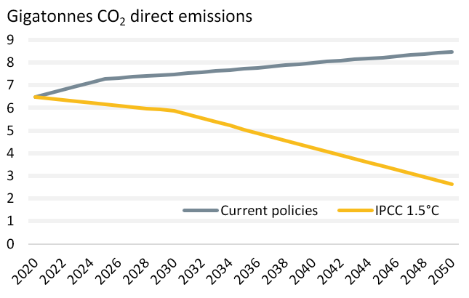

33. Inland transport’s freight activity could grow from 41.2 trillion tonne-km to 93.6 trillion tonne-km by 2050, while its CO2 emissions would grow 10 per cent. The emission increase among the inland transport modes will be mostly completely recorded by non-urban road freight.[[38]](#footnote-39)

34. In Asia, the largest regional emitter in 2019, it is estimated that the transport CO2 emissions could grow 1.5 per cent annually until 2030, with the share of freight emissions rising from 48 per cent in 2000 to 57 per cent in 2030.[[39]](#footnote-40)

35. Under current policies, urban transport emissions would decrease slightly, by 5 per cent.[[40]](#footnote-41) The current economy-wide policies announced or implemented by national governments will still lead to average global temperature rise of 2.8°C by 2100. Achieving unconditional and conditional targets set in NDCs would reduce this to 2.6°C and 2.4°C respectively.[[41]](#footnote-42)

B. Decarbonization Pathways for Transport

36. Under the decarbonization pathway to limit global warming to 1.5°C (with no or limited overshoot), total economy-wide greenhouse gas emissions need to peak before 2025. In order to limit warming to 1.5°C, net zero CO2 emissions are required by 2050. For pathways limiting warming to 2°C, net zero CO2 emissions are required in the early 2070s.

37. Recent transport projections indicate a need to reduce transport CO2 emissions to a range between 0.4 to 2.9 gigatonnes CO2 by 2050:

* International Transport Forum (ITF) Transport Outlook ‘High Ambition’ scenario: 1.6 gigatonnes[[42]](#footnote-43)
* IEA Net Zero Scenarios (2023 update): 0.58 gigatonnes[[43]](#footnote-44)
* IPCC Sixth Assessment Report scenarios for 1.5°C: between 0.7 and 2.9 gigatonnes[[44]](#footnote-45)
* International Renewable Energy Agency (IRENA) pathway: 0.4 gigatonnes[[45]](#footnote-46)

38. The major difference between these transport decarbonisation projections is that they are based on different assumptions and for each projection transport contributes differently to the overall economy-wide decarbonisation pathways. For example, in the IPCC Sixth Assessment Report, other sectors are expected to contribute to emission reductions significantly more than the transport sector. Carbon capture levels differ among the different scenarios. Projections staying within the carbon budget for limiting warming to 1.5°C will require drastic and immediate greenhouse gas emission reductions.

39. According to the IPCC Sixth Assessment Report, achieving low-carbon transport pathways that limit global warming to 1.5°C (with no or limited overshoot) will require at least a 59 per cent reduction in transport-related CO2 emissions by 2050, compared to 2020 levels.[[46]](#footnote-47)

40. In IEA’s net zero scenarios, a 90 per cent drop in transport CO2 emissions (below 2020 levels) is required by 2050. Among the major inland transport modes, CO2 emissions must be reduced by more than 88 per cent for heavy-duty trucks and rail, 93 per cent for two-/three-wheelers and other road vehicles and 97 per cent for light-duty vehicles compared to 2020 levels (see Figure VI).*[[47]](#footnote-48)*

Figure VI

**Global transport CO2 emission trajectories by mode, 2020-2050[[48]](#footnote-49)**

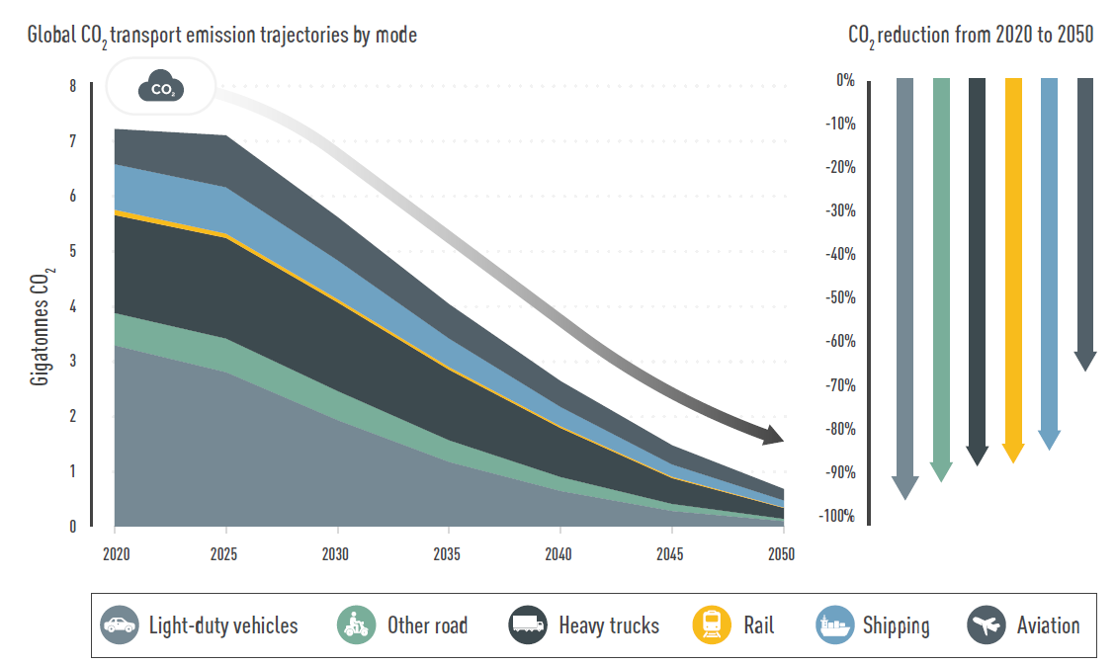

41. The IEA Net Zero emissions roadmap for transport also provides some target milestones for 2030, 2035 and 2050. These are heavily reliant on electrification and the use of biofuels, with electricity representing three-quarters of energy consumption in road transport in 2050 (see Table 1).

# Table 1

**Milestones towards net zero inland transport emissions, according to the IEA Net Zero Scenario (compilation of 2021 publication and 2023 update)**[[49]](#footnote-50)

| *2030* | *2035* | *2050* |
| --- | --- | --- |
|  |  |  |
| - 65 per cent of rail is electric  - 78 per cent of global car sales are battery-electric, plug-in hybrid or fuel cell electric  - 56 per cent of buses sold are plug-in hybrid, battery and fuel cell electric  - 20 per cent of road transport energy consumption from alternative fuels (biofuels, electricity and hydrogen) | - 65 per cent of heavy truck sales are battery-electric, plug-in hybrid or fuel cell electric  - No new internal combustion engine cars, vans and two-/ three-wheelers are sold after 2035  - 22 per cent of road transport energy is sourced from electricity | - Passenger rail nearly doubles its share of total transport activity, to 20 per cent  - All heavy trucks and buses sold are battery-electric, plug-in hybrid or fuel cell electric  - Electricity represents 75 per cent of energy consumption in road transport |

42. Freight transport emissions could be reduced 76 per cent below 2020 levels by 2050 with policies that support higher operational efficiencies, optimised routing and asset sharing, freight consolidation, enhanced collaboration in supply chains, shift to railways or inland waterways, standardisation and low-carbon solutions.[[50]](#footnote-51) Ambitious actions on urban passenger transport can reduce emissions more than 80 per cent below 2019 levels by 2050.[[51]](#footnote-52)

C. Decarbonization Pathways for the Different Regions

43. Recent projections have shown that transport emissions in Asia deviated from pre-2015 projections, which had predicted a near-doubling in business-as-usual emissions between 2021 and 2050. On the contrary, emissions were lower during the period 2015-2020 due to average fuel efficiency improvements, progress in electrification and other policies. Even so, at the growth rate of 2021, the region’s transport emissions would not peak before 2050, whereas a net zero emissions pathway or a pathway consistent with keeping global temperature rise below 1.5°C would require emissions to peak by 2025.[[52]](#footnote-53)

44. Based on measures planned or in place as of October 2022, total transport emissions in the EU were projected to fall below 1990 levels by 2029. In this scenario, only road transport emissions, representing 77 per cent of the EU’s transport greenhouse gas emissions, would decline until 2030. Emissions from other modes would either remain stable or increase, particularly aviation.[[53]](#footnote-54)

45. According to the synthesis of models by the IPCC, regions would contribute differently to transport decarbonisation. Stronger transport CO2 emission mitigation levels are expected in high-income countries in Europe and North America than in low- and middle-income countries:[[54]](#footnote-55)

* Western Europe and North America need to reduce transport CO2 emissions by at least 60 per cent below 2020 levels by 2050 to be aligned with the 2°C scenario and at least 80 per cent by 2050 to be aligned with the 1.5°C scenario with low overshoot.
* Eastern Europe, Western Asia and Central Asia could achieve reductions of 50 per cent below 2020 levels by 2050 for the 2°C scenario and 75 per cent for the 1.5°C scenario with low overshoot.
* Asia and the Pacific would register reduction levels of transport CO2 emissions 50 per cent below 2020 levels by 2050 for the 1.5°C scenario with low overshoot.
* Latin America and the Caribbean would be expected to reduce emissions by 30 per cent below 2020 levels by 2050 for the 2°C scenario, and 75 per cent for the 1.5°C scenario with low overshoot.
* The Middle East would reduce their GHG emissions by 20 per cent by 2050 for the 2°C scenario and 55 per cent for the 1.5°C scenario with low overshoot.
* African countries would be able to increase their transport CO2 emissions 20 per cent by 2030 and then be required to reduce emissions by at least 10 per cent below 2020 levels by 2050.

Figure VII

**Regional transport decarbonisation pathways for 2030 and 2050, by scenario**[[55]](#footnote-56)

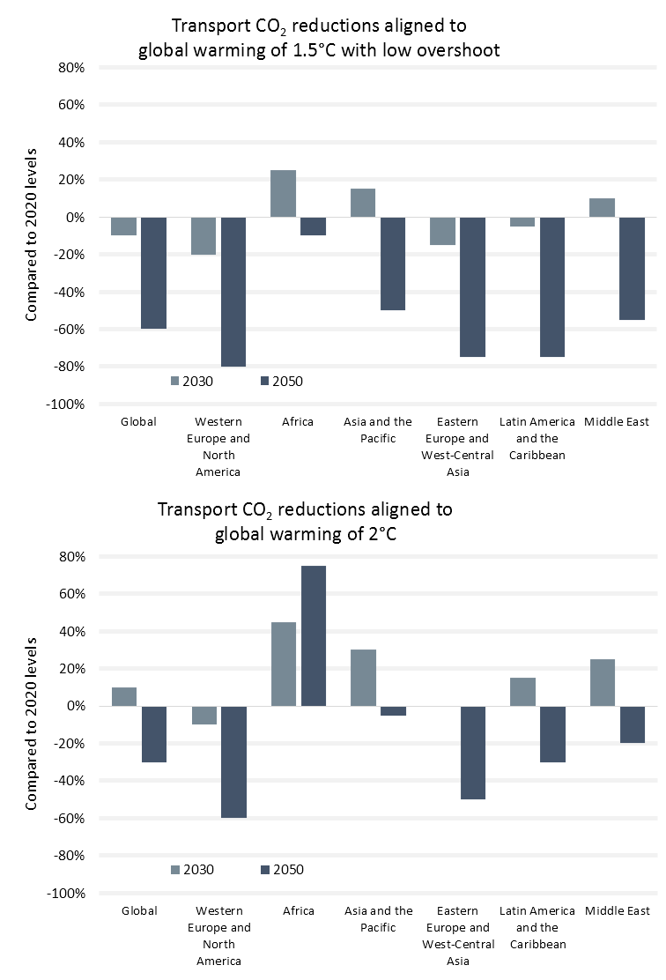

III. International actions, commitments and initiatives towards Inland Transport Decarbonization

A. Taking Stock of International initiatives and the potential role of the United Nations

46. During the 2021 United Nations Climate Change Conference in Glasgow, United Kingdom (COP26), stakeholders launched an unprecedented number of commitments and initiatives on sustainable, low-carbon transport (i.e., zero-emission passenger and freight vehicles, shipping, aviation), and several of these have since expanded in scope and/or signatories. The Glasgow Climate Pact, agreed to COP26, makes a clear call for countries to phase out inefficient fossil fuel subsidies and to support a just transition towards low-emission energy systems.[[56]](#footnote-57)

47. At the 2022 United Nations Climate Change Conference in Sharm El-Sheikh, Egypt (COP27), the COP27 Presidency of Egypt launched the initiative ‘Low Carbon Transport for Urban Sustainability’ (LOTUS) that aims to activate systemic change beyond the legacy “mode-first” mindset of focusing on a specific transport modes and the “Improve” pillar.

1. Overview of some of the most relevant inland transport-related initiatives announced during COP26 and COP27

# Table 2

**Main Inland transport-related initiatives announced during COP26 and COP27**

|  | *Mission* | *Number of total signatories as of October 2023* | *Geographic coverage* | *Mode focus* |
| --- | --- | --- | --- | --- |
|  |  |  |  |  |
| [**Accelerating to Zero Coalition (A2Z)**](https://acceleratingtozero.org/signatories-views/) | All sales of new cars and vans being zero emission in leading markets no later than 2035 and globally by 2040 | 178 signatories | Global | Cars and vans |
| [**Breakthrough Agenda on Transport**](https://racetozero.unfccc.int/system/breakthroughs/) | BEV (Battery Electric Vehicle) and FCEV (Fuel Cell Electric Vehicle) make up 60 per cent of global bus sales by 2030  BEV and FCEV makes up 35-40 per cent of global heavy goods vehicles sales by 2030  zero-emission vehicle (ZEV) makes up 100 per cent of total global passenger vehicles and vans sales by 2030 (in key markets) | 49 signatories | Global | All vehicles |
| [**Global Memorandum of Understanding on Zero-Emission Medium- and Heavy-Duty Vehicles**](https://globaldrivetozero.org/mou-nations/) | Leading countries to target 100 per cent zero-emission truck and bus sales by 2040, interim goal is 30 per cent zero-emission vehicle sales by 2030. | 27 signatories | Global | Medium- and heavy-duty vehicles |
| [**Low Carbon Transport for Urban Sustainability (LOTUS)**](https://cop27.eg/assets/files/initiatives/LOTUS-BR-01-EGY-10-22-EN.pdf) | Scale up investments for electric vehicles and sustainable mobility infrastructure  Empower and invest in informal transportation to decarbonise, mobilise towards Sustainable Development Goal 11, achieve climate resilience and develop a global agenda for a just transition and transformation  Build capacity to develop integrated, multimodal policy frameworks in low- and middle-income countries | Not available | LMICs | Urban Transport |

48. Non-legally binding commitments, such as the COP26 and COP27 initiatives, made in parallel to formal COP negotiations can encourage multi-stakeholder action towards the implementation of the Paris Agreement. These initiatives can be supported through monitoring, review and verification mechanisms by the UNFCCC and an enhanced alignment of these commitments to the NDCs of signatory countries. As of the end of 2022, the NDCs of signatory countries continued lacking explicit references to the transport commitments they signed to on the occasion of COP26. There is still weak alignment between the NDCs of signatory countries and the transport commitments and initiatives launched on the occasion of COP26 and COP27 that they signed to.[[57]](#footnote-58)

2. Breakthrough Agenda on Road Transport

49. The Breakthrough Agenda was initiated by the United Kingdom COP26 Presidency under the joint stewardship of Mission Innovation and Clean Energy Ministerial from COP27 onwards and the backing of the United Nations High Level Champions.[[58]](#footnote-59) The Breakthrough Agenda has the overarching mission to make clean technologies and sustainable solutions the most affordable, accessible and attractive options before 2030.[[59]](#footnote-60) In road transport it means that battery-electric and fuel cell electric vehicles across all modes are expected to represent a substantive share of sales. The Road Breakthrough Agenda is concerned with long-term vision, finance and investment, supply chains, infrastructure and trade conditions. At COP27, the countries which are part of the Road Transport Breakthrough Agenda have committed to implement common and coordinated actions for the zero-emission vehicle transition and to review progress by COP28. The Breakthrough Agenda will coordinate with other global initiatives and work on synergies. The Accelerating to Zero (A2Z) Coalition was nominated to coordinate six initiatives (ZEV declaration, Electric Vehicles Initiative, EV100, EV100+, Global Memorandum of Understanding on Zero-Emission Medium- and Heavy-Duty Vehicles, First Movers Coalition's Trucking Commitments).[[60]](#footnote-61)

3. United Nations’ Transport Activities

50. The United Nations recognises the crucial role of sustainable transport for sustainable development and the achievement of the Sustainable Development Goals (Sustainable Development Goals). The role of transport in sustainable development is being captured in outcome document of all major United Nations conferences, such as:

* Agenda 21 of the 1992 United Nations Earth Summit in Rio de Janeiro (Brazil);
* Johannesburg Plan of Implementation (JPoI) of the 2002 World Summit on Sustainable Development in Johannesburg (South Africa);
* The Future We Want of the 2012 United Nations Conference on Sustainable Development (Rio +20).

51. There were two dedicated United Nations conferences on sustainable transport. The first global conference was held in Ashgabat (Turkmenistan) in 2016, followed by the second global conference in Beijing (China) in 2021. At the second global conference, United Nations Secretary-General António Guterres stressed the importance of transport decarbonisation in his opening remarks. He shared three priorities for the sector:[[61]](#footnote-62)

(a) “Phase out the production of internal combustion engine vehicles by 2035 for leading manufacturing countries, and by 2040 for developing countries.

(b) Zero emission ships must be the default choice, and commercially available for all by 2030, in order to achieve zero emissions in the shipping sector by 2050.

(c) Companies must start using sustainable aviation fuels now, in order to cut carbon emissions per passenger by 65 per cent by 2050.”

52. The second conference concluded with the Beijing Statement, an action-oriented outcome document.[[62]](#footnote-63) In 2023, the United Nations General Assembly declared 26 November as World Sustainable Transport Day through resolution A/77/286.

53. This shows the growing political attention that transport has received over the past years in high level United Nations fora. Building on these achievements, the next frontier is to lay out specific targets on sustainable transport to show a clear pathway to support countries in setting their own objectives. The recent November 2023 resolution (A/C.2/78/L.27/rev.1), calling for a Decade on sustainable transport from 2026, offers an unprecedented window of political opportunity to enhance the scope of possible global targets which could convey an ambitious and clear multilateral message for pathways to be determined at a national level.

B. Involvement of the Financing and Private Sectors to support Inland Transport Decarbonization

54. Achieving the needed reductions in greenhouse gas emissions from transport will require strong actions, including regulations and fiscal incentives as well as large investments in infrastructure to enable low- and zero-emission transport. The average amount dedicated to climate finance in fiscal year 2019 and 2020 was USD 585 billion, which is less than a quarter of the estimated amount required to achieve climate goals with only a small percentage covering transport decarbonisation projects. International finance and investments from development financial institutions for transport reached 169 billion USD in the same period.[[63]](#footnote-64) Although this was an increase from USD 136 billion in 2017-2018, this is still far short of what is needed. Achieving the goal of keeping global temperature rise within 1.5°C by 2050 through improvements in the efficiency of road transport would cost USD 3 trillion.[[64]](#footnote-65)

55. In addition to the gap in climate finance, there is a strong imbalance in investments. Road transport represented around three-quarters of all transport infrastructure investment in Africa and the Americas in 2022.[[65]](#footnote-66) Transport was a major recipient of COVID-19 recovery investment. In the G20 countries, the majority of the stimulus funding for transport went to the rail and road sectors, with almost no funding for active transport; this is in line with overall G20 transport investment in recent years.[[66]](#footnote-67) Fossil fuel subsidies have continued to grow, rising 27 per cent in 2021 to USD 227 billion. Repurposing the funds that go into fossil fuel subsidies towards more sustainable, low-carbon transport models should be sought.[[67]](#footnote-68)

56. There are also severe capacity building needs: It is estimated that at least 250,000 skilled staff on urban transport planning across low- and middle-income countries would be needed. However, this estimate does not take into account the significant needs at the national and local levels for skilled planners in non-urban transport planning or in related areas such as urban planning and land management.[[68]](#footnote-69)

1. Paris Alignment in Multilateral Development Bank Operations

57. Multilateral Development Banks (MDBs) play an important role in financing global climate action. The largest MDBs were able to leverage more than 30 times their paid-in capital since their creation and they are steadily increasing climate finance goals.[[69]](#footnote-70)

58. MDBs have a strong influence to incentivize the uptake of private investment and help countries to transition away from fossil fuels through more grants and ‘concessional’ loans.[[70]](#footnote-71) MDBs might further increase their efforts on gradually bringing their operations into alignment with the Paris Agreement, supporting client countries to develop and implement stronger NDCs, and providing further support for the Sustainable Development Goals.[[71]](#footnote-72)

2. Private Sector Engagements

59. Various private sector stakeholders are willing to take the lead in the decarbonisation process, including vehicle manufacturers, public and freight transport service providers and operators, as well as companies that use transport services. Broadening the involvement of all part of the private sector, especially of small and medium enterprises (SMEs) is necessary to accelerate the decarbonization of transport. Indeed, as of 2022, the ambitions by the private sector remained insufficient to achieve a pathway consistent with limiting global temperature rise to below 1.5°C.

60. Overall, the climate leadership among businesses has improved. More companies have set emission reduction targets, disclosed climate-relevant information and developed transition plans since the adoption of the Paris Agreement. However, up to 74 per cent of plans developed by 930 transport service companies worldwide lacked credibility due to a lack of key elements such as governance, financial planning, value chain initiatives, targets and emission accounting with verification.[[72]](#footnote-73)

61. Among the 114 transport-related companies in the Science Based Targets initiative (SBTi) as of March 2023, 62 per cent (71 companies) had committed to targets to reduce greenhouse gas emissions, and 38 per cent (43) had approved targets, with more likely to follow once the initiative releases sector-specific guidelines.[[73]](#footnote-74)

62. A global benchmarkof 30 auto manufacturers in 2021 showed that 56 per cent (17 companies) had set targets to reduce emissions and 83 per cent (25 companies) had targets to increase sales of low-emission vehicles (including battery electric, fuel cell electric, and plug-in hybrid cars and vans).[[74]](#footnote-75) However, no company had targets covering all of its business areas and fully aligning with the International Energy Agency’s (IEA) 1.5°C pathway for light-duty electric vehicles.[[75]](#footnote-76)

63. To be within the IEA’s scenarios for the 1.5°C pathway, the global automotive industry will have to increase annual production of battery-electric and hydrogen fuel cell electric vehicles to 52 per cent of total vehicle production in 2029.[[76]](#footnote-77)

3. Accelerating Climate Action by Private Actors

64. Companies can improve the comprehensiveness of their climate transition plans that detail emission reduction measures, how action is integrated in business governance and strategy, policy lobbying and advocacy efforts, and a just transition for the workforce, suppliers and communities.[[77]](#footnote-78) For inland transport, actions should focus around the Avoid-Shift-Improve (A-S-I) framework while integrating gender considerations. Companies should balance out unabated emissions by purchasing only high-integrity carbon credits.

65. Resources and good practices for the private sector are the Science Based Target Initiative (SBTi) with its strict target verification and measurement methodologies, the International Sustainability Standards Board with a climate disclosure standard to meet investors’ needs for sustainability reporting and the EU Corporate Sustainability Reporting Directive requiring large EU companies to disclose on sustainability issues to inform investors and other stakeholders.[[78]](#footnote-79) To prevent greenwashing and to increase private sector action, businesses should ensure that their plans are based on credible action, advocacy and accountability. The United Nations High Level Expert Group on the Net Zero Emissions Commitments of Non-State Entities provided five principles and ten recommendations for companies to ensure that pledges towards net zero do not lead to greenwashing (see Box 1).[[79]](#footnote-80)

|  |
| --- |
| **Box 1. Five principles and ten recommendations for net-zero commitments from non‑state actors including corporations, financial institutions, and local and regional governments**[[80]](#footnote-81)  *Five Principles*  1. Ambition which delivers significant near— and medium —term emissions reductions on a path to global net zero by 2050  2. Demonstrated integrity by aligning commitments with actions and investments  3. Radical transparency in sharing relevant, non-competitive, comparable data on plans and progress  4. Established credibility through plans based in science and third-party accountability  5. Demonstrable commitment to both equity and justice in all actions  *Ten Recommendations*  1. Announcing a Net Zero Pledge  2. Setting Net Zero Targets  3. Using Voluntary Credits  4. Creating a Transition Plan  5. Phasing out of Fossil Fuels and Scaling Up Renewable Energy  6. Aligning Lobbying and Advocacy  7. People and Nature in the Just Transition  8. Increasing Transparency and Accountability  9. Investing in Just Transitions  10. Accelerating the Road to Regulation |

IV. Way Forward

66. To implement decarbonisation across freight and passenger transport, an integrated, inter-modal and multi-dimensional approach is required. The Avoid-Shift-Improve (A-S-I) Framework has been central to strategies to scale up access to sustainable, low carbon transport and mobility for over a decade. When using the A-S-I Framework, it is important to highlight that there is no one-size-fits-all solution, and the optimal pathway is likely to be different in different regions and countries. To achieve success a mix of various policies needs to be deployed. The A-S-I Framework calls for the following (Figure VIII):

* Avoid unnecessary motorised trips based on proximity and accessibility;
* Shift to less carbon-intensive modes – that is, from private vehicles to public transport, shared mobility, walking and cycling, water-based freight, electrified road-railway freight, and cargo bikes for last-mile deliveries, among others; and
* Improve vehicle design, energy efficiency and switch to low carbon and sustainable energy sources for different types of freight and passenger vehicles.

67. Applying A-S-I measures through integrated, inter-modal and balanced approaches is critical to unleashing the full benefits of sustainable, low carbon transport.[[81]](#footnote-82)

Figure VIII

**Avoid-Shift-Improve Framework**

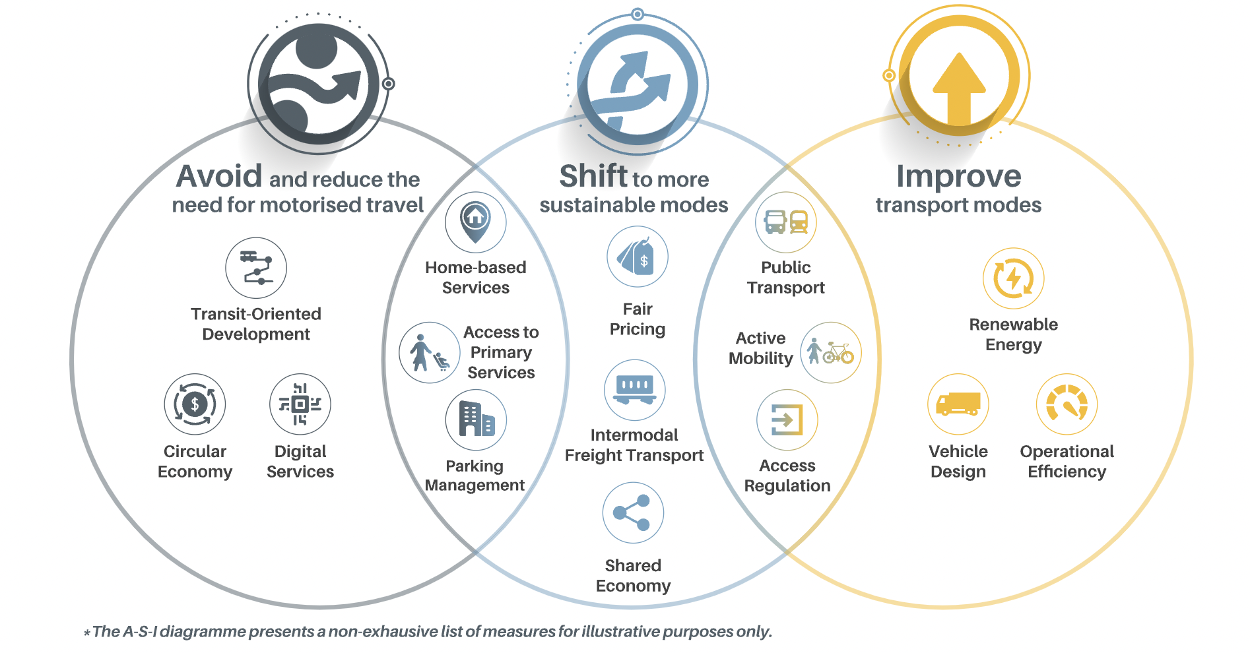

68. More robust measures on transport decarbonisation are needed by 2030 to limit global warming to 1.5°C, that could for example include reducing vehicle kilometres travelled and electrifying vehicles. Sustainable modes of travel, such as public transport, could play a crucial role in reducing the growth of private motor vehicle use, while at the same time bus fleets are being electrified.

69. Low- and middle-income countries have the opportunity to circumvent this lock-in to unsustainable models and to prevent the misperception that technological solutions alone (such as replacing more polluting vehicles with electric vehicles) are the silver bullet. Depending on the regional context, “Avoid” and “Shift” measures might result in nearly equivalent emission reduction as “Improve” measures.[[82]](#footnote-83)

* “Avoid” and “Shift” measures are needed to support transport decarbonisation, as emission reductions are not expected to be achieved without critical shifts in transport modes. “Avoid” and “Shift” strategies can account for 40-60 per cent of transport emission reductions, sometimes at lower costs than “Improve” strategies.
* “Improve” measures (e.g., electrification and fuel switch) are vital to decarbonising the transport sector. Vehicle electrification will happen faster in high-income countries, with a delay of only around five years for low- and middle-income countries. Electric cars will represent 20 per cent of all cars globally by 2030 and 60 per cent by 2040, resulting in 350 million electric cars on the roads by 2030. Electric two- and three-wheelers will double from the current 300 million to 600 million by 2030 and surpass 1.2 billion by 2050. For buses, 23 per cent of all buses in operation will be electric by 2030 and 79 per cent by 2050, when more than 50 million electric buses will be in operation.[[83]](#footnote-84)

# 

# **Annex**

Definitions and Concepts Used in the in-depth Reports

1. Inland transport: Under inland transport the report understands road, rail, and inland waterways. Freight and passenger transport are also covered and if data available, segregated with explicit remarks to either passenger or freight transport.

2. Fossil CO2 emissions: The CO2 estimates in this report are based on the Emissions Database for Global Atmospheric Research (EDGAR) and adjusted the typology of countries participating in the UNFCCC process, as defined by SLOCAT.[[84]](#footnote-85)\* EDGAR provides estimates for fossil CO2 emissions from all anthropogenic activities with the exception of land use, land-use change, forestry and the large-scale burning of biomass.

3. Transport CO2 emissions: Transport activities covered within EDGAR include road transport, non-road transport, domestic aviation, and inland waterways on the country level. CO2 emissions for international aviation and shipping are indicated separately in EDGAR. The transport CO2 emissions are the direct CO2 emissions from transport activity. They do not cover the indirect emissions, such as fossil fuel extraction, vehicle production and land-use impacts associated with certain modes of transport.

4. The sources for most statements are provided. In the case that other emission units (such as greenhouse gas emissions or CO2 equivalent) are used, they are clearly marked, and the source is provided.

1. \* The present document is being issued without formal editing. [↑](#footnote-ref-2)
2. IPCC (2022), “Climate Change 2022: Mitigation of Climate Change. Summary for Policymakers”, <https://www.ipcc.ch/report/ar6/wg3/downloads/report/IPCC_AR6_WGIII_SPM.pdf>. [↑](#footnote-ref-3)
3. US National Aeronautics and Space Administration (NASA) (2022), “GISS Surface Temperature Analysis (v4)”, <https://data.giss.nasa.gov/gistemp/graphs_v4>. [↑](#footnote-ref-4)
4. Analysis from the SLOCAT Partnership on Sustainable, Low Carbon Transport (SLOCAT), based on M. Crippa et al. (2023), “GHG emissions of all world countries – 2023 Report”, <https://edgar.jrc.ec.europa.eu/report_2023> [↑](#footnote-ref-5)
5. Other sectors is a summary of fuel exploration, industrial combustion, processes and waste. [↑](#footnote-ref-6)
6. Analysis from SLOCAT, based on M. Crippa et al. (2023), “GHG emissions of all world countries – 2023 Report”, https://edgar.jrc.ec.europa.eu/report\_2023 [↑](#footnote-ref-7)
7. Analysis from SLOCAT, based on M. Crippa et al. (2023), “GHG emissions of all world countries – 2023 Report”, <https://edgar.jrc.ec.europa.eu/report_2023> [↑](#footnote-ref-8)
8. World Resources Institute (2022), “Transport, Systems Change Lab”, <https://systemschangelab.org/transport>; J.D. Sachs et al. (2022), “Sustainable Development Report 2022: From Crisis to Sustainable Development: The SDGs as Roadmap to 2030 and Beyond”, <https://bit.ly/3qtgdQT>. [↑](#footnote-ref-9)
9. SLOCAT (2023), Takeaways for Decision Makers From Turbulence to Transformation: Navigating Challenges Towards Action on Transport, Climate and Sustainability, SLOCAT Global Status Report on Transport, Climate and Sustainability - 3rd edition, <https://tcc-gsr.com/takeways-for-decision-makers/> [↑](#footnote-ref-10)
10. United Nations Statistics Division (2023), “The Sustainable Development Goals Report 2023: Special Edition”, <https://unstats.un.org/sdgs/report/2023/> [↑](#footnote-ref-11)
11. United Nations Conference on Trade and Development (UNCTAD) (2022), “Maritime Trade Disrupted: The War in Ukraine and Its Effects on Maritime Trade Logistics”, <https://unctad.org/system/files/official-document/osginf2022d2_en.pdf>. [↑](#footnote-ref-12)
12. E.E. Koks et al. (2019), “A global multi-hazard risk analysis of road and railway infrastructure assets”, Nature Communications, Vol. 10, No. 2677, https:// [www.nature.com/articles/s41467-019-10442-3](http://www.nature.com/articles/s41467-019-10442-3). [↑](#footnote-ref-13)
13. S. Hallegatte, J. Rentschler and J. Rozenberg (2019), “Lifelines: The Resilient Infrastructure Opportunity”, World Bank, <https://openknowledge.worldbank.org/handle/10986/31805>. [↑](#footnote-ref-14)
14. Analysis from the SLOCAT Partnership on Sustainable, Low Carbon Transport (SLOCAT), based on M. Crippa et al. (2022), “CO2 Emissions of All World Countries – 2022 Report”, <https://edgar.jrc.ec.europa.eu/report_2022> [↑](#footnote-ref-15)
15. IEA (2022), “World CO2 Emissions from Fuel Combustion”. [↑](#footnote-ref-16)
16. Shell (2020), “The Energy Transformation Scenarios”, <https://www.shell.com/energy-and-innovation/the-energy-future/scenarios/the-energy-transformation-scenarios.html>, accessed 20 August 2022. [↑](#footnote-ref-17)
17. ITF (2021), “ITF Transport Outlook 2021”, <https://www.itf-oecd.org/itf-transport-outlook-2021>; Shell (2020), “The Energy Transformation Scenarios”, https://www.shell.com/energy-and-innovation/the-energy-future/scenarios/the-energy-transformation-scenarios.html, accessed 20 August 2022. [↑](#footnote-ref-18)
18. S.C. Anenberg et al. (2019), “The global burden of transportation tailpipe emissions on air pollution-related mortality in 2010 and 2015”, Environmental Research Letters, Vol. 14, p. 094012, https://iopscience.iop.org/article/10.1088/1748-9326/ab35fc/pdf. [↑](#footnote-ref-19)
19. Income groups according to World Bank (2022), “World Bank Country and Lending Groups”, <https://datahelpdesk.worldbank.org/knowledgebase/articles/906519>, last accessed 20 August 2022. [↑](#footnote-ref-20)
20. Analysis from SLOCAT, based on M. Crippa et al. (2023), “GHG emissions of all world countries – 2023 Report”, https://edgar.jrc.ec.europa.eu/report\_2023 [↑](#footnote-ref-21)
21. L. Cozzi, O. Chen and H. Kim, 2023, “The world’s top 1% of emitters produce over 1 000 times more CO2 than the bottom 1%,” IEA, https://www.iea.org/commentaries/the-world-s-top-1-of-emitters-produce-over-1-000-times-more-co2-than-the-bottom-1. [↑](#footnote-ref-22)
22. Analysis from SLOCAT, based on M. Crippa et al. (2023), “GHG emissions of all world countries – 2023 Report”, <https://edgar.jrc.ec.europa.eu/report_2023> [↑](#footnote-ref-23)
23. Analysis from SLOCAT, based on M. Crippa et al. (2023), “GHG emissions of all world countries – 2023 Report”, <https://edgar.jrc.ec.europa.eu/report_2023> [↑](#footnote-ref-24)
24. Analysis from SLOCAT, based on M. Crippa et al. (2023), “GHG emissions of all world countries – 2023 Report”, <https://edgar.jrc.ec.europa.eu/report_2023> [↑](#footnote-ref-25)
25. UNEP, “Restoring Clean Air”, https://www.unep.org/regions/asia-and-pacific/regional-initiatives/restoring-clean-air, (accessed 7 July 2023). [↑](#footnote-ref-26)
26. Analysis from SLOCAT, based on M. Crippa et al. (2023), “GHG emissions of all world countries – 2023 Report”, <https://edgar.jrc.ec.europa.eu/report_2023> [↑](#footnote-ref-27)
27. Destatis, 2022, “Road Transport: Car Dominance Unbroken”, https://www.destatis.de/Europa/EN/Topic/Transport/Car.html [↑](#footnote-ref-28)
28. IRF, op. cit. note 4. Figure 1 from Eurostat, 2022, “Stock of Vehicles by Category and NUTS 2 Regions”, https://ec.europa.eu/eurostat/databrowser/view/TRAN\_R\_VEHST\_\_custom\_3245293/default/table; Government of the United Kingdom, 2023, “Vehicles Statistics”, https://www.gov.uk/government/collections/vehicles-statistics; IRF, 2022, “World Road Statistics 2022”, https://datawarehouse.worldroadstatistics.org; E.A. Nanaki, 2018, “Measuring the Impact of Economic Crisis to the Greek Vehicle Market”, Sustainability, Vol. 10, p. 510. https://doi.org/10.3390/su10020510. [↑](#footnote-ref-29)
29. IDB, 2021, “Logistics in Latin America and the Caribbean: Opportunities, Challenges and Courses of Action”, http://dx.doi.org/10.18235/0003278. [↑](#footnote-ref-30)
30. International Road Federation, 2022, “World Road Statistics 2022”, https://datawarehouse.worldroadstatistics.org [↑](#footnote-ref-31)
31. Analysis from SLOCAT, based on M. Crippa et al. (2023), “GHG emissions of all world countries – 2023 Report”, <https://edgar.jrc.ec.europa.eu/report_2023> [↑](#footnote-ref-32)
32. International Road Federation (IRF), 2022, “World Road Statistics 2022”, https://datawarehouse.worldroadstatistics.org. [↑](#footnote-ref-33)
33. IPCC (2022), “Climate Change 2022: Mitigation of Climate Change”, <https://www.ipcc.ch/report/sixth-assessment-report-working-group-3>. [↑](#footnote-ref-34)
34. International Transport Forum (ITF) (2023), “ITF Transport Outlook 2023”, <https://www.itf-oecd.org/itf-transport-outlook-2023> [↑](#footnote-ref-35)
35. International Transport Forum (ITF) (2023), “ITF Transport Outlook 2023”, <https://www.itf-oecd.org/itf-transport-outlook-2023> [↑](#footnote-ref-36)
36. International Transport Forum (ITF) (2023), “ITF Transport Outlook 2023”, <https://www.itf-oecd.org/itf-transport-outlook-2023> [↑](#footnote-ref-37)
37. OECD-ITF (2021), “ITF Transport Outlook 2021”, Chapter 2, Figure 2.8, available at: https://www.oecd-ilibrary.org/transport/itf-transport-outlook-2021\_16826a30-en [↑](#footnote-ref-38)
38. ITF (2021), “ITF Transport Outlook 2021”, <https://www.itf-oecd.org/itf-transport-outlook-2021> [↑](#footnote-ref-39)
39. S. Gota and C. Huizenga (2022), “Asian Transport 2030 Outlook”, https://asiantransportoutlook.com/analytical-outputs/asian-transport-2030-outlook. [↑](#footnote-ref-40)
40. International Transport Forum (ITF) (2023), “ITF Transport Outlook 2023”, <https://www.itf-oecd.org/itf-transport-outlook-2023> [↑](#footnote-ref-41)
41. United Nations Environment Programme (UNEP) (2022), “Emissions Gap Report 2022: The Closing Window – Climate Crisis Calls for Rapid Transformation of Societies”, https://www.unep.org/emissions-gap-report-2022. [↑](#footnote-ref-42)
42. International Transport Forum (ITF) (2023), “ITF Transport Outlook 2023”, https://www.itf-oecd.org/itf-transport-outlook-2023 [↑](#footnote-ref-43)
43. IEA (2023), “Net Zero Roadmap: A Global Pathway to Keep the 1.5 °C Goal in Reach, 2023 Update”, <https://www.iea.org/reports/net-zero-roadmap-a-global-pathway-to-keep-the-15-0c-goal-in-reach> [↑](#footnote-ref-44)
44. P. Jaramillo et al. (2022), “Transport”, in IPCC (2022), “Climate Change 2022: Mitigation of Climate Change”, <https://www.ipcc.ch/report/sixth-assessment-report-working-group-3>. [↑](#footnote-ref-45)
45. International Renewable Energy Agency (IRENA) (2022), “World Energy Transitions Outlook 2022”, <https://www.irena.org/Digital-Report/World-Energy-Transitions-Outlook-2022> [↑](#footnote-ref-46)
46. P. Jaramillo et al. (2022), “Transport”, in IPCC (2022), “Climate Change 2022: Mitigation of Climate Change”, https://www.ipcc.ch/report/sixth-assessment-report-working-group-3. [↑](#footnote-ref-47)
47. IEA (2021), “Net Zero by 2050”, https://www.iea.org/reports/net-zero-by-2050. [↑](#footnote-ref-48)
48. IEA (2021), “Net Zero by 2050”, https://www.iea.org/reports/net-zero-by-2050. [↑](#footnote-ref-49)
49. IEA (2021), “Net Zero by 2050”, <https://www.iea.org/reports/net-zero-by-2050>; IEA (2023), “Net Zero Roadmap: A Global Pathway to Keep the 1.5 °C Goal in Reach, 2023 Update”, https://www.iea.org/reports/net-zero-roadmap-a-global-pathway-to-keep-the-15-0c-goal-in-reach [↑](#footnote-ref-50)
50. International Transport Forum (ITF) (2023), “ITF Transport Outlook 2023”, <https://www.itf-oecd.org/itf-transport-outlook-2023>. [↑](#footnote-ref-51)
51. International Transport Forum (ITF) (2023), “ITF Transport Outlook 2023”, <https://www.itf-oecd.org/itf-transport-outlook-2023>. [↑](#footnote-ref-52)
52. Asian Transport Outlook, 2021, “A New Perspective on Transport and Climate Change”, <https://asiantransportoutlook.com/analytical-outputs/climate-change-in-asia>. [↑](#footnote-ref-53)
53. European Environment Agency (nd), ” Greenhouse gas emissions from transport in Europe”, <https://www.eea.europa.eu/ims/greenhouse-gas-emissions-from-transport>, accessed 10 July 2023 [↑](#footnote-ref-54)
54. P. Jaramillo et al. (2022), “Transport”, in IPCC (2022), “Climate Change 2022: Mitigation of Climate Change”, <https://www.ipcc.ch/report/sixth-assessment-report-working-group-3>. [↑](#footnote-ref-55)
55. Figure based on P. Jaramillo et al. (2022), “Transport”, in IPCC (2022), “Climate Change 2022: Mitigation of Climate Change”, https://www.ipcc.ch/report/sixth-assessment-report-working-group-3. [↑](#footnote-ref-56)
56. United Nations Framework Convention on Climate Change (2021), “Glasgow Climate Pact”, <https://unfccc.int/sites/default/files/resource/cop26_auv_2f_cover_decision.pdf> [↑](#footnote-ref-57)
57. SLOCAT (2022), “Are Nationally Determined Contributions aligned with the commitments and initiatives on transport announced on the occasion of COP26? A Comparative Analysis by SLOCAT”, <https://slocat.net/cop26-commitments-ndc-alignment-2022/> [↑](#footnote-ref-58)
58. https://climatechampions.unfccc.int/system/breakthrough-agenda/ [↑](#footnote-ref-59)
59. https://racetozero.unfccc.int/system/breakthroughs/ [↑](#footnote-ref-60)
60. IEA, IRENA and United Nations Climate Change High-Level Champions (2023), “The Breakthrough Agenda Report 2023”, https://climatechampions.unfccc.int/wp-content/uploads/2023/09/THEBREAKTHROUGHAGENDAREPORT2023.pdf [↑](#footnote-ref-61)
61. United Nations (2021), “Secretary-General's remarks to the Second Global Sustainable Transport Conference [as delivered]”, https://www.un.org/sg/en/content/sg/statement/2021-10-14/secretary-generals-remarks-the-second-global-sustainable-transport-conference-delivered [↑](#footnote-ref-62)
62. Second Global Sustainable Transport Conference (2021), “Beijing Statement of the Second United Nations Global Sustainable Transport Conference”, https://www.un.org/sites/un2.un.org/files/2021/10/gstc2\_beijing\_statement\_16\_oct\_2021.pdf [↑](#footnote-ref-63)
63. B. Buchner et al. (2019), “Global Landscape of Climate Finance 2019”, Climate Policy Initiative (CPI), <https://www.climatepolicyinitiative.org/wp-content/uploads/2019/11/2019-Global-Landscape-of-Climate-Finance.pdf> [↑](#footnote-ref-64)
64. MIT Energy Initiative (2019), “Insights into Future Mobility”, http://energy.mit.edu/insightsintofuturemobility [↑](#footnote-ref-65)
65. Oxford Economics (2023), “Global Infrastructure Outlook”, https://outlook.gihub.org, accessed 28 August 2023 [↑](#footnote-ref-66)
66. Global Infrastructure Hub (n.d.), “Infra tracker”, https://infratracker.gihub.org, accessed 31 July 2023 [↑](#footnote-ref-67)
67. OECD (2023), “Government Support and Subsidies Portal”, <https://www.oecd.org/subsidies>, accessed 26 August 2023 [↑](#footnote-ref-68)
68. GSR Spotlight 5: Capacity and Institutional Support to Achieve Sustainable, Low Carbon Transport [↑](#footnote-ref-69)
69. Prizzon, A. and Leautier, F. (2022), “Multilateral development banks need a bolder vision and urgent reform to tackle the climate crisis”, https://odi.org/en/insights/multilateral-development-banks-need-a-bolder-vision-and-urgent-reform-to-tackle-the-climate-crisis/ [↑](#footnote-ref-70)
70. Carbon Brief (2022), “Explainer: How can climate finance be increased from ‘billions to trillions’?”

    https://www.carbonbrief.org/explainer-how-can-climate-finance-be-increased-from-billions-to-trillions/ [↑](#footnote-ref-71)
71. World Resources Institute (2018), “Towards Paris Alignment. How the Multilateral Development Banks Can Better Support the Paris Agreement.” [↑](#footnote-ref-72)
72. CDP (2023), “Are companies developing credible climate transition plans?” https://www.cdp.net/en/articles/climate/new-cdp-data-shows-companies-are-recognizing-the-need-for-climate-transition-plans-but-are-not-moving-fast-enough-amidst-incoming-mandatory-disclosure [↑](#footnote-ref-73)
73. Science Based Targets, op. cit. note 2; Science Based Targets (n.d.), "Transport", https://sciencebasedtargets.org/sectors/transport#our-updated-oems-policy, accessed 25 February 2023. [↑](#footnote-ref-74)
74. World Benchmarking Alliance (WBA) (2021), “2021 Automotive Benchmark”, Climate and Energy Benchmark, https://www.worldbenchmarkingalliance.org/publication/automotive. [↑](#footnote-ref-75)
75. L. Paoli, A. Dasgupta and S. McBain (2022), "Electric Vehicles", International Energy Agency (IEA),<https://www.iea.org/reports/electric-vehicles>. [↑](#footnote-ref-76)
76. InfluenceMap (2023), “Automotive Climate Tool”, https://automotive.influencemap.org, updated January 2023. [↑](#footnote-ref-77)
77. We Mean Business Coalition et al. (2022), “Climate Transition Action Plans – Activate your journey to climate leadership”, <https://www.wemeanbusinesscoalition.org/blog/climate-transition-action-plans-activate-your-journey-to-climate-leadership>. [↑](#footnote-ref-78)
78. Science based Target Initiative (2023), “Ambitious corporate climate action”, https://sciencebasedtargets.org/; International Financial Reporting Standards Foundation (n.d.), "About the International Sustainability Standards Board”, https://www.ifrs.org/groups/international-sustainability-standards-board Council of the EU (2022), “Council gives final green light to corporate sustainability reporting directive” <https://www.consilium.europa.eu/en/press/press-releases/2022/11/28/council-gives-final-green-light-to-corporate-sustainability-reporting-directive> [↑](#footnote-ref-79)
79. United Nations High Level Expert Group (HLEG) on the Net Zero Emissions Commitments of Non-State Entities (2022), “Integrity Matters: Net zero commitments by businesses, financial institutions, cities and regions”, https://www.un.org/sites/un2.un.org/files/high-level\_expert\_group\_n7b.pdf [↑](#footnote-ref-80)
80. United Nations High Level Expert Group (HLEG) on the Net Zero Emissions Commitments of Non-State Entities (2022), “Integrity Matters: Net zero commitments by businesses, financial institutions, cities and regions”, https://www.un.org/sites/un2.un.org/files/high-level\_expert\_group\_n7b.pdf [↑](#footnote-ref-81)
81. SLOCAT (2021), “Avoid-Shift-Improve Refocusing”, https://slocat.net/asi/ [↑](#footnote-ref-82)
82. F. Creutzig et al. (2022), “Demand-side solutions to climate change mitigation consistent with high levels of well-being”, Nature Climate Change, Vol. 12, pp. 36-46, https://doi.org/10.1038/s41558-021-01219-y. [↑](#footnote-ref-83)
83. IEA (2021), “Net Zero by 2050”, https://www.iea.org/reports/net-zero-by-2050. [↑](#footnote-ref-84)
84. \* Based on United Nations Statistics Division M49 regional codes: https://unstats.un.org/unsd/methodology/m49/ [↑](#footnote-ref-85)