|  |  |  |  |
| --- | --- | --- | --- |
|  | United Nations | ECE/TRANS/WP.29/2024/15 | |
| _unlogo | **Economic and Social Council** | | Distr.: General  21 December 2023  Original: English |

**Economic Commission for Europe**

Inland Transport Committee

**World Forum for Harmonization of Vehicle Regulations**

**192nd session**

Geneva, 5–8 March 2024

Item 4.8.5 of the provisional agenda

**1958 Agreement:**

**Consideration of draft amendments to existing**

**UN Regulations submitted by GRSG**

Proposal for 03 series of amendments to UN Regulation No. 55 (Mechanical couplings)

Submitted by the Working Party on General Safety Provisions[[1]](#footnote-2)\*

The text reproduced below was adopted by the Working Party on General Safety Provisions (GRSG) at its 126th session (ECE/TRANS/WP.29/GRSG/105, para. 17). ECE/TRANS/WP.29/GRSG/2023/18, as amended by annex VI to the report. It is submitted to the World Forum for Harmonization of Vehicle Regulations (WP.29) and to the Administrative Committee (AC.1) for consideration at their March 2024 sessions.

.

*Insert new paragraphs 13.6. to 13.10.*,to read:

"13.6. As from the official date of entry into force of the 03 series of amendments, no Contracting Party applying this Regulation shall refuse to grant or refuse to accept type approvals under this Regulation as amended by the 03 series of amendments.

13.7. As from 1 September 2025, Contracting Parties applying this Regulation shall not be obliged to accept type approvals issued to the preceding series of amendments to this Regulation.

13.8. Notwithstanding paragraph 13.7., Contracting Parties applying this Regulation shall continue to accept type approvals of mechanical coupling devices and components issued according to the preceding series of amendments to this Regulation.

13.9. Notwithstanding paragraph 13.7., Contracting Parties applying this Regulation shall continue to accept type approvals issued according to the preceding series of amendments to this Regulation, for the vehicles which are not affected by the changes introduced by the 03 series of amendments.

13.10. Contracting Parties applying this Regulation shall not refuse to grant type approvals according to any preceding series of amendments to this Regulation or extensions thereof."

*Annex 3,* amend to read*:*

"Annex 3

Example of an arrangement of the approval mark

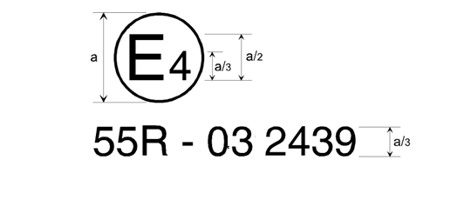

a = 8 mm minimum

The mechanical coupling device or component or vehicle bearing the approval mark shown above is a device or component approved in the Netherlands (E 4), under approval number 2439, meeting the requirements of the 03 series of amendments to this Regulation.

*…* "

*Annex 7, paragraph 1.4. to 1.4.3.,* amend to read:

"1.4. Attachment of coupling devices and drawbars on trailers.

1.4.1. Drawbars for centre axle trailers shall have a support device which is adjustable in height if the bearing mass at the coupling device on the trailer exceeds 50 kg, when the trailer is uniformly loaded to its technically permissible maximum mass.

This requirement shall not apply in the case of trailers designed for special operations where they are normally only separated in a workshop (i.e. Class T couplings) or when loading and unloading in specifically designed operating areas.

1.4.2. When attaching coupling device and drawbar to centre-axle trailers with a maximum mass, C, of more than 3.5 tonnes and more than one axle, the trailers shall be equipped with device for axle load sharing.

1.4.3. Hinged drawbars shall be clear of the ground. They shall not fall below a height of 200 mm from the ground when released from the horizontal position. See also Annex 5, paragraphs 5.3. and 5.4."

1. \* In accordance with the programme of work of the Inland Transport Committee for 2024 as outlined in proposed programme budget for 2024 (A/78/6 (Sect. 20), table 20.5), the World Forum will develop, harmonize and update UN Regulations in order to enhance the performance of vehicles. The present document is submitted in conformity with that mandate. [↑](#footnote-ref-2)