|  |  |  |  |
| --- | --- | --- | --- |
|  | United Nations | ST/SG/AC.10/C.3/2024/16 | |
| _unlogo | **Secretariat** | | Distr.: General  9 April 2024  Original: English |

**Committee of Experts on the Transport of Dangerous Goods  
and on the Globally Harmonized System of Classification  
and Labelling of Chemicals**

**Sub-Committee of Experts on the Transport of Dangerous Goods**

**Sixty-fourth session**

Geneva, 24 June-3 July 2024

Item 2 (h) of the provisional agenda

**Explosives and related matters:  
Miscellaneous**

Screening procedures for estimating the self-accelerating decomposition temperature of 50 kg packages

Transmitted by the European Chemical Industry Council (Cefic)[[1]](#footnote-2)\*

I. Introduction

1. The self-accelerating decomposition temperature (SADT), the lowest temperature at which self-accelerating decomposition may occur in a substance in the packaging as offered for transport, is one of the defining characteristics of self-reactive substances and organic peroxides. Among other differentiation criteria, substances should be considered self-reactive if they have an SADT of 75 °C or less for a 50 kg package. The thermal stability should be determined by one of the four SADT test methods of test series H as described in section 28 of the *Manual of Tests and Criteria*.

2. These tests generally require specialized equipment and significant amounts of substance, requirements which may present a barrier for groups with limited experience in the classification of dangerous groups, as well as for situations where only limited amounts of substance are available (e.g., in research and development). This barrier might cause substances to be transported incorrectly as not self-reactive, or might cause substances that should not be classified as self-reactive to be unnecessarily over-regulated.

3. Appendix 6 of the *Manual of Tests and Criteria* (MTC) provides some relief for this problem through screening criteria for several of the hazard classes. Specifically for self-reactive substances, Section A6.5.1 (b) states that classification procedures need not be applied if “the estimated SADT is greater than 75 °C,” which offers an exemption from classification as a self-reactive substance without going through extensive testing.

4. Unfortunately, the MTC does not offer any guidance as to which techniques would be appropriate to reliably estimate the SADT beyond a generic reference to “a suitable calorimetric technique.”

5. Closing this gap in the MTC by establishing a simple and reliable screening method would greatly benefit the transport of dangerous goods by:

(a) Making classification more efficient by avoiding unnecessary testing and focussing lab resources on substances that realistically could pose a self-reactive hazard; and

(b) Simplifying initial assessment of potential self-reactive substances and thus increasing accessibility to groups with less experience in classification.

6. In the December 2023 session, Cefic presented an informal document that introduced simple screening rules to make this estimation based on standard differential scanning calorimetry (DSC) measurements (INF.42 of the sixty-third session of the Sub-Committee[[2]](#footnote-3)). Cefic has updated their proposal following helpful comments from national and non-governmental organizations, and come back now with a formal proposal for this concept.

7. Cefic asks the Sub-Committee to consider the proposals laid out in this document and requests to have them discussed in the Explosives Working Group.

II. Background and justification

8. As outlined in the informal document from December 2023 session of the Sub-Committee, the estimated SADT for **liquids** in a standard 50 kg package can be considered to be above 75 °C if:

(a) the DSC-onset is equal to or higher than 175 °C; or

(b) the isothermal heat flow at 75 °C is equal to or less than 100 mW kg-1.

9. Similarly, the estimated SADT for **solids** in a standard 50 kg package can be considered to be above 75 °C if:

(c) The DSC-onset is equal to or higher than 200 °C; or

(d) The isothermal heat flow at 75 °C is equal to or less than 50 mW kg-1.

10. These screening rules for solids and liquids are derived from fundamental principles of thermal safety assuming zero-order kinetics for the decomposition reaction. For convenience these calculations are repeated here in the appendices of this document.

11. For the derivation of these screening rules, no specific characteristics were assumed for the solid or liquid substances other than their physical states. Thus, these calculations apply generally to substances when considered for exemption from classification in a 50 kg package.

12. One of the important points of these rules is that they do not require a specialized kind DSC measurement or apparatus, but rather can be applied with any DSC measurement suitable for assessing the thermal stability of a substance. Guidelines as to how such a DSC is to be run (e.g., closed crucible, slow heating rate, how to determine onset) are already given in section 20.3.3.3 of the MTC and are equally valid for use with these screening rules. Cefic has revised their proposal to make clear reference to this section.

13. In a comparison of the predictions from these screening rules with empirical data graciously provided from industry and competent parties for over 300 compounds (both liquids and solids), no case was found where a compound with an SADT less than 75 °C (as measured by any of the recommended methods in test series H) had a DSC-onset of greater than 150 °C. The DSC-onsets in the proposed the screening rules are even higher than this result, which supports the validity of our approach and models, and highlights the conservative nature of our assumptions.

14. To date Cefic is not aware of any “false negatives” from these proposed rules (i.e., a substance with a DSC-onset above 175 °C or 200 °C and with an SADT below 75 °C). While a few cases were revealed as “false positives”, where a substance had an SADT above 75 °C for a 50 kg package despite having a DSC-onset below 175 °C or 200 °C, a much larger number of these samples were correctly identified as having an SADT greater than 75 °C from their DSC-onset temperature. These observations show both that the proposed guidelines are conservative enough to maintain a high level of safety in transport, while still allowing for the vast majority of non-critical cases to be properly assessed with a minimum of effort.

15. These screening rules might fail for substances that show strong autocatalytic behaviour during decomposition. Further calorimetric data is needed for such substances to determine if the DSC rules can be applied when attempting to exclude them from classification as self-reactive. Such information could be attempts to detect critical shifts in the onset temperature by comparing:

(a) DSC-measurements of tempered samples in comparison to fresh samples; or

(b) DSC-scans with different scan rates.

The onset temperature or heat flux criteria should always be met for fresh and aged samples representing the anticipated duration of transport.

16. During our preparation of this formal proposal, we noticed some existing wording in Appendix 6 of the MTC concerning screening rules for self-reactive substances that is imprecise and we feel should be changed.

17. The first sentence of paragraph A6.5.1 (b) exempts substances from the classification procedure for self-reactive if “…the estimated SADT is greater than 75 °C…”, but the second sentence then discusses how to estimate the “onset temperature”. “Onset temperature” is a more general term than “SADT” not usually used to describe the beginning of a self-accelerating decomposition. Cefic believes using “onset temperature” here is inaccurate and potentially confusing, especially in the context of this proposal to estimate the SADT from the onset temperature of a DSC-experiment.

18. Cefic would thus propose, in addition to the screening rules for liquids and solids, replacing “onset temperature” in this sentence with “SADT”.

III. Proposals

19. Insert the following new text after section A6.5.1 (b) of the MTC:

“(c) The estimated SADT for a 50 kg package is greater than 75 °C if:

1. The first detected exothermic reaction (onset, detection limit maximum 20 W kg-1) in a screening DSC is equal to or above 175 °C for liquids or 200 °C for solids; or

2. The measured isothermal maximum heat flow at 75 °C is equal to or less than 100 mW kg-1 for liquids or 50 mW kg-1 for solids.

Calorimetric data should be obtained following the guidelines in Section 20.3.3.3.

***Note****: These screening rules can fail for substances showing strong autocatalytic behavior in the decomposition. For such substances, further information is needed to determine if these simple screening rules apply to the particular substance (e.g., the effect of sample aging on the decomposition). Information concerning potential autocatalytic behaviour may be obtained from further calorimetric measurements (e.g., comparison of DSC-measurements of tempered samples with fresh samples, or DSC-scans with different scan rates). The onset temperature criteria or heat flow criteria should always be met for fresh and aged samples representing the anticipated duration of transport*.”

20. In the second sentence of section A6.5.1 (b) of the MTC replace “onset temperature” with “SADT:

“(b) … The ~~onset temperature~~ **SADT** and decomposition energy may be estimated using a suitable calorimetric technique (see 20.3.3.3).”

IV. Conclusion

21. In this document Cefic proposes a simplified and readily accessible method for estimating if the SADT for a 50 kg package is above 75 °C. This simplification closes a gap in the current screening rules given in Appendix 6 of the MTC and provides much needed guidance for the classification of self-reactive substances.

22. Through these screening rules organizations not familiar with transport regulations will be given the added security of knowing via a simple and readily applied test method if a given substance requires further testing for self-reactivity. Thus, it is clearer when substances need to be further tested or provisionally handled as self-reactive substances.

23. Similarly, application of the screening rules in this proposal would help define when new substances clearly would not fall under the provisions of Division 4.1 Self-reactives, simplifying transport of these substances and avoiding unnecessary testing.

24. In this manner these proposals will increase safety in the transport of dangerous goods and support our green goals.

Annex I

[English only]

Derivation of the proposed screening rules (Semenov Model)

1. One of the fundamental boundary conditions for a self-accelerating thermal decomposition of a substance is the point where the heat generated by the decomposition is greater than the heat loss to the surroundings. A mathematical description of this situation is given by the ratio between the thermal relaxation time (trelax) and the adiabatic induction time (tchem) respectively. The critical value for this ratio where the decomposition leads to a thermal runaway varies with the physical state of the substance and the packaging in question. When considering a liquid sample under the Semenov model for heat flow, where the main resistance to heat flow is at the boundary of the package with the surroundings, this value is approximately given by 1/e.

|  |  |  |  |  |
| --- | --- | --- | --- | --- |
|  |  | trelax | = | Thermal relaxation time (s) |
|  | tchem | = | Adiabatic induction time (s) |
|  | C | = | Constant |
|  |  | e | = | Euler’s number |

2. Conservatively assuming zero-order kinetics for the decomposition reaction, the adiabatic induction time can be calculated from the following equation:

|  |  |  |  |  |
| --- | --- | --- | --- | --- |
|  |  | tchem | = | Adiabatic induction time (s) |
|  | cp | =̇ | Heat capacity (J kg-1 K-1) |
|  | R | = | Universal gas constant (8.314 J mol-1 K-1) |
|  |  | T | = | Temperature (K) |
|  |  | Ea | = | Activation energy (J mol-1) |
|  |  | q̇T | = | Specific heat release rate at temperature T (W kg-1) |

3. Meanwhile, trelax for the substance in question can be derived by solving Newton’s law of cooling for the half-time of cooling.

|  |  |  |  |  |
| --- | --- | --- | --- | --- |
|  |  | trelax | = | Thermal relaxation time (s) |
|  | t1/2 | =̇ | Half-time of cooling (s) |
|  |  |  |  |

4. A relationship between trelax and the heat loss per unit mass (L) for the packaged substance can then be derived by combining this equation with one defining the heat loss from a package (see 28.3.5 of the MTC):

|  |  |  |  |  |
| --- | --- | --- | --- | --- |
|  |  | trelax | = | Thermal relaxation time (s) |
|  | cp | = | Heat capacity (J kg-1 K-1) |
|  | L | = | Heat loss per unit mass (W kg-1 K-1) |

5. Finally, combining the three equations from paragraphs 25, 26, and 28 allows for a derivation of the critical heat flow that leads to a thermal explosion as a function of the characteristic heat losses from the given package.

|  |  |  |  |  |
| --- | --- | --- | --- | --- |
| $${\dot{q}}_{T}=\frac{R∙T^{2}}{E_{a}}∙L∙\frac{1}{e}$$ |  | q̇T | =̇ | Specific heat release rate at temperature T (W kg-1) |
|  | R | = | Universal gas constant (8.314 J mol-1 K-1) |
|  | T | = | Temperature (K) |
|  |  | Ea | = | Activation energy (J mol-1) |
|  |  | L | = | Heat loss from the packaging (W kg-1 K-1) |
|  |  | e | = | Euler’s number |

6. Solving this equation with representative activation energies (50-200 kJ mol-1) and the standard heat loss for liquids (60 mW kg-1 K-1) recommended by the MTC for classification purposes (see footnote b in Table 28.4 of the MTC) gives the following critical heat flows at 75 °C (Table 1).

Table 1: Critical heat flow for liquids with an SADT of 75 °C for a standard 50 kg package (Semenov model)

|  |  |  |  |  |
| --- | --- | --- | --- | --- |
| **Activation Energy (kJ mol-1)** | **50** | **100** | **150** | **200** |
| (mW kg-1) | 444 | 222 | 148 | 111 |

Minimum heat flow highlighted in red

7. The temperature dependence of heat flow from an exothermic reaction at low levels of conversion (e.g., at the beginning of the decomposition) is given by the following equation.

|  |  |  |  |  |
| --- | --- | --- | --- | --- |
| $$\dot{{ q}_{T}}={∆H}_{r}∙k_{0}∙e^{-\frac{E_{a}}{RT}}∙C$$ |  | q̇T | = | Specific heat release rate at temperature T (W kg-1) |
|  | DHr | = | Reaction enthalpy (J kg-1) |
|  | ko | = | Arrhenius pre-exponential factor (s-1) |
|  |  | e | = | Euler’s number |
|  |  | Ea | = | Activation energy (J mol-1) |
|  |  | R | = | Universal gas constant (8.314 J mol-1 K-1) |
|  |  | T | = | Temperature (K) |
|  |  | C | = | Constant |

8. To derive screening rules for classification of a substance in a 50 kg package, we need to compare the critical heat flow at two different temperatures, specifically, that at the temperature relevant for classification (75 °C, TSADT), and that at the observed onset temperature in a DSC-experiment (TDSC). The ratio of these two heat flows is given by:

|  |  |  |  |  |
| --- | --- | --- | --- | --- |
| $$\frac{{\dot{q}}_{SADT}}{{\dot{q}}_{DSC}}=e^{\frac{E_{a}}{R}\left(\frac{1}{T_{DSC}}-\frac{1}{T_{SADT}}\right)}$$ |  | q̇ | = | Heat flow (W kg-1) |
|  | e | = | Euler’s number |
|  | Ea | = | Activation energy (J mol-1) |
|  |  | R | = | Universal gas constant (8.314 J mol-1 K-1) |
|  |  | T | = | Temperature (K) |

9. Solving this equation then for TDSC leads to:

|  |  |  |  |  |
| --- | --- | --- | --- | --- |
| $$T_{DSC}=\frac{1}{\frac{R}{E_{a}}∙\ln\left(\frac{{\dot{q}}_{SADT}}{{\dot{q}}_{DSC}}\right)+\frac{1}{T_{SADT}}}$$ |  | T | = | Temperature (K) |
|  | R | = | Universal gas constant (8.314 J mol-1 K-1) |
|  | Ea | = | Activation energy (J mol-1) |
|  |  | q̇ | = | Heat flow (W kg-1) |

10. To obtain the DSC-onset temperatures (Table 2), this equation was solved using:

* 1. The representative activation energies (50-200 kJ mol-1) and corresponding critical heat flows calculated in paragraph 6 above.
  2. Taking 75 °C (348 K) as the TSADT relevant for classification of a 50 kg package.
  3. Assuming 20 W kg-1 for q̇DSC as a conservative assumption for the sensitivity of the DSC measurement.

Table 2: Predicted DSC-onset for liquids with an SADT of 75 °C for a standard 50 kg package (Semenov model)

|  |  |  |  |  |
| --- | --- | --- | --- | --- |
| **Activation Energy (kJ mol-1)** | **50** | **100** | **150** | **200** |
| TDSC (°C) | 173 | 127 | 111 | 103 |

Maximum DSC-onset highlighted in red

11. Similar treatment of solids with the standard heat loss recommended by the MTC for classification purposes (30 mW kg-1 K-1, see footnote b in Table 28.4 of the MTC) leads to the following critical heat flows and estimated DSC-onset temperatures (Table 3).

Table 3: Critical heat flow and corresponding DSC-onset for solids with an SADT of 75 °C for a standard 50 kg package (Semenov model)

|  |  |  |  |  |
| --- | --- | --- | --- | --- |
| **Activation Energy (kJ mol-1)** | **50** | **100** | **150** | **200** |
| (mW kg-1) | 222 | 111 | 74 | 56 |
| TDSC (°C) | 198 | 136 | 117 | 107 |

Minimum heat flow and maximum DSC-onset highlighted in red

12. Although the Semenov model is generally only used in assessing liquids, experience has shown that it can also be extended to solids in relatively small packages where a nearly uniform temperature profile can be assumed. A detailed and comprehensive discussion about solids will follow in a separate informal document that will be made available in due time before the July 2024 session.

Annex II

[English only]

Sensitivity analysis for the derived screening rules (Semenov model)

1. The proposed DSC rules for liquids derived under the Semenov model were subjected to sensitivity analyses.

2. Taking the assumed values for heat losses for liquids (60 mW kg-1 K-1), activation energy (100 kJ mol-1) and the DSC-detection limit (20 W kg-1), a DSC-onset temperature of approximately 130 °C can be calculated as a starting reference point for this analysis (black dash line). Systematically varying one of these three variables while holding the other two constant then leads to the following sensitivity plot for the screening rules for liquids (Figure 1).

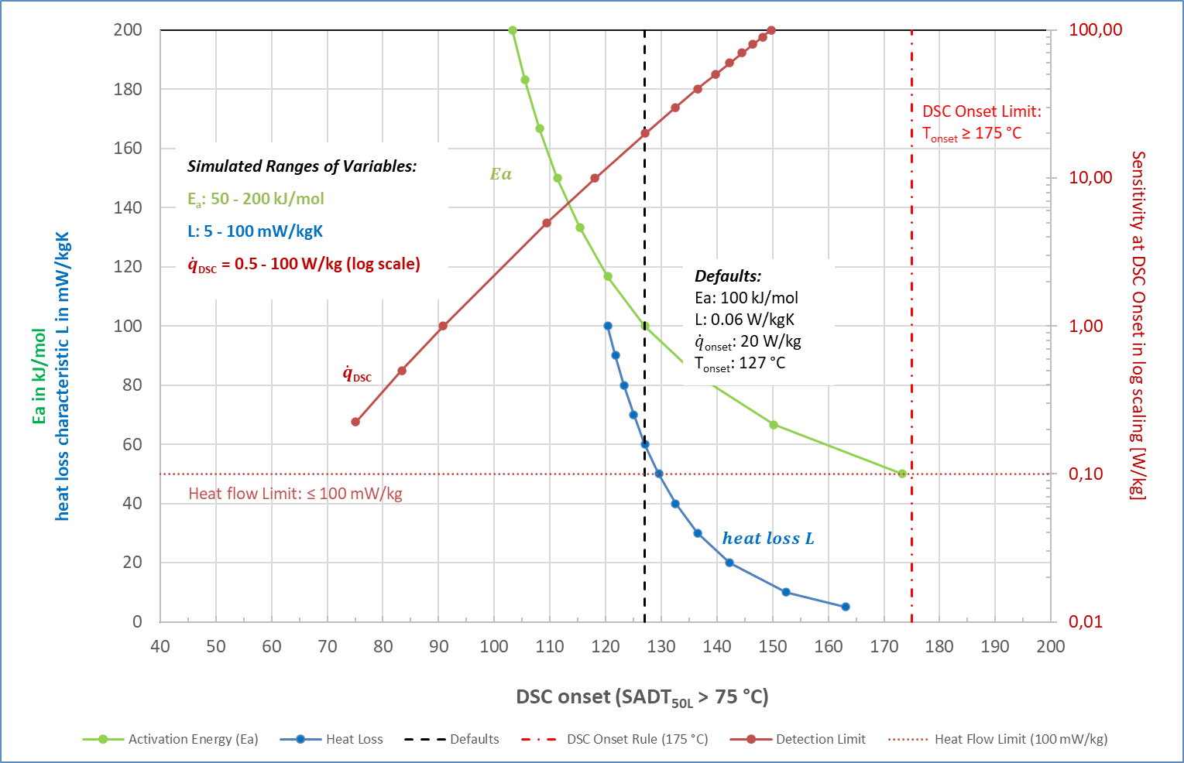

Figure I: Sensitivity plot for the screening rules for liquids (Semenov model)

3. The sensitivity test showed that the screening rules liquids are sufficiently conservative versus variation in DSC-detection limit, and that the 175 °C limit would only be breached at unrealistically poor levels of detection (far above 100 W kg-1). On the other hand, very low activation energies (less than 50 kJ/mol) or heat loss values (less than 50 mW kg-1 K-1) could lead to false negatives using these screening rules.

4. While such low activation energies are not to be expected for substances presented for transportation, the sensitivity to lower heat losses show that although these screening rules are appropriate for exemption from classification purposes, they should not be applied when assessing self-reactive properties in other situations or settings (e.g., larger package sizes).

5. Similar results were obtained when this sensitivity analysis was performed for the screening rules for solids obtained using the Semenov model.

6. These sensitivity analyses support the use of the proposed DSC-screening rules for excluding liquid or solid substances from classification as self-reactive according to the guidelines for classification described in section 28 and Appendix 6 of the MTC.

1. \* A/78/6 (Sect. 20), table 20.5. [↑](#footnote-ref-2)
2. <https://unece.org/sites/default/files/2023-11/UN-SCETDG-63-INF42e.pdf>. [↑](#footnote-ref-3)